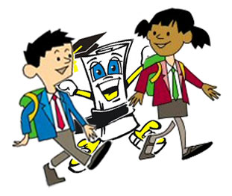**Hallway/Quad Expectations**

|  |  |  |
| --- | --- | --- |
| **Be Respectful** | **Be Responsible** | **Be**  **Safe** |
| Use quiet voices – so not to disrupt others | Stay in line facing forward unless directed by an adult | Walk at all times |
| **STOP LOOK**  **LISTEN** when spoken to by adults | Pick up trash | Keep hands, feet & objects to yourself |
| Respect instruction | Keep halls clean: this is a food and gum free zone | Stay on the playground, away from classrooms, during breaks |