Chapter 15
The Chromosomal Basis of Inheritance
Lecture Outline
Overview: Locating Genes Along Chromosomes
- Today we know that genes—Gregor Mendel’s “hereditary factors”—are located on chromosomes.
- A century ago, the relationship between genes and chromosomes was not so obvious.
- Many biologists were skeptical about Mendel’s laws of segregation and independent assortment until evidence mounted that they had a physical basis in the behavior of chromosomes.

Concept 15.1 Mendelian inheritance has its physical basis in the behavior of chromosomes.
- Around 1900, cytologists and geneticists began to see parallels between the behavior of chromosomes and the behavior of Mendel’s factors.
- Using improved microscopy techniques, cytologists worked out the process of mitosis in 1875 and meiosis in the 1890s.
- Chromosomes and genes are both present in pairs in diploid cells.
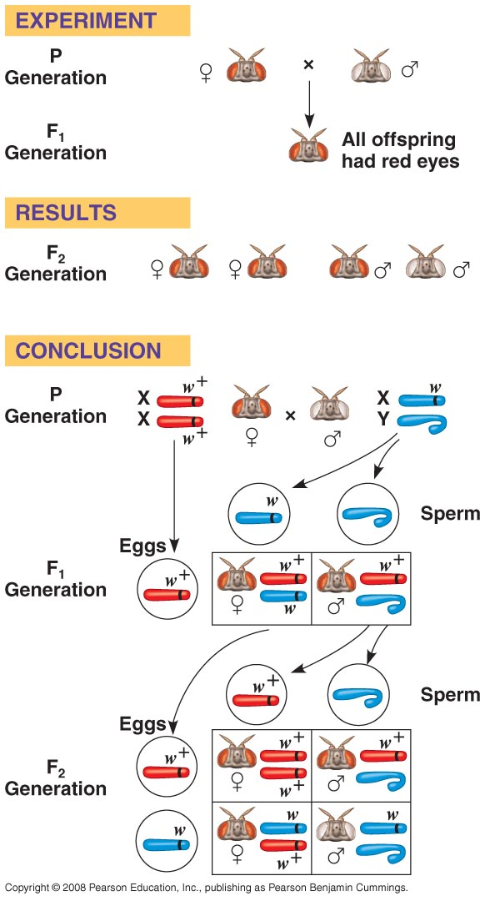
- Homologous chromosomes separate and alleles segregate during meiosis.
- Fertilization restores the paired condition for both chromosomes and genes.
- Around 1902, Walter Sutton, Theodor Boveri, and others noted these parallels, and a chromosome theory of inheritance began to take form:
- Genes occupy specific loci on chromosomes.
- Chromosomes undergo segregation during meiosis.
- Chromosomes undergo independent assortment during meiosis.
- The behavior of homologous chromosomes during meiosis can account for the segregation of the alleles at each genetic locus to different gametes.
- The behavior of nonhomologous chromosomes can account for the independent assortment of alleles for two or more genes located on different chromosomes.
- In the early 20th century, Thomas Hunt Morgan was the first geneticist to associate a specific gene with a specific chromosome.
- Like Mendel, Morgan made an insightful choice in his experimental animal. Morgan worked with Drosophila melanogaster, a fruit fly that eats fungi on fruit.
- Fruit flies are prolific breeders and have a generation time of two weeks.
- Fruit flies have three pairs of autosomes and a pair of sex chromosomes (XX in females, XY in males).
- Morgan spent a year looking for variant individuals among the flies he was breeding.
- He discovered a single male fly with white eyes instead of the usual red.
- The normal character phenotype is called the wild type.
- For a given character in flies, the gene’s symbol is chosen from the first mutant discovered.
- The allele for white eyes in Drosophila is symbolized by w.
- A superscript identifies the wild-type (red-eye) allele (w⁺).
- The symbols for human genes are capital letters (for example, HD for the allele for Huntington’s disease).
- Alternative traits are called mutant phenotypes because they are due to alleles that originate as mutations in the wild-type allele.
- When Morgan crossed his white-eyed male with a red-eyed female, all the F₁ offspring had red eyes, suggesting that the red allele was dominant to the white allele.
- Crosses between the F₁ offspring produced the classic 3:1 phenotypic ratio in the F₂ offspring.
- Surprisingly, the white-eyed trait appeared in only F₂ males.
- All the F₂ females and half the F₂ males had red eyes.
- Morgan concluded that a fly’s eye color was linked to its sex.
- Morgan deduced that the gene with the white-eyed mutation is on the X chromosome, with no corresponding allele present on the Y chromosome.
- Females (XX) may have two red-eyed alleles and have red eyes or may be heterozygous and have red eyes.
- Males (XY) have only a single allele. They will have red eyes if they have a red-eyed allele or white eyes if they have a white-eyed allele.
- Morgan’s finding of the correlation between a particular trait and an individual’s sex provided support for the chromosome theory of inheritance.
- A specific gene (for eye color) is carried on a specific chromosome (the X chromosome).

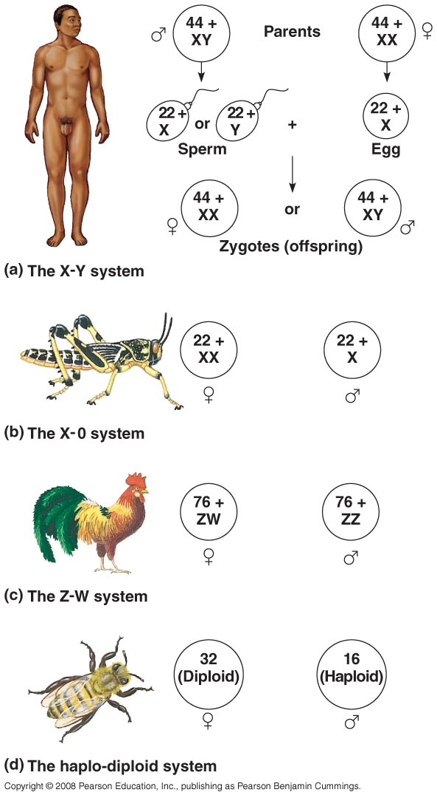
Concept 15.2 Sex-linked genes exhibit unique patterns of inheritance.
- Although the anatomical and physiological differences between women and men are numerous, the chromosomal basis of sex is rather simple.
- In humans and other mammals, there are two varieties of sex chromosomes, X and Y.
- An individual who inherits two X chromosomes usually develops as a female.
- An individual who inherits an X and a Y chromosome usually develops as a male.
- Short segments at either end of the Y chromosome are the only regions that are homologous with the corresponding regions of the X.
- These homologous regions allow the X and Y chromosomes in males to pair and behave like homologous chromosomes during meiosis in the testes.
- In both testes (XY) and ovaries (XX), the two sex chromosomes segregate during meiosis, and each gamete receives one.
- Each ovum receives an X chromosome.
- Half the sperm cells receive an X chromosome, and half receive a Y chromosome.
- Therefore, each conception has about a fifty-fifty chance of producing a particular sex.
- If a sperm cell bearing an X chromosome fertilizes an ovum, the resulting zygote is female (XX).
- If a sperm cell bearing a Y chromosome fertilizes an ovum, the resulting zygote is male (XY).
- Other animals have different methods of sex determination.
- The X-0 system is found in some insects. Females are XX and males are X.
- In birds, some fishes, and some insects, females are ZW and males are ZZ.
- In bees and ants, females are diploid and males are haploid.
- In humans, the anatomical signs of sex first appear when the embryo is about two months old.
- Before that, the gonads can develop into either testes or ovaries.
- In 1990, a British research team identified a gene on the Y chromosome required for the development of testes.
- They named the gene SRY (sex-determining region of the Y chromosome).
- In individuals with the SRY gene, the generic embryonic gonads develop into testes.
- The SRY gene codes for a protein that regulates many other genes, triggering a cascade of biochemical, physiological, and anatomical features.
- In individuals lacking the SRY gene, the generic embryonic gonads develop into ovaries.
- In the X-Y system, the Y chromosome is much smaller than the X chromosome.
- Researchers have sequenced the Y chromosome and identified 78 genes coding for about 25 proteins.
- Half of the genes are expressed only in the testes, and some are required for normal testicular function.
- Some genes on the Y chromosome are necessary for the production of functional sperm.
- In the absence of these genes, an XY individual is male but does not produce normal sperm.
- In addition to their role in determining sex, the sex chromosomes, especially the X chromosome, have genes for many characters unrelated to sex.
- A gene located on either sex chromosome is called a sex-linked gene.
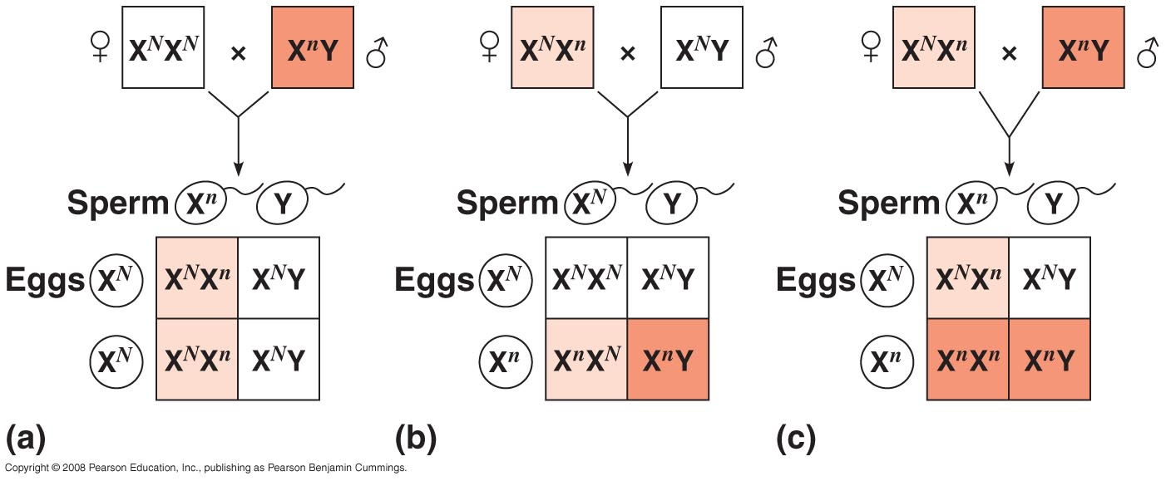
- In humans, the term sex-linked gene refers to a gene on the X chromosome.
- Human sex-linked genes follow the same pattern of inheritance as Morgan’s white-eye locus in Drosophila.
- Fathers pass sex-linked alleles to all their daughters but none of their sons.
- Mothers pass sex-linked alleles to both sons and daughters.
- If a sex-linked trait is due to a recessive allele, a female will express this phenotype only if she is homozygous.
- Heterozygous females are carriers for the recessive trait.
- Because males have only one X chromosome (hemizygous), any male who receives the recessive allele from his mother will express the recessive trait.
- The chance of a female inheriting a double dose of the mutant allele is much less than the chance of a male inheriting a single dose.
- Therefore, males are far more likely to exhibit sex-linked recessive disorders than are females.
- For example, color blindness is a mild disorder inherited as a sex-linked trait.
- A color-blind daughter may be born to a color-blind father whose mate is a carrier.
- The odds of this happening are fairly low.
- Several serious human disorders are sex-linked.
- Duchenne muscular dystrophy affects one in 3,500 males born in the United States.
- Affected individuals rarely live past their early 20s.
- This disorder is due to the absence of an X-linked gene for a key muscle protein called dystrophin.
- The disease is characterized by a progressive weakening of the muscles and a loss of coordination.
- Hemophilia is a sex-linked recessive disorder defined by the absence of one or more proteins required for blood clotting.
- These proteins normally slow and then stop bleeding.
- Individuals with hemophilia have prolonged bleeding because a firm clot forms slowly.
- Bleeding in muscles and joints can be painful and can lead to serious damage.
- Today, people with hemophilia can be treated with intravenous injections of the missing protein.
- Although female mammals inherit two X chromosomes, only one X chromosome is active.
- Therefore, males and females have the same effective dose (one copy) of genes on the X chromosome.
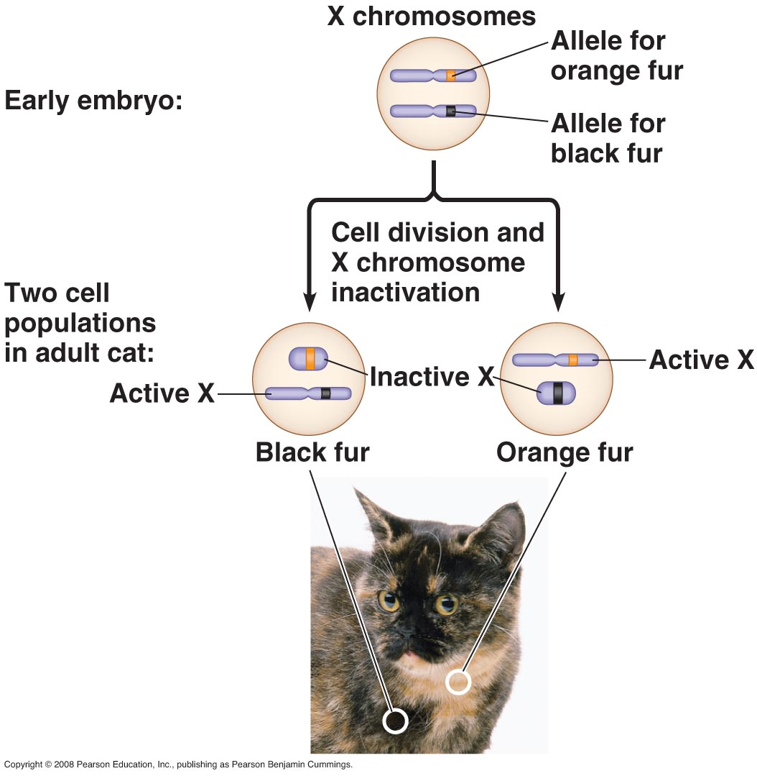
- During female development, one X chromosome per cell condenses into a compact object called a Barr body.
- Most of the genes on the Barr-body chromosome are not expressed.
- The condensed Barr-body chromosome is reactivated in ovarian cells that produce ova.
- Mary Lyon, a British geneticist, demonstrated that selection of which X chromosome will form the Barr body occurs randomly and independently in embryonic cells at the time of X inactivation.
- As a consequence, females consist of a mosaic of two types of cells, some with an active paternal X chromosome and others with an active maternal X chromosome.
- After an X chromosome is inactivated in a particular cell, all mitotic descendants of that cell will have the same inactive X.
- If a female is heterozygous for a sex-linked trait, approximately half her cells will express one allele, and the other half will express the other allele.
- In humans, this mosaic pattern is evident in women who are heterozygous for an X-linked mutation that prevents the development of sweat glands.
- A heterozygous woman has patches of normal skin and patches of skin that lacks sweat glands.
- Similarly, the orange-and-black pattern on tortoiseshell cats is due to patches of cells expressing an orange allele while other patches have a non-orange allele.
- X inactivation involves modification of the DNA by the attachment of methyl (—CH₃) groups to one of the nitrogenous bases on the X chromosome that will become the Barr body.
- Researchers have discovered a gene called XIST (X-inactive specific transcript).
- This gene is active only on the Barr-body chromosome and produces multiple copies of an RNA molecule that attach to the X chromosome on which they were made.
- This initiates X inactivation.
- The mechanism that connects XIST RNA and DNA methylation is unknown.
- What determines which of the two X chromosomes has an active XIST gene is also unknown.

Concept 15.3 Linked genes tend to be inherited together because they are located near each other on the same chromosome.
- Each chromosome has hundreds or thousands of genes.
- Genes located on the same chromosome that tend to be inherited together are called linked genes.
- The results of crosses with linked genes differ from those expected according to the law of independent assortment.
- Morgan observed this linkage and its deviations when he followed the inheritance of characters for body color and wing size in Drosophila.
- The wild-type body color is gray (b⁺), and the mutant is black (b).
- The wild-type wing size is normal (vg⁺), and the mutant has vestigial wings (vg).
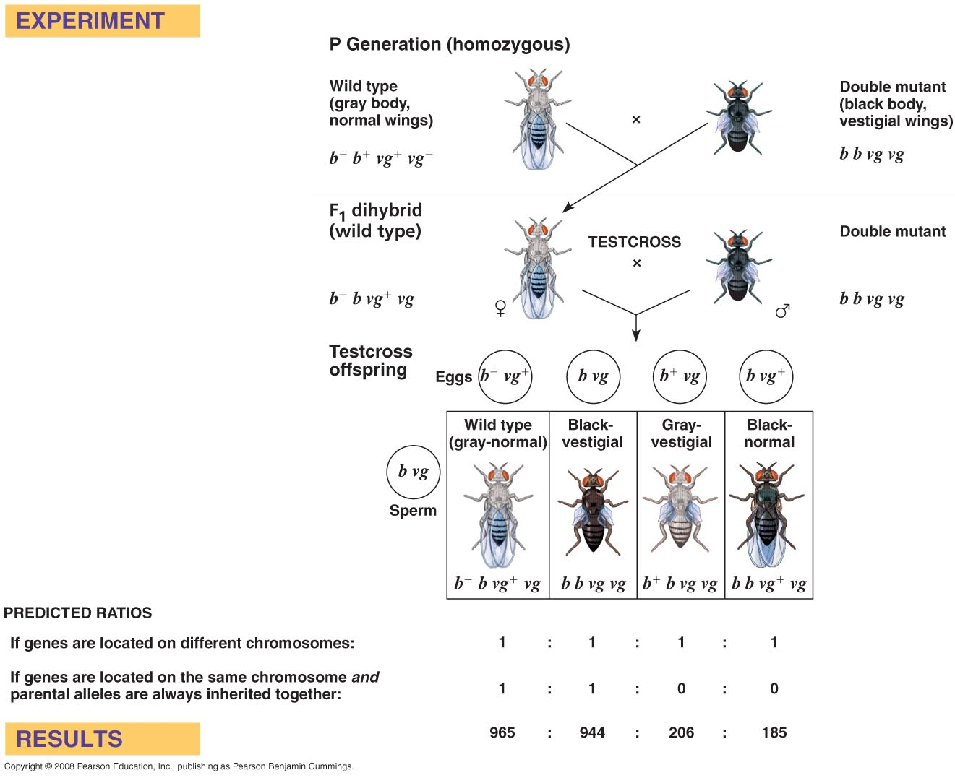
- The mutant alleles are recessive to the wild-type alleles.
- Neither gene is on a sex chromosome.
- Morgan crossed F₁ heterozygous females (b⁺bvg⁺vg) with homozygous recessive males (bbvgvg).
- According to independent assortment, this should produce four phenotypes in a 1:1:1:1 ratio.
- Surprisingly, Morgan observed a large number of wild-type (gray-normal) and double-mutant (black-vestigial) flies among the offspring.
- These phenotypes are those of the parents.
- Morgan reasoned that body color and wing shape are usually inherited together because the genes for these characters are on the same chromosome.
- The other two phenotypes (gray-vestigial and black-normal) were rarer than expected based on independent assortment (but totally unexpected from dependent assortment).
- What led to this genetic recombination, the production of offspring with new combinations of traits?
Independent assortment of chromosomes produces genetic recombination of unlinked genes.
- Genetic recombination can result from independent assortment of genes located on nonhomologous chromosomes.
- Mendel’s dihybrid cross experiments produced offspring that had a combination of traits that did not match either parent in the P generation.
- If the P generation consists of a yellow-round seed parent (YYRR) crossed with a green-wrinkled seed parent (yyrr), all the F₁ plants have yellow-round seeds (YyRr).
- A cross between an F₁ plant and a homozygous recessive plant (a testcross) produces four phenotypes.
- Half are the parental types, with phenotypes that match the original P parents, with either yellow-round seeds or green-wrinkled seeds.
- Half are recombinant types or recombinants, new combinations of parental traits, with yellow-wrinkled or green-round seeds.
- A 50% frequency of recombination is observed for any two genes located on different (nonhomologous) chromosomes.
- The physical basis of recombination between unlinked genes is the random orientation of homologous chromosomes at metaphase I of meiosis, which leads to the independent assortment of alleles.
- The F₁ parent (YyRr) produces gametes with four different combinations of alleles: YR, Yr, yR, and yr.
- The orientation of the tetrad containing the seed-color gene has no bearing on the orientation of the tetrad with the seed-shape gene.
Crossing over produces genetic recombination of linked genes.
- In contrast, linked genes, genes located on the same chromosome, tend to move together through meiosis and fertilization.
- Under normal Mendelian genetic rules, we would not expect linked genes to recombine into assortments of alleles not found in the parents.
- The results of Morgan’s testcross for body color and wing shape did not conform to either independent assortment or complete linkage.
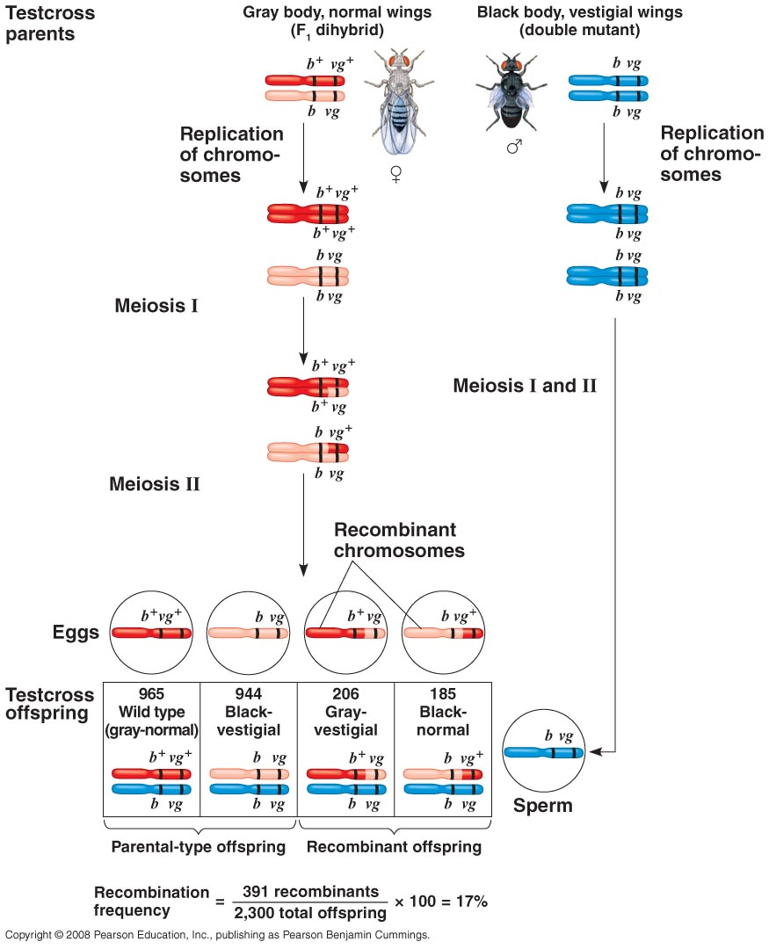
- Under independent assortment, the testcross should produce a 1:1:1:1 phenotypic ratio.
- Under complete linkage, we should expect to see a 1:1:0:0 ratio, with only parental phenotypes among the offspring.
- Most of the offspring had parental phenotypes, suggesting linkage between the genes.
- However, a small percentage of the flies were recombinants, suggesting incomplete linkage.
- Morgan proposed that some mechanism must occasionally break the physical connection between genes on the same chromosome.
- This process, called crossing over, accounts for the recombination of linked genes.
- Crossing over occurs while replicated homologous chromosomes are paired during prophase of meiosis I.
- One maternal and one paternal chromatid break at corresponding points and then rejoin with each other.
- The occasional production of recombinant gametes during meiosis accounts for the occurrence of recombinant phenotypes in Morgan’s testcross.
- The percentage of recombinant offspring, the recombination frequency, is related to the distance between linked genes.
Geneticists can use recombination data to map a chromosome’s genetic loci.
- One of Morgan’s students, Alfred Sturtevant, used the crossing over of linked genes to develop a method for constructing a genetic map, an ordered list of the genetic loci along a particular chromosome.
- Sturtevant hypothesized that the frequency of recombinant offspring reflects the distance between genes on a chromosome.
- He assumed that crossing over is a random event and that the chance of crossing over is approximately equal at all points on a chromosome.
- Sturtevant predicted that the farther apart two genes are, the higher the probability that a crossover will occur between them and, therefore, the higher the recombination frequency.
- The greater the distance between two genes, the more points there are between them where crossing over can occur.
- Sturtevant used recombination frequencies from fruit fly crosses to map the relative positions of genes along chromosomes.
- A genetic map based on recombination frequencies is called a linkage map.
- Sturtevant used the testcross design to map the relative positions of three fruit fly genes: body color (b), wing size (vg), and eye color (cn).
- Cinnabar (cn), one of many Drosophila genes affecting eye color, results in a bright red eye.
- The recombination frequency between cn and b is 9%.
- The recombination frequency between cn and vg is 9.5%.
- The recombination frequency between b and vg is 17%.
- The only possible arrangement of these three genes places the eye-color gene between the other two.
- Sturtevant expressed the distance between genes, the recombination frequency, as map units.
- One map unit (called a centimorgan) is equivalent to a 1% recombination frequency.
- You may notice that the three recombination frequencies in our mapping example are not quite additive: 9% (b-cn) + 9.5% (cn-vg) > 17% (b-vg). This results from multiple crossing-over events.
- A second crossing over “cancels out” the first and reduces the observed number of recombinant offspring.
- Genes father apart (for example, b-vg) are more likely to experience multiple crossing-over events.
- Some genes on a chromosome are so far apart that a crossover between them is virtually certain.
- In this case, the frequency of recombination reaches its maximum value of 50% and the genes behave as if found on separate chromosomes.
- In fact, two genes studied by Mendel—for seed color and flower color—are located on the same chromosome but still assort independently.
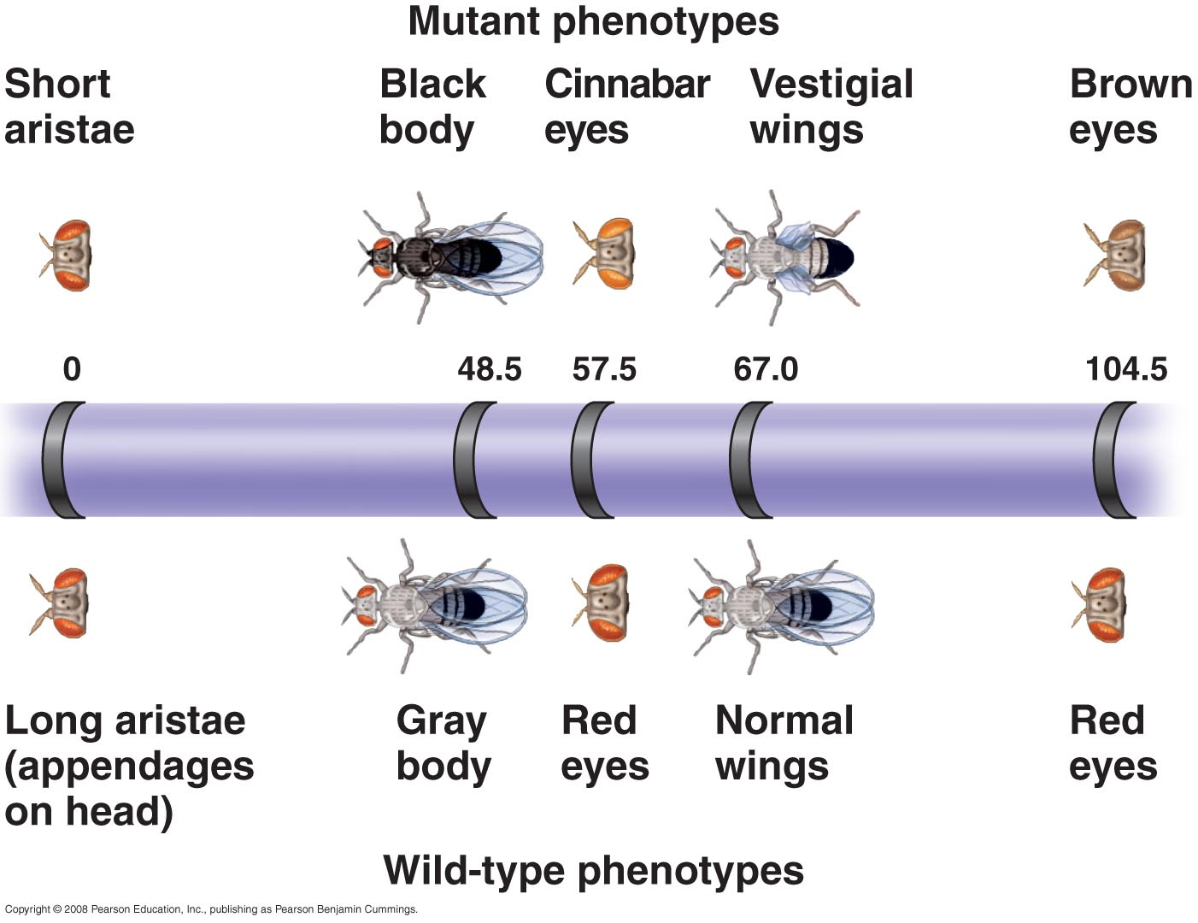
- Such genes are physically linked, because they are on the same chromosome, but genetically unlinked, because they sort independently on each other.
- Genes located far apart on a chromosome are mapped by adding the recombination frequencies between the distant genes and the intervening genes.
- Sturtevant and his colleagues were able to map the linear positions of genes in Drosophila into four groups, one for each chromosome.
- A linkage map provides an imperfect picture of a chromosome.
- Map units indicate relative distance and order, not precise locations of genes.
- The frequency of crossing over is not actually uniform over the length of a chromosome.
- By combining linkage maps with other methods like chromosomal banding, geneticists can develop cytogenetic maps of chromosomes.
- These maps indicate the positions of genes with respect to chromosomal features.
- Recent techniques show the physical distances between gene loci in DNA nucleotides.

Concept 15.4 Alterations of chromosome number or structure cause some genetic disorders.
- Physical and chemical disturbances can damage chromosomes in major ways.
- Errors during meiosis can alter the number of chromosomes in a cell.
- Plants tolerate genetic defects to a greater extent than do animals.
- Nondisjunction occurs when problems with the meiotic spindle cause errors in daughter cells.
- Nondisjunction may occur if tetrad chromosomes do not separate properly during meiosis I.
- Alternatively, sister chromatids may fail to separate during meiosis II.
- As a consequence of nondisjunction, one gamete receives two of the same type of chromosome, and another gamete receives no copy.
- Offspring resulting from the fertilization of a normal gamete with one produced by nondisjunction have an abnormal chromosome number, a condition known as aneuploidy.
- Trisomic cells have three copies of a particular chromosome type and have 2n + 1 total chromosomes.
- Monosomic cells have only one copy of a particular chromosome type and have 2n − 1 chromosomes.
- If the organism survives, aneuploidy typically leads to a distinct phenotype.
- Aneuploidy can also occur during failures of the mitotic spindle.
- If this happens early in development, the aneuploid condition is passed along by mitosis to a large number of cells.
- This is likely to have a substantial effect on the organism.
- Organisms with more than two complete sets of chromosomes are polyploid.
- Polyploidy may occur when a normal gamete fertilizes another gamete in which there has been nondisjunction of all its chromosomes.
- The resulting zygote is triploid (3n).
- Alternatively, if a 2n zygote fails to divide after replicating its chromosomes, a tetraploid (4n) embryo results from subsequent successful cycles of mitosis.
- Polyploidy is relatively common among plants and much less common among animals, although it is known to occur in fishes and amphibians.
- The spontaneous origin of polyploid individuals plays an important role in the evolution of plants.
- Many crop plants are polyploid. For example, bananas are triploid and wheat is hexaploid (6n).
- Recently, researchers in Chile identified a new rodent species that may be tetraploid.
- Polyploids are more nearly normal in phenotype than aneuploids.
- One extra or missing chromosome apparently upsets the genetic balance during development more than does an entire extra set of chromosomes.
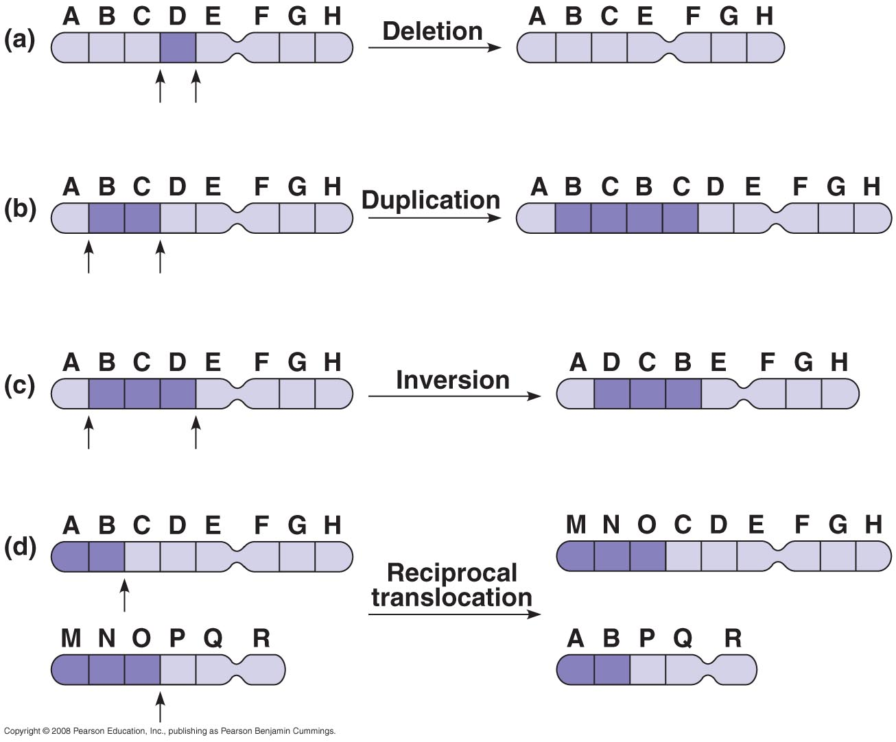
- Breakage of a chromosome can lead to four types of changes in chromosome structure.
- A deletion occurs when a chromosome fragment lacking a centromere is lost during cell division.
    - This chromosome will be missing certain genes.
- A duplication occurs when a fragment becomes attached as an extra segment to a sister chromatid.
    - Alternatively, a detached fragment may attach to a nonsister chromatid of a homologous chromosome.
    - In this case, the duplicated segments will not be identical if the homologs carry different alleles.
- An inversion occurs when a chromosomal fragment reattaches to the original chromosome, but in the reverse orientation.
- In translocation, a chromosomal fragment joins a nonhomologous chromosome.
- Deletions and duplications are especially likely to occur during meiosis.
- Homologous chromatids may break and rejoin at incorrect places during crossing over, so that one chromatid loses more genes than it receives.
- The products of such a nonreciprocal crossover are one chromosome with a deletion and one chromosome with a duplication.
- A diploid embryo that is homozygous for a large deletion or a male with a large deletion to its single X chromosome is usually missing many essential genes.
- This is usually lethal.
- Duplications and translocations are typically harmful.
- Reciprocal translocation or inversion can alter phenotype because a gene’s expression is influenced by its location among neighboring genes.
Human disorders are due to chromosome alterations.
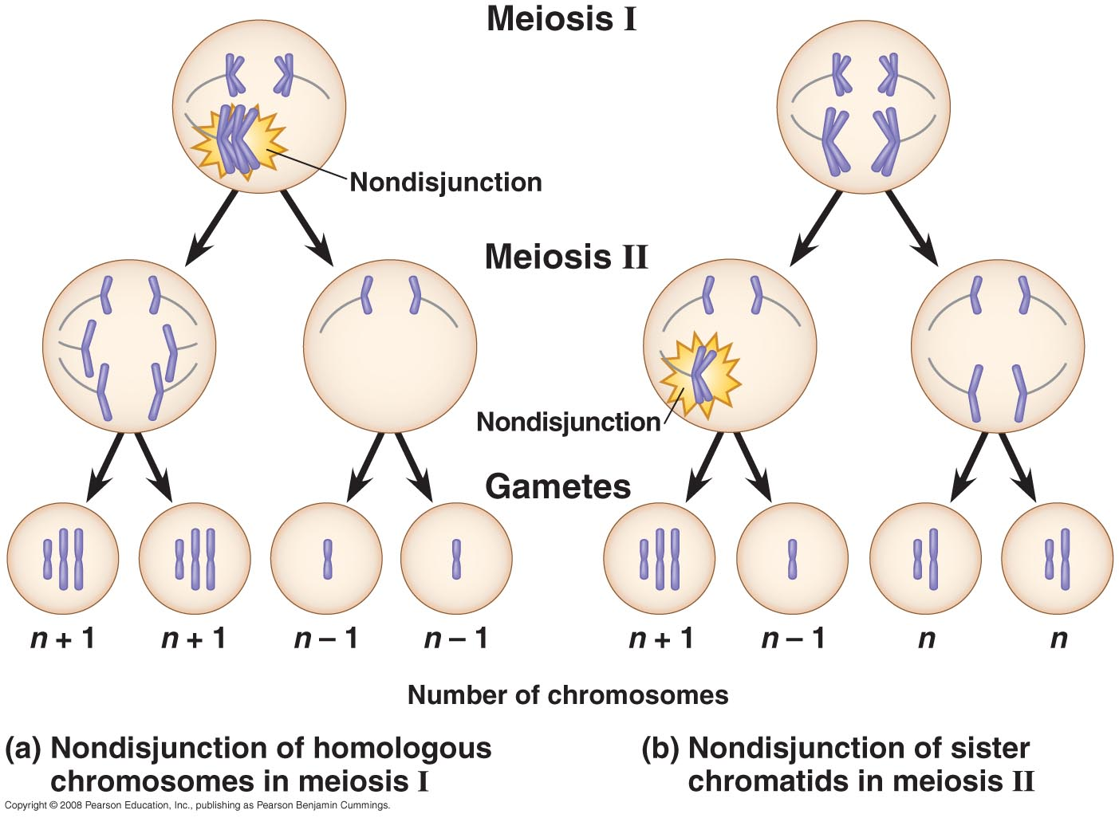
- Several serious human disorders are due to alterations of chromosome number and structure.
- Although the frequency of aneuploid zygotes may be quite high in humans, most of these alterations are so disastrous to development that the embryos are spontaneously aborted long before birth.
- Severe developmental problems result from an imbalance among gene products.
- Certain aneuploid conditions upset the balance less, making survival to birth and beyond possible.
- Surviving individuals have a set of symptoms—a syndrome—characteristic of the type of aneuploidy.
- Genetic disorders caused by aneuploidy can be diagnosed before birth by fetal testing.
- One aneuploid condition, Down syndrome, is due to three copies of chromosome 21, or trisomy 21.
- Trisomy 21 affects one in 700 children born in the United States.
- Although chromosome 21 is the smallest human chromosome, trisomy 21 severely alters an individual’s phenotype in specific ways.
- Individuals with Down syndrome have characteristic facial features, short stature, heart defects, susceptibility to respiratory infection, mental retardation, and increased risk of developing leukemia and Alzheimer’s disease.
- Most are sexually underdeveloped and sterile.
- Most cases of Down syndrome result from nondisjunction during gamete production in one parent.
- The frequency of Down syndrome increases with the age of the mother.
- Trisomy 21 may be linked to some age-dependent abnormality in a meiosis I checkpoint that normally delays anaphase until all the kinetochores are attached to the spindle.
- Trisomies of other chromosomes also increase in incidence with maternal age, but it is rare for infants with these autosomal trisomies to survive for long.
- Nondisjunction of sex chromosomes produces a variety of aneuploid conditions in humans.
- This aneuploidy upsets the genetic balance less severely that autosomal aneuploidy.
- This may be because the Y chromosome contains relatively few genes and because extra copies of the X chromosome become inactivated as Barr bodies in somatic cells.
- An XXY male has Klinefelter’s syndrome, which occurs once in every 2,000 live births.
- These individuals have male sex organs but abnormally small testes and are sterile.
- Although the extra X is inactivated, some breast enlargement and other female characteristics are common.
- Affected individuals have normal intelligence.
- Males with an extra Y chromosome (XYY) tend to be somewhat taller than average.
- Trisomy X (XXX), which occurs once in every 2,000 live births, produces healthy females.
- Monosomy X, or Turner syndrome (X0), occurs once in every 5,000 births.
- This is the only known viable monosomy in humans.
- X0 individuals are phenotypically female but are sterile because their sex organs do not mature.
- When given estrogen replacement therapy, girls with Turner syndrome develop secondary sex characteristics.
- Most have normal intelligence.
- Structural alterations of chromosomes can also cause human disorders.
- Deletions, even in a heterozygous state, can cause severe problems.
- One syndrome, cri du chat, results from a specific deletion in chromosome 5.
- These individuals are mentally retarded, have small heads with unusual facial features, and have a cry like the mewing of a distressed cat.
- This syndrome is fatal in infancy or early childhood.
- Chromosomal translocations between nonhomologous chromosomes are also associated with human disorders.
- Chromosomal translocations have been implicated in certain cancers, including chronic myelogenous leukemia (CML).
- CML occurs when a large fragment of chromosome 22 switches places with a small fragment from the tip of chromosome 9.
- The resulting short, easily recognized chromosome 22 is called the Philadelphia chromosome.

Concept 15.5 Some inheritance patterns are exceptions to the standard chromosome theory.
The phenotypic effects of some mammalian genes depend on whether they are inherited from the mother or the father.
- For most genes, it is a reasonable assumption that a specific allele will have the same effect whether it is inherited from the mother or the father.
- For a few dozen mammalian traits, phenotype varies depending on which parent passed along the alleles for those traits.
- The genes involved are not necessarily sex-linked and may or may not lie on the X chromosome.
- Variation in phenotype depending on whether an allele is inherited from the male or female parent is called genomic imprinting.
- Genomic imprinting occurs during the formation of gametes and results in the silencing of certain genes.
- Imprinted genes are not expressed.
- Because different genes are imprinted in sperm and ova, some genes in a zygote are maternally imprinted and others are paternally imprinted.
- These maternal and paternal imprints are transmitted to all body cells during development.
- For a maternally imprinted gene, only the paternal allele is expressed.
- For a paternally imprinted gene, only the maternal allele is expressed.
- Patterns of imprinting are characteristic of a given species.
- The gene for insulin-like growth factor 2 (Igf2) was one of the first imprinted genes to be identified.
- Although the growth factor is required for normal prenatal growth, only the paternal allele is expressed.
- Evidence that the Igf2 allele is imprinted initially came from crosses between wild-type mice and dwarf mice homozygous for a recessive mutation in the Igf2 gene.
- The phenotypes of heterozygous offspring differ, depending on whether the mutant allele comes from the mother or the father.
- The Igf2 allele is imprinted in eggs, turning off expression of the imprinted allele.
- In sperm, the Igf2 allele is not imprinted and functions normally.
- In many cases, the genomic imprint consists of methyl (—CH₃) groups that are added to the cytosine nucleotides of one of the alleles.
- The hypothesis that methylation directly silences an allele is consistent with the evidence that heavily methylated genes are usually inactive.
- Other mechanisms may lead to silencing of imprinted genes.
- For a few genes, however, methylation has been shown to activate expression of the allele.
- This is the case for the Igf2 gene: Methylation of certain DNA nucleotides on the paternal chromosome leads to expression of the paternal Igf2 allele.
- Most of the known imprinted genes are critical for embryonic development.
- In experiments with mice, embryos engineered to inherit both copies of certain chromosomes from the same parent die before birth, whether their lone parent is male or female.
- In 2004, scientists in Japan combined the genetic material from two eggs in a zygote, while allowing expression of the Igf2 gene from only one of the egg nuclei.
- Normal development requires that embryonic cells have one active copy of certain genes.
- Aberrant imprinting is associated with abnormal development and certain cancers.
Extranuclear genes exhibit a non-Mendelian pattern of inheritance.
- Not all of a eukaryote cell’s genes are located on nuclear chromosomes, or even in the nucleus.
- Extranuclear or cytoplasmic genes are found in small circles of DNA in mitochondria and chloroplasts.
- These organelles reproduce themselves and transmit their genes to daughter organelles.
- Their cytoplasmic genes do not display Mendelian inheritance because they are not distributed to offspring according to the same rules that direct the distribution of nuclear chromosomes during meiosis.
- Karl Correns first observed cytoplasmic genes in plants in 1909, when he studied the inheritance of patches of yellow or white on the leaves of an otherwise green plant.
- Correns determined that this variegation was due to mutations in plastid genes that control pigmentation.
- In most plants, a zygote receives all of its plastids from the egg cytoplasm.
- As a result, the maternal parent determines the coloration of the offspring’s leaves.
- Because a zygote inherits all its mitochondria from the ovum, all mitochondrial genes in most animals and plants demonstrate maternal inheritance.
- Several rare human disorders are produced by mutations to mitochondrial DNA.
- These disorders affect primarily the ATP supply by producing defects in the electron transport chain or ATP synthase.
- Tissues that require large energy supplies (the nervous system and muscles) may suffer energy deprivation from these defects.
- For example, a person with mitochondrial myopathy suffers weakness, intolerance of exercise, and muscle deterioration.
- Another mitochondrial disorder is Leber’s hereditary optic neuropathy, which can produce sudden blindness in young adults.
- The four mutations that have been found thus far to cause this disorder affect oxidative phosphorylation during cellular respiration, clearly a crucial function for the cell.
- Other mitochondrial mutations may contribute to diabetes, heart disease, and other diseases of aging, such as Alzheimer’s disease.
- Over a lifetime, new mutations gradually accumulate in mitochondrial DNA.
- Some researchers think that these mutations play a role in the normal aging process.

