Chapter 18
Regulation of Gene Expression
Lecture Outline
Overview: Conducting the Genetic Orchestra
- Both prokaryotes and eukaryotes alter their patterns of gene expression in response to changes in environmental conditions.
- In multicellular eukaryotes, each cell type contains the same genome but expresses a different subset of genes.
- During development, gene expression must be carefully regulated to ensure that the right genes are expressed only at the correct time and in the correct place.
- Gene expression in eukaryotes and bacteria is often regulated at the transcription stage.
- Control of other levels of gene expression is also important.
- RNA molecules play many roles in regulating eukaryotic gene expressions.
- Disruptions in gene regulation can lead to cancer.

Concept 18.1 Bacteria often respond to environmental change by regulating transcription.
- Natural selection favors bacteria that express only those genes whose products are needed by the cell.
- A bacterium in a tryptophan-rich environment that stops producing tryptophan conserves its resources.
- Metabolic control occurs on two levels.
- First, cells can adjust the activity of enzymes already present.
- This may happen by feedback inhibition, in which the activity of the first enzyme in a pathway is inhibited by the pathway’s end product.
- Feedback inhibition, typical of anabolic (biosynthetic) pathways, allows a cell to adapt to short-term fluctuations in the supply of a needed substance.
- Second, cells can vary the number of specific enzyme molecules they make by regulating gene expression.
- Genes of the bacterial genome may be switched on or off by changes in the metabolic status of the cell.
- The basic mechanism for the control of gene expression in bacteria, known as the operon model, was described by Francois Jacob and Jacques Monod in 1961.
The operon model controls tryptophan synthesis.
- Escherichia coli synthesizes tryptophan from a precursor molecule in a series of steps, with each reaction catalyzed by a specific enzyme.
- The five genes coding for these enzymes are clustered together on the bacterial chromosome as a transcription unit, served by a single promoter.
- Transcription gives rise to one long mRNA molecule that codes for all five enzymes in the tryptophan pathway.
- The mRNA is punctuated with start and stop codons that signal where the coding sequence for each polypeptide begins and ends.
- A key advantage of grouping genes with related functions into one transcription unit is that a single on-off switch can control a cluster of functionally related genes.
- In other words, these genes are under coordinate control.
- When an E. coli cell must make tryptophan for itself, all the enzymes are synthesized at one time.
- The switch is a segment of DNA called an operator.
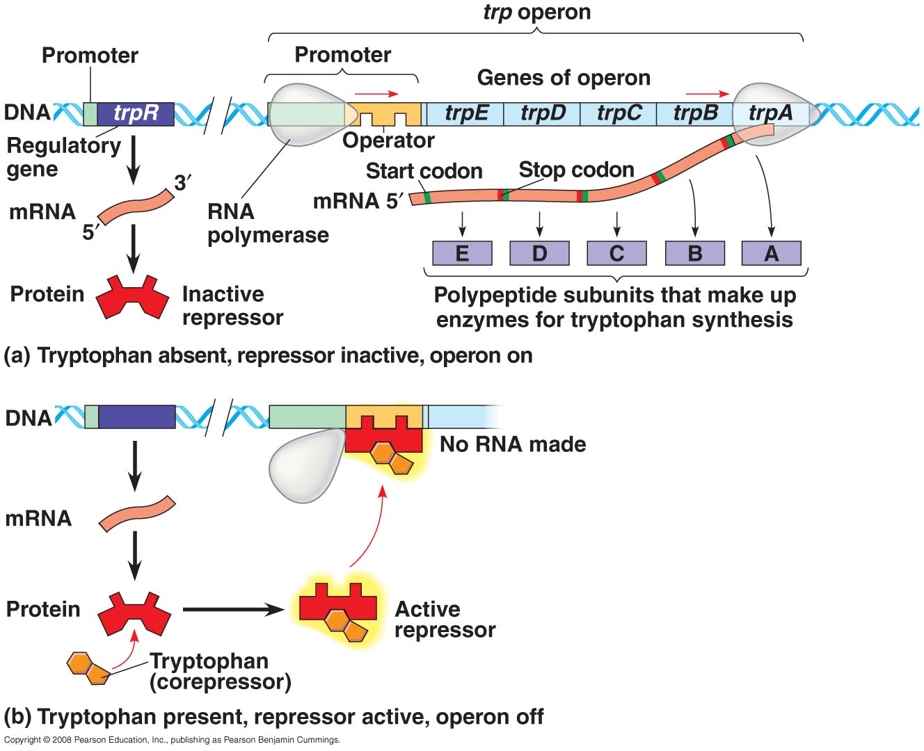
- The operator, located between the promoter and the enzyme-coding genes, controls the access of RNA polymerase to the genes.
- The operator, the promoter, and the genes they control constitute an operon.
- The trp operon (trp for tryptophan) is one of many operons in the E. coli genome.
- By itself, an operon is turned on. RNA polymerase can bind to the promoter and transcribe the genes.
- The operon can be switched off by a protein called the trp repressor.
- The repressor binds to the operator, blocks attachment of RNA polymerase to the promoter, and prevents transcription of the operon’s genes.
- Each repressor protein recognizes and binds only to the operator of a particular operon.
- The trp repressor is the product of a regulatory gene called trpR, which is located at some distance from the operon it controls and has its own promoter.
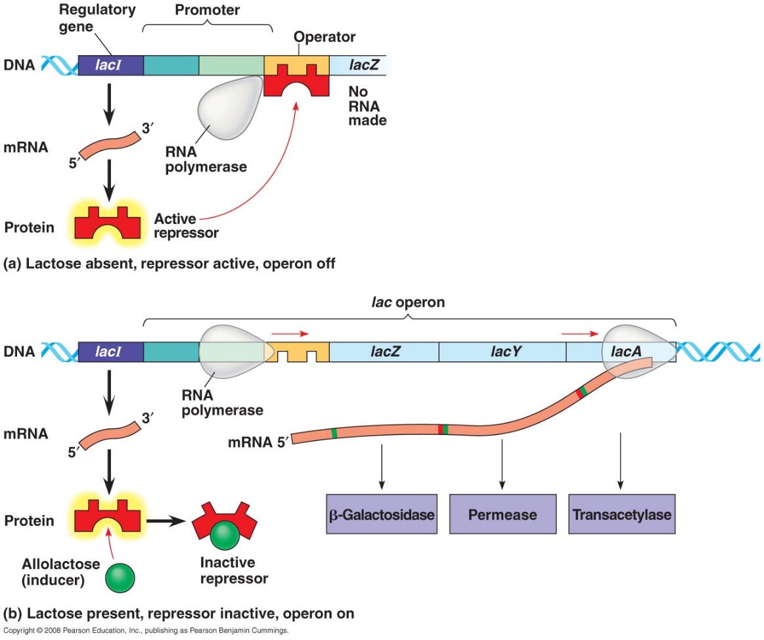
- Regulatory genes are transcribed continuously at slow rates, and a few trp repressor molecules are always present in an E. coli cell.
- Why is the trp operon not switched off permanently?
- First, binding by the repressor to the operator is reversible.
- An operator vacillates between two states, with and without a repressor bound to it.
- Second, repressors contain allosteric sites that change shape depending on the binding of other molecules.
- The trp repressor has two shapes: active and inactive.
- In the case of the trp operon, when concentrations of tryptophan in the cell are high, some tryptophan molecules bind as a corepressor to the repressor protein.
- This activates the repressor and turns the operon off.
- At low levels of tryptophan, most of the repressors are inactive, and the operon is transcribed.
- As tryptophan accumulates, more tryptophan molecules associate with trp repressor molecules, which bind to the trp operator and shut down production of the enzymes of the tryptophan pathway.
There are two types of operons: repressible and inducible.
- The trp operon is an example of a repressible operon, one that is inhibited when a specific small molecule (tryptophan) binds allosterically to a regulatory protein.
- In contrast, an inducible operon is stimulated or induced when a specific small molecule interacts with a regulatory protein.
- In inducible operons, the regulatory protein is active (inhibitory) as synthesized, and the operon is off.
- Allosteric binding by an inducer molecule makes the regulatory protein inactive, and the operon is turned on.
- The lac operon contains a series of genes that code for enzymes that play a major role in the hydrolysis and metabolism of lactose (milk sugar).
- In the absence of lactose, this operon is off because an active repressor binds to the operator and prevents transcription.
- Lactose metabolism begins with hydrolysis of lactose into its component monosaccharides, glucose and galactose. This reaction is catalyzed by the enzyme ß-galactosidase.
- Only a few molecules of β-galactosidase are present in an E. coli cell grown in the absence of lactose.
- If lactose is added to the bacterium’s environment, the number of ß-galactosidase molecules increases by a thousandfold within 15 minutes.
- The gene for ß-galactosidase is part of the lac operon, which includes two other genes coding for enzymes that function in lactose metabolism.
- The regulatory gene, lacI, located outside the operon, codes for an allosteric repressor protein that can switch off the lac operon by binding to the operator.
- Unlike the trp operon, the lac repressor is active all by itself, binding to the operator and switching the lac operon off.
- An inducer inactivates the repressor.
- When lactose is present in the cell, allolactose, an isomer of lactose, binds to the repressor.
- This inactivates the repressor, and the lac operon can be transcribed.
- Repressible enzymes generally function in anabolic pathways, synthesizing end products from raw materials.
- When the end product is present in sufficient quantities, the cell can allocate its resources to other uses.
- Inducible enzymes usually function in catabolic pathways, digesting nutrients to simpler molecules.
- By producing the appropriate enzymes only when the nutrient is available, the cell avoids making proteins that have nothing to do.
- Both repressible and inducible operons demonstrate negative control of genes because active repressors switch off the active form of the repressor protein.
Some gene regulation is positive.
- Positive gene control occurs when a protein molecule interacts directly with the genome to switch transcription on.
- The lac operon is an example of positive gene regulation.
- When glucose and lactose are both present, E. coli preferentially uses glucose.
- The enzymes for glucose breakdown in glycolysis are always present in the cell.
- Only when lactose is present and glucose is in short supply does E. coli use lactose as an energy source and synthesize the enzymes for lactose breakdown.
- When glucose levels are low, cyclic AMP (cAMP) accumulates in the cell.
- The regulatory protein catabolite activator protein (CAP) is an activator of transcription.
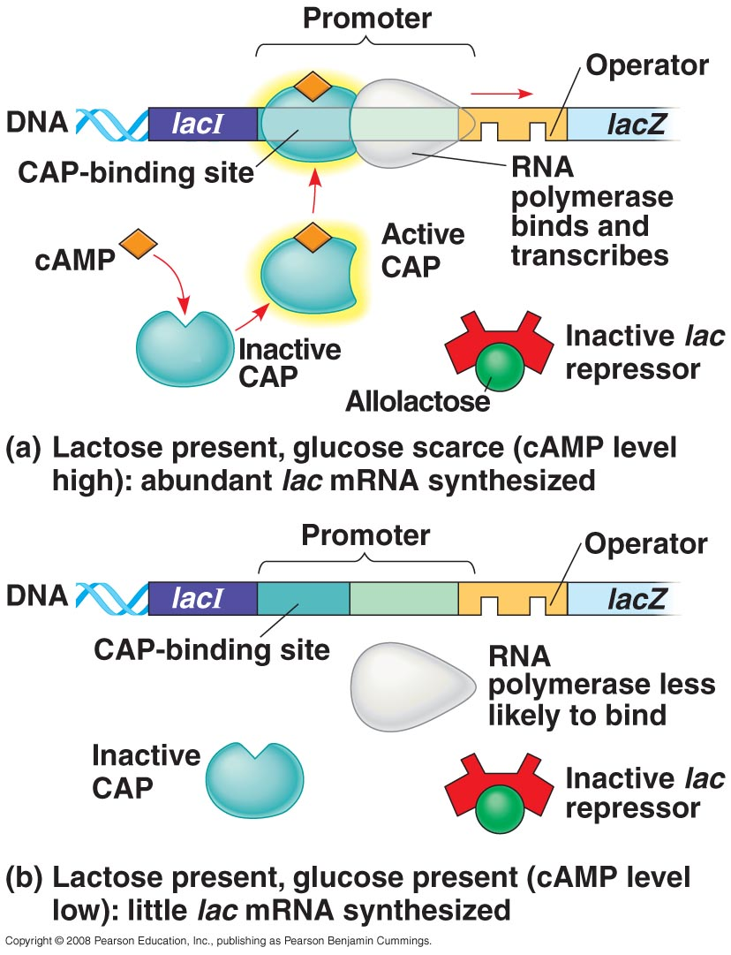
- When cAMP is abundant, it binds to CAP, and the regulatory protein assumes its active shape and can bind to a specific site at the upstream end of the lac promoter.
- The attachment of CAP to the promoter increases the affinity of RNA polymerase for the promoter, directly increasing the rate of transcription.
- Thus, this mechanism qualifies as positive regulation.
- If glucose levels in the cell rise, cAMP levels fall.
- Without cAMP, CAP detaches from the operon.
- The lac operon is transcribed but at a low level.
- The lac operon is under dual control: negative control by the lac repressor and positive control by CAP.
- The state of the lac repressor (with or without bound allolactose) determines whether or not the lac operon’s genes are transcribed.
- The state of CAP (with or without bound cAMP) controls the rate of transcription if the operon is repressor-free.
- The operon has both an on-off switch and a volume control.
- CAP works on several operons that encode enzymes used in catabolic pathways. It affects the expression of more than 100 E. coli genes.
- If glucose is present and CAP is inactive, then the synthesis of enzymes that catabolize other compounds is slowed.
- If glucose levels are low and CAP is active, then the genes that produce enzymes that catabolize whichever other fuel is present are transcribed at high levels.

Concept 18.2 Eukaryotic gene expression can be regulated at any stage.
- Like unicellular organisms, the tens of thousands of genes in the cells of multicellular eukaryotes are continuously turned on and off in response to signals from their internal and external environments.
- Gene expression must be controlled on a long-term basis during cellular differentiation, the divergence in form and function as cells in a multicellular organism specialize.
Differential gene expression is the expression of different genes by cells with the same genome.
- A typical human cell probably expresses about 20% of its genes at any given time.
- Highly specialized cells, such as nerves or muscles, express only a tiny fraction of their genes.
- Although all the cells in an organism contain an identical genome, the subset of genes expressed in the cells of each type is unique.
- The differences between cell types are due to differential gene expression, the expression of different genes by cells with the same genome.
- The genomes of eukaryotes may contain tens of thousands of genes.
- For quite a few species, only a small amount of the DNA—1.5% in humans—codes for protein.
- Of the remaining DNA, a very small fraction consists of genes for rRNA and tRNA.
- The rest of the DNA either codes for RNA products, such as tRNAs, or isn’t transcribed.
- Problems with gene expression and control can lead to imbalance and disease, including cancer.
- Our understanding of the mechanisms that control gene expression in eukaryotes has been enhanced by new research methods, including advances in DNA technology.
- In all organisms, the expression of specific genes is most commonly regulated at transcription, often in response to signals coming from outside the cell.
- For this reason, the term gene expression is often equated with transcription.
- With their greater complexity, eukaryotes have opportunities for controlling gene expression at additional stages.
Chromatin modifications affect the availability of genes for transcription.
- The DNA of eukaryotic cells is packaged with proteins in a complex called chromatin.
- The location of a gene’s promoter relative to nucleosomes and to the sites where the DNA attaches to the chromosome scaffold or nuclear lamina can affect whether the gene is transcribed.
- Genes of densely condensed heterochromatin are usually not expressed, presumably because transcription proteins cannot reach the DNA.
- A gene’s location relative to nucleosomes and to attachment sites to the chromosome scaffold or nuclear lamina can affect transcription.
Histone modifications regulate gene transcription.
- Chemical modifications of the histones and DNA of chromatin play a key role in chromatin structure and gene expression.
- The N-terminus of each histone molecule in a nucleosome protrudes outward from the nucleosome.
- These histone tails are accessible to various modifying enzymes, which catalyze the addition or removal of specific chemical groups.
- Histone acetylation (addition of an acetyl group, —COCH₃) and deacetylation appear to play a direct role in the regulation of gene transcription.
- Acetylated histones grip neighboring nucleosomes less tightly, providing easier access for transcription proteins in this region.
- Some of the enzymes responsible for acetylation or deacetylation are associated with or are components of transcription factors that bind to promoters.
- Thus, histone acetylation enzymes may promote the initiation of transcription not only by modifying chromatin structure but also by binding to and recruiting components of the transcription machinery.
- Several other chemical groups, such as methyl and phosphate groups, can be reversibly attached to amino acids in histone tails.
- The attachment of methyl groups (—CH₃) to histone tails leads to condensation of chromatin.
- The addition of a phosphate group (phosphorylation) to an amino acid next to a methylated amino acid has the opposite effect.
- The recent discovery that modifications to histone tails can affect chromatin structure and gene expression has led to the histone code hypothesis.
- This hypothesis proposes that specific combinations of modifications, rather than the overall level of histone acetylation, determine chromatin configuration.
- Chromatin configuration in turn influences transcription.
DNA methylation reduces gene expression.
- While some enzymes methylate the tails of histone proteins, other enzymes methylate certain bases in DNA itself.
- The DNA of most plants, animals, and fungi has methylated bases, usually cytosine.
- Inactive DNA is generally highly methylated compared to DNA that is actively transcribed.
- For example, the inactivated mammalian X chromosome in females is heavily methylated.
- Genes are usually more heavily methylated in cells where they are not expressed.
- Demethylating certain inactive genes turns them on.
- DNA methylation proteins recruit histone deacetylation enzymes, providing a mechanism by which DNA methylation and histone deacetylation cooperate to repress transcription.
- In some species, DNA methylation is responsible for the long-term inactivation of genes during cellular differentiation.
- Once methylated, genes usually stay that way through successive cell divisions in a given individual.
- Methylation enzymes recognize sites on one strand that are already methylated and correctly methylate the daughter strand after each round of DNA replication.
- This methylation pattern accounts for genomic imprinting, in which methylation turns off either the maternal or paternal alleles of certain genes at the start of development.
- The chromatin modifications just discussed do not alter the DNA sequence, and yet they may be passed along to future generations of cells.
- Inheritance of traits by mechanisms not directly involving the nucleotide sequence is called epigenetic inheritance.
- Researchers are amassing more and more evidence for the importance of epigenetic information in the regulation of gene expression.
- Epigenetic variations may explain why one identical twin acquires a genetically based disease, such as schizophrenia, while another does not, despite their identical genomes.
- Enzymes that modify chromatin structure are integral parts of the cell’s machinery for regulating transcription.
Transcription initiation is controlled by proteins that interact with DNA and with each other.
- Chromatin-modifying enzymes provide initial control of gene expression by making a region of DNA either more available or less available for transcription.
- A cluster of proteins called a transcription initiation complex assembles on the promoter sequence at the upstream end of the gene.
- One component, RNA polymerase II, transcribes the gene, synthesizing a primary RNA transcript or pre-mRNA.
- RNA processing includes enzymatic addition of a 5′ cap and a poly-A tail, as well as splicing out of introns to yield a mature mRNA.
- Multiple control elements are associated with most eukaryotic genes.
- Control elements are noncoding DNA segments that regulate transcription by binding certain proteins.
- These control elements and the proteins they bind are critical to the precise regulation of gene expression in different cell types.
- To initiate transcription, eukaryotic RNA polymerase requires the assistance of proteins called transcription factors.
- General transcription factors are essential for the transcription of all protein-coding genes.
- Only a few general transcription factors independently bind a DNA sequence such as the TATA box within the promoter.
- Others are involved in protein-protein interactions, binding each other and RNA polymerase II.
- Only when the complete initiation complex has been assembled can the polymerase begin to move along the DNA template strand to produce a complementary strand of RNA.
- The interaction of general transcription factors and RNA polymerase II with a promoter usually leads to only a slow rate of initiation and the production of few RNA transcripts.
- In eukaryotes, high levels of transcription of particular genes depend on the interaction of control elements with specific transcription factors.
- Some control elements, named proximal control elements, are located close to the promoter.
- Distal control elements, enhancers, may be thousands of nucleotides away from the promoter or even downstream of the gene or within an intron.
- A given gene may have multiple enhancers, each active at a different time or in a different cell type or location in the organism.
- Interactions between enhancers and specific transcription factors called activators or repressors are important in controlling gene expression.
- An activator is a protein that binds to an enhancer to stimulate transcription of a gene.
- Protein-mediated bending of DNA brings bound activators in contact with a group of mediator proteins that interact with proteins at the promoter.
- These interactions help assemble and position the initiation complex on the promoter.
- Hundreds of transcription activators have been discovered in eukaryotes.
- Two common structural elements characterize a large number of activator proteins: a DNA-binding domain and one or more activation domains.
- Activation domains bind other regulatory proteins or components of the transcription machinery to facilitate transcription.
- Eukaryotic genes also have repressors to inhibit the expression of a specific gene.
- Eukaryotic repressors can inhibit gene expression by blocking the binding of activators to their control elements or to components of the transcription machinery.
- Other repressors bind directly to control-element DNA, turning off transcription even in the presence of activators.
- Some activators and repressors act indirectly to influence chromatin structure.
- Some activators recruit proteins that acetylate histones near the promoters of specific genes, promoting transcription.
- Some repressors recruit proteins that deacetylate histones, reducing transcription or silencing the gene.
- Recruitment of chromatin-modifying proteins seems to be the most common mechanism of repression in eukaryotes.
The control of transcription in eukaryotes depends on the binding of activators to DNA control elements.
- The number of nucleotide sequences found in control elements is surprisingly small: about a dozen.
- On average, each enhancer is composed of about ten control elements, each of which can bind to only one or two specific transcription factors.
- The particular combination of control elements in an enhancer may be more important than the presence of a single unique control element in regulating transcription of the gene.
- Even with only a dozen control element sequences, a large number of combinations are possible.
- A particular combination of control elements is able to activate transcription only when the appropriate activator proteins are present, such as at a precise time during development or in a particular cell type.
- The use of different combinations of control elements allows fine regulation of transcription with a small set of control elements.
- In prokaryotes, coordinately controlled genes are often clustered into an operon with a single promoter and other control elements upstream.
- The genes of the operon are transcribed into a single mRNA and translated together.
- In contrast, very few eukaryotic genes are organized this way.
- Recent studies of the genomes of several eukaryotic species have found that some co-expressed genes are clustered near one other on the same chromosome.
- Each gene in these clusters has its own promoter and is individually transcribed.
- The coordinate regulation of clustered genes in eukaryotic cells is thought to involve changes in the chromatin structure that make the entire group of genes either available or unavailable for transcription.
- In other cases, including 15% of nematode genes, several related genes share a promoter and are transcribed into a single pre-mRNA, which is then processed into separate mRNAs.
- More commonly, genes coding for the enzymes of a metabolic pathway are scattered over different chromosomes.
- Coordinate gene expression in eukaryotes depends on the association of a specific control element or combination of control elements with every gene of a dispersed group.
- A common group of transcription factors binds to all the genes in the group, promoting simultaneous gene transcription.
- For example, a steroid hormone enters a cell and binds to a specific receptor protein in the cytoplasm or nucleus, forming a hormone–receptor complex that serves as a transcription activator.
- Every gene whose transcription is stimulated by that steroid hormone has a control element recognized by that hormone–receptor complex.
- Other signal molecules control gene expression indirectly by triggering signal-transduction pathways that lead to activation of transcription.
- The principle of coordinate regulation is the same: Genes with the same control elements are activated by the same chemical signals.
- Systems for coordinating gene regulation probably arose early in evolutionary history and evolved by the duplication and distribution of control elements within the genome.
Post-transcriptional mechanisms play supporting roles in the control of gene expression.
- Gene expression may be blocked or stimulated by any post-transcriptional step.
- By using regulatory mechanisms that operate after transcription, a cell can rapidly fine-tune gene expression in response to environmental changes, without altering its transcriptional patterns.
- RNA processing in the nucleus and the export of mRNA to the cytoplasm provide opportunities for gene regulation that are not available in prokaryotes.
- In alternative RNA splicing, different mRNA molecules are produced from the same primary transcript, depending on which RNA segments are treated as exons and which as introns.
- Regulatory proteins specific to a cell type control intron-exon choices by binding to regulatory sequences within the primary transcript.
- Alternative RNA splicing significantly expands the repertoire of a set of genes.
- The life span of an mRNA molecule is an important factor in determining the pattern of protein synthesis.
- Prokaryotic mRNA molecules are typically degraded after only a few minutes.
- Eukaryotic mRNAs typically last for hours, days, or weeks.
- In red blood cells, mRNAs for hemoglobin polypeptides are unusually stable and are translated repeatedly.
- A common pathway of mRNA breakdown begins with enzymatic shortening of the poly-A tail.
- This triggers the enzymatic removal of the 5′ cap.
- The next step is rapid degradation of the mRNA by nucleases.
- Nucleotide sequences in the untranslated trailer region (UTR) at the 3′ end affect mRNA stability.
- Transferring such a sequence from a short-lived mRNA to a normally stable mRNA results in quick mRNA degradation.
Translation presents an opportunity for the regulation of gene expression.
- The initiation of translation of an mRNA can be blocked by regulatory proteins that bind to specific sequences or structures within the 5′ UTR of the mRNA, preventing ribosome attachment.
- The mRNAs present in the eggs of many organisms lack poly-A tails of sufficient length to allow initiation of translation.
- During embryonic development, a cytoplasmic enzyme adds more adenine nucleotides so that translation can begin at the appropriate time.
- Translation of all the mRNAs in a eukaryotic cell may be regulated simultaneously by the activation or inactivation of the protein factors required to initiate translation.
- This mechanism starts the translation of mRNAs that are stored in eggs.
- Just after fertilization, translation is triggered by the sudden activation of translation initiation factors, resulting in a burst of protein synthesis.
- Some plants and algae store mRNAs during periods of darkness. Light triggers the reactivation of the translational apparatus.
The final opportunities for controlling gene expression occur after translation.
- Often, eukaryotic polypeptides are processed to yield functional proteins.
- For example, cleavage of pro-insulin forms the active hormone.
- Many proteins must undergo chemical modifications before they are functional.
- Phosphate groups activate regulatory proteins.
- Sugars are added to cell-surface proteins, which are then transported to their target destination in the cell.
- Regulation may occur at any of the steps involved in modifying or transporting a protein.
- Finally, the length of time a protein functions before it is degraded is strictly regulated.
- Proteins such as the cyclins that regulate the cell cycle must be relatively short-lived.
- To mark a protein for destruction, the cell attaches a small protein called ubiquitin to it.
- Giant protein complexes called proteasomes recognize and degrade the tagged proteins.
- Mutations making specific cell cycle proteins impervious to proteasome degradation can lead to cancer.

Concept 18.3 Noncoding RNAs play multiple roles in controlling gene expression.
- Only 1.5% of the human genome codes for proteins.
- Of the remainder, only a very small fraction consists of genes for ribosomal RNA and transfer RNA.
- Until recently, it was assumed that most of the rest of the DNA was untranscribed. Recent data have challenged that assumption, however.
- In one study of two human chromosomes, it was found that ten times as much of the genome was transcribed as was predicted by the number of protein-coding exons present.
- Introns accounted for only a small fraction of this transcribed, nontranslated RNA.
- A significant amount of the genome may be transcribed into non–protein-coding RNAs (or noncoding RNAs), including a variety of small RNAs.
- These discoveries suggest that there may be a large, diverse population of RNA molecules that play crucial roles in regulating gene expression in the cell.
MicroRNAs can bind to complementary sequences in mRNA molecules.
- In the past few years, researchers have found small, single-stranded RNA molecules called microRNAs (miRNAs) that bind to complementary sequences in mRNA molecules.
- miRNAs are formed from longer RNA precursors that fold back on themselves to form one or more short, double-stranded hairpin structures stabilized by hydrogen bonding.
- An enzyme called Dicer cuts each hairpin into a short, double-stranded fragment of about 20 nucleotide pairs.
- One of the two strands is degraded. The other strand (miRNA) associates with a protein complex and directs the complex to any mRNA molecules that have a complementary sequence.
- The miRNA–protein complex either degrades the target mRNA or blocks its translation.
- It is estimated that the expression of up to one-third of all human genes may be regulated by miRNAs.
- The phenomenon of inhibition of gene expression by RNA molecules is called RNA interference (RNAi).
- RNA interference is due to small interfering RNAs (siRNAs), which are similar in size and function to miRNAs and are generated by similar mechanisms in eukaryotic cells.
- Both miRNAs and siRNAs can associate with the same proteins, with similar results.
- The distinction between these molecules is the nature of the precursor molecules from which they are formed.
- Each miRNA is formed from a single hairpin in the precursor RNA, whereas siRNAs are formed from longer, double-stranded RNA molecules that give rise to many siRNAs.
- Cellular RNAi pathways lead to the destruction of RNAs and may have originated as a natural defense against infection by double-stranded RNA viruses.
- The fact that the RNAi pathway can also affect the expression of nonviral cellular genes may reflect a different evolutionary origin for the RNAi pathway.
- Some species possess long, double-stranded RNAs that arise from cellular genes and are cut into small RNAs that block various steps in gene expression.
- Whatever their origin, RNAi plays an important role in regulating gene expression in the cell.
Small RNAs can remodel chromatin and silence transcription.
- Small RNAs can cause remodeling of chromatin structure.
- In yeast, siRNAs are necessary for the formation of heterochromatin at the centromeres of chromosomes.
- Experimental evidence suggests that an RNA transcript produced from DNA in the centromeric region of the chromosome is copied into double-stranded RNA by a yeast enzyme and then processed into siRNAs.
- The siRNAs associate with a protein complex, targeting the complex back to the centromeric sequences of DNA.
- The proteins in the complex recruit enzymes to modify the chromatin, turning it into the highly condensed centromeric heterochromatin.
- When the enzyme Dicer is inactivated in chicken and mouse cells, heterochromatin fails to form at the centromeres.
- Related mechanisms may also block the transcription of specific genes.
- Many of the miRNAs that have been characterized play important roles in embryonic development, the ultimate example of an elaborate program of regulated gene expression.

