Standard Form: | Parent Function
Opens:  If a > 0, the function opens up.  If a < 0, the function opens down.  Vertex: (h,k)  y-intercept:  Substitute zero for x, and solve for y.  x-intercepts:  Substitute zero for y, solve for x. Remember, when solving absolute value equations, two equations need to be set up.  Range:  If a > 0, the range is .  If a < 0, the range is  Domain: | 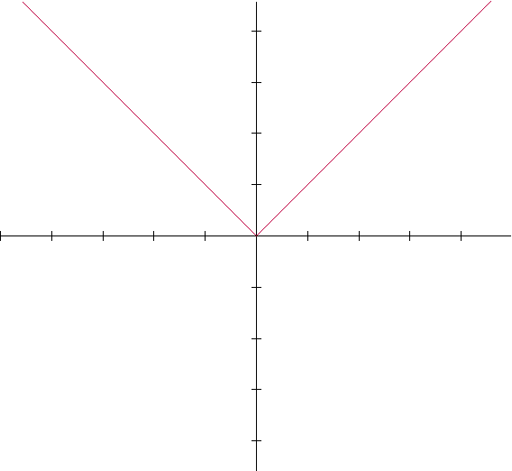
 | Axis of Symmetry
ABSOLUTE VALUE FUNCTIONS

