Chapter 36: Resource Acquisition and Transport in Vascular Plants
- How did mycorrhizae contribute to the successful colonization of land by vascular plants?

- Briefly explain the following types of transport across a cell membrane:
- Passive transport:
- Active transport:
- Proton pump:
- Cotransport:
- Osmosis:
- Discuss turgor pressure in plant cells. Describe plasmolysis.

- Compare a flaccid cell to a turgid cell.

- Contrast apoplastic vs. symplastic movement of materials in a plant.

- What is the function of the Casparian strip?

- Explain the contribution of each of the following phenomena to the long-distance transport of water.
- Transpiration:
- Cohesion:
- Adhesion:
- Root pressure
- Explain how guard cells open and close to control the loss of water from leaves.

- Describe the translocation of phloem sap from a sugar source to a sugar sink.

- What is meant by saying that plants face a photosynthesis-transpiration compromise? Explain how a hot sunny day with a dry wind can affect this compromise in a plant.

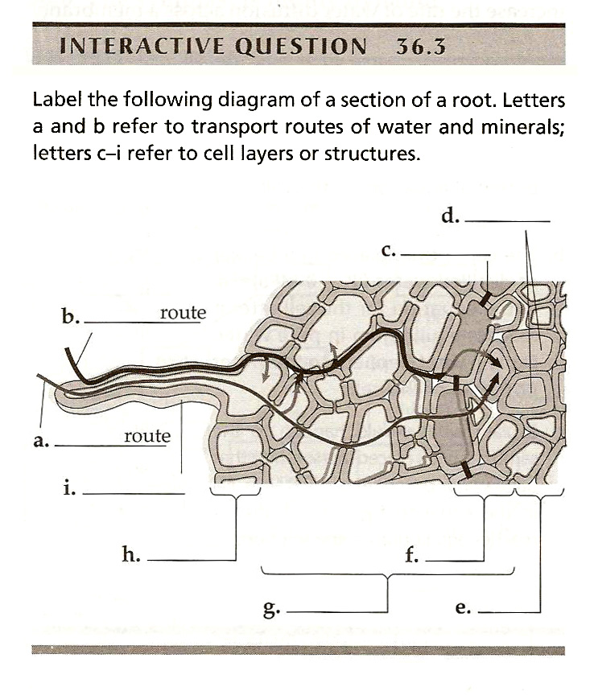

Chapter 37: Soil and Plant Nutrition
- Contrast macronutrients and micronutrients for plants.

- Describe these mutualistic relationships with plants:
- Rhizobium bacteria:
- Mycorrhizae:

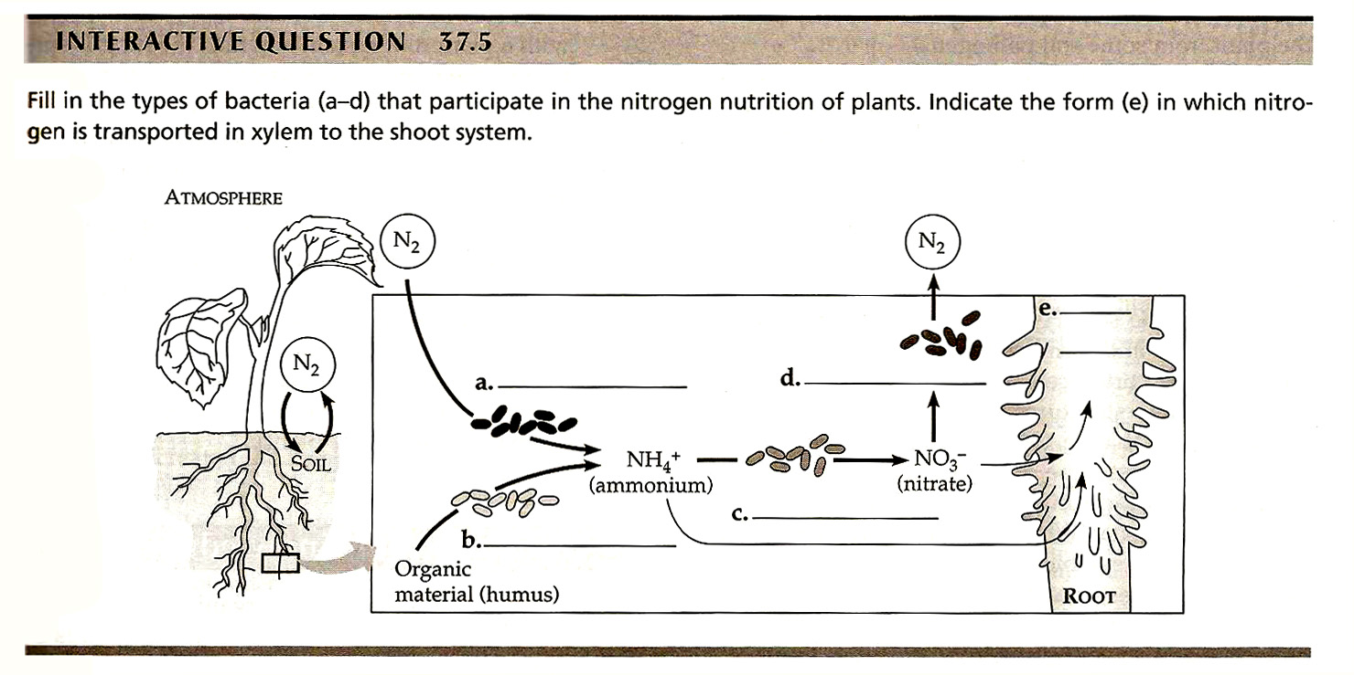
- List and describe 3 examples of non-mutualistic relationships with plants.

