Chapter 11
Cell Communication
Lecture Outline
Overview: The Cellular Internet
- Cell-to-cell communication is absolutely essential for multicellular organisms.
- Cells must communicate to coordinate their activities.
- Communication between cells is also important for many unicellular organisms.
- Biologists have discovered universal mechanisms of cellular regulation involving the same small set of cell-signaling mechanisms.
- The ubiquity of these mechanisms provides additional evidence for the evolutionary relatedness of all life.
- Cells most often communicate by chemical signals, although signals may also take other forms.

Concept 11.1 External signals are converted to responses within the cell.
- What messages are passed from cell to cell? How do cells respond to these messages?
Cell signaling evolved early in the history of life.
- One topic of cell “conversation” is sex.
- The cells of Saccharomyces cerevisiae, the yeast of bread, wine, and beer, identify potential mates by chemical signaling.
- There are two sexes, a and α, each of which secretes a specific signaling molecule, a factor and α factor, respectively.
- These factors each bind to receptor proteins on the other mating type.
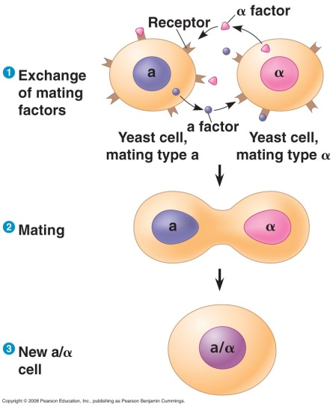
- After the mating factors have bound to the receptors, the two cells grow toward each other and undergo other cellular changes.
- The two cells fuse, or mate, to form an a/α cell containing the genes of both cells.
- The process by which a signal on a cell’s surface is changed or transduced into a specific cellular response is a series of steps called a signal transduction pathway.
- The molecular details of these pathways are strikingly similar in yeast and animal cells, even though their last common ancestor lived more than a billion years ago.
- Signaling systems of bacteria and plants also share similarities.
- The similarities in signal transduction pathways suggest that ancestral signaling molecules evolved long ago in ancient prokaryotes and single-celled eukaryotes and have since been adopted for new uses by their multicellular descendents.
- Cell signaling has remained important in the microbial world.
- Cells of many bacterial species secrete small molecules that can be detected by other bacterial cells.
- The concentration of signaling molecules enables bacteria to sense the local density of bacterial cells, a phenomenon called quorum sensing.
- Signaling among members of a bacterial population can lead to coordination of their activities.
- In response to a signal, bacterial cells come together to form biofilms, aggregations of bacteria containing regions of specialized function.
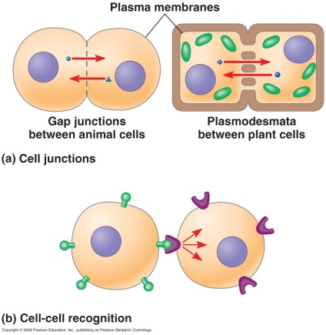
Communicating cells may be close together or far apart.
- Multicellular organisms release signaling molecules that target other cells.
- Cells may communicate by direct contact.
- Both animals and plants have cell junctions that connect to the cytoplasm of adjacent cells.
- Signaling substances dissolved in the cytosol can pass freely between adjacent cells.
- Animal cells can communicate by direct contact between membrane-bound cell-surface molecules.
- Such cell-cell recognition is important to processes like embryonic development and the immune response.
- In other cases, the signaling cell secretes messenger molecules.
- Some transmitting cells release local regulators that influence cells in the local vicinity.
- One class of local regulators in animals, growth factors, includes compounds that stimulate nearby target cells to grow and multiply.
- This is an example of paracrine signaling, which occurs when numerous cells simultaneously receive and respond to growth factors produced by a single cell in their vicinity.
- In synaptic signaling, a nerve cell secretes a neurotransmitter that diffuses across a synapse to a single cell that is almost touching the sender.
- The neurotransmitter stimulates the target cell.
- Local signaling in plants is not well understood. Because of their cell walls, plants use different mechanisms from animals.
- Plants and animals use hormones for long-distance signaling.
- In animals, specialized endocrine cells release hormones into the circulatory system, by which they travel to target cells in other parts of the body.
- Plant hormones, called growth regulators, may travel in vessels but more often travel from cell to cell or move through air by diffusion.
- Hormones and local regulators range widely in molecular size and type.
- The plant hormone ethylene (C₂H₄), a gas that promotes fruit ripening and regulates growth, is a hydrocarbon with only six atoms, capable of passing through cell walls.
- Insulin, which regulates blood sugar levels in mammals, is a protein with thousands of atoms.
- The transmission of a signal through the nervous system is also an example of long-distance signaling.
- An electrical signal travels the length of a nerve cell and is then converted back to a chemical signal when a signaling molecule is released and crosses the synapse to another nerve cell.
- It is then converted back to an electrical signal.
- In this way, a nerve signal can travel along a series of nerve cells, sometimes over great distances.
The three stages of cell signaling are reception, transduction, and response.
- What happens when a cell encounters a signal?
- The signal must be recognized by a specific receptor molecule, and the information it carries (the signal) must be changed into another form, or transduced, inside the cell, before the cell can respond.
- E. W. Sutherland and his colleagues pioneered our understanding of cell signaling by investigating how the animal hormone epinephrine stimulates the breakdown of the storage polysaccharide glycogen in liver and skeletal muscle cells.
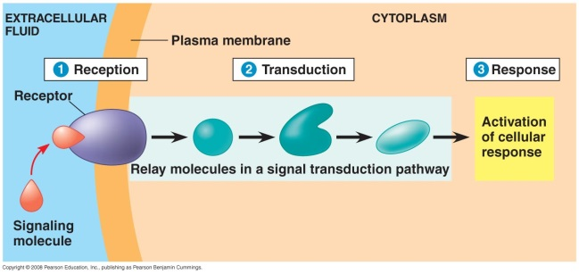
- The breakdown of glycogen releases glucose derivatives that can be used for fuel in glycolysis or released as glucose in the blood for fuel elsewhere.
- Thus, one effect of epinephrine, which is released from the adrenal gland during times of physical or mental stress, is mobilization of fuel reserves.
- Sutherland’s research team discovered that epinephrine stimulates glycogen breakdown by activating a cytosolic enzyme, glycogen phosphorylase.
- Epinephrine does not activate the phosphorylase directly in vitro, however, but acts only via intact cells.
- Therefore, there must be an intermediate step or steps occurring inside the cell.
- The plasma membrane must be involved in transmitting the epinephrine signal.
- Cell signaling involves three stages: reception, transduction, and response.
- In reception, a chemical signal binds to a cellular protein, typically at the target cell’s surface or inside the cell.
- In transduction, binding of the signaling molecule changes the receptor protein in some way, initiating the process of transduction.
- Transduction may occur in a single step but more often triggers a series of changes in a series of different molecules along a signal transduction pathway.
- The molecules in the pathway are called relay molecules.
3. In response, the transduced signal triggers a specific cellular activity.
- The cell-signaling process helps ensure that crucial activities occur in the right cells, at the right time, and in proper coordination with the other cells of the organism.

Concept 11.2 Reception: A signal molecule binds to a receptor protein, causing it to change shape.
- The cell targeted by a particular chemical signal has a receptor protein on or in the target cell that recognizes the signal molecule.
- Recognition occurs when the signal binds to a specific site on the receptor that is complementary in shape to the signal.
- The signal molecule behaves as a ligand, a small molecule that binds with specificity to a larger molecule.
- Ligand binding generally causes the receptor protein to undergo a change in shape.
- Ligand binding may activate the receptor so that it can interact with other molecules.
- For other receptors, ligand binding causes aggregation of receptor molecules, leading to further molecular events inside the cell.
- In a general sense, ligand binding is similar to the binding of an allosteric regulator to an enzyme, causing a shape change that either promotes or inhibits enzyme activity.
- In the case of signal transduction, binding of the ligand alters the ability of the receptor to transmit the signal.
- Most signal receptors are plasma membrane proteins, whose ligands are large, water-soluble molecules that are too large to cross the plasma membrane.
- Other signal receptors are located inside the cell.
Most signal receptors are plasma membrane proteins.
- Water-soluble signaling molecules bind to receptor proteins on the plasma membrane.
- The bound receptor transmits information from the extracellular environment to the inside of the cell by changing shape or aggregating with other receptors.
- There are three major types of membrane receptors: G-protein-linked receptors, receptor tyrosine kinases, and ion channel receptors.
- A G-protein-linked receptor consists of a receptor protein associated with a G protein on the cytoplasmic side.
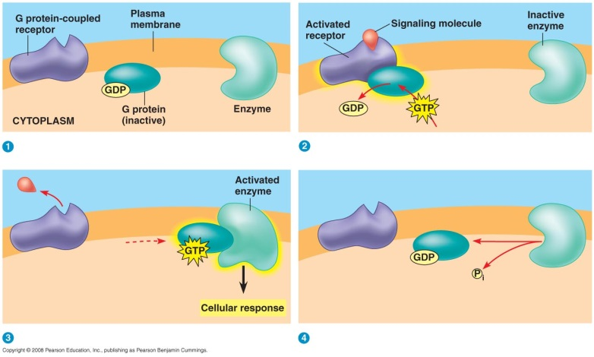
- Seven α helices span the membrane.
- G-protein-linked receptors bind many different signal molecules, including yeast mating factors, epinephrine and many other hormones, and neurotransmitters.
- The G protein acts as an on-off switch.
- If GDP is bound to the G protein, the G protein is inactive.
- When the appropriate signal molecule binds to the extracellular side of the receptor, the G protein binds GTP (instead of GDP) and becomes active.
- The activated G protein dissociates from the receptor and diffuses along the membrane, where it binds to an enzyme, altering its activity.
- The activated enzyme triggers the next step in a pathway leading to a cellular response.
- The G protein can also act as a GTPase enzyme to hydrolyze GTP to GDP.
- This change turns the G protein off.
- Now inactive, the G protein leaves the enzyme, which returns to its original state.
- The whole system can be shut down quickly when the extracellular signal molecule is no longer present.
- G-protein receptor systems are extremely widespread and diverse in their functions.
- They play important roles during embryonic development.
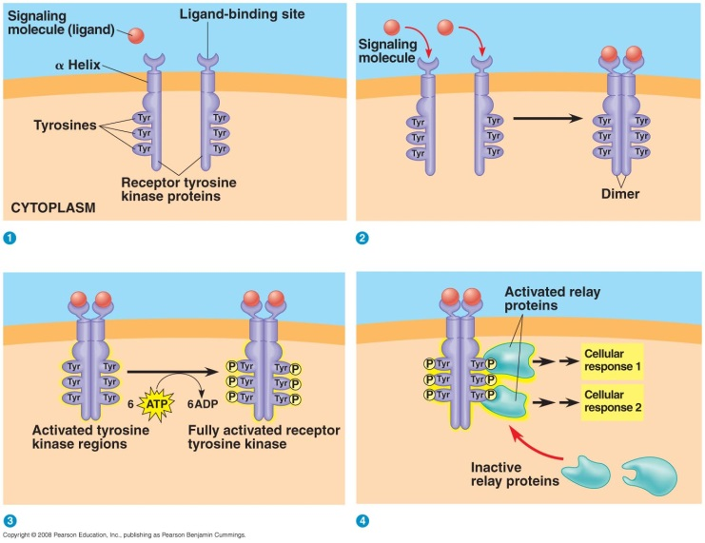
- Vision and smell in humans depend on these proteins.
- Similarities among G proteins and G-protein-linked receptors of modern organisms suggest that this signaling system evolved very early.
- Several human diseases involve G-protein systems.
- For example, bacterial infections that cause cholera and botulism interfere with G-protein function.
- The tyrosine-kinase receptor system is especially effective when the cell needs to trigger several signal transduction pathways and cellular responses at once.
- This system helps the cell regulate and coordinate many aspects of cell growth and reproduction.
- The tyrosine-kinase receptor belongs to a major class of plasma membrane receptors that have enzymatic activity.
- A kinase is an enzyme that catalyzes the transfer of phosphate groups.
- The cytoplasmic side of these receptors functions as a tyrosine kinase, transferring a phosphate group from ATP to tyrosine on a substrate protein.
- An individual tyrosine-kinase receptor consists of three parts: an extracellular signal-molecule-binding site, a single α helix spanning the membrane, and an intracellular tail with several tyrosines.
- The signal molecule binds to an individual receptor.
- Ligands bind to two receptors, causing the two receptors to aggregate and form a dimer.
- This dimerization activates the tyrosine-kinase section of the receptors, each of which then adds phosphate from ATP to the tyrosine tail of the other polypeptide.
- The fully activated receptor proteins activate a variety of specific relay proteins that bind to specific phosphorylated tyrosine molecules.
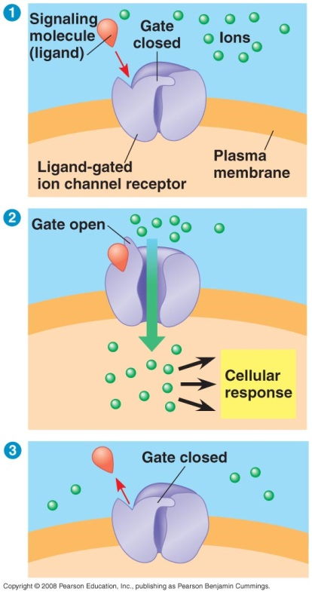
- One tyrosine-kinase receptor dimer may activate ten or more different intracellular proteins simultaneously.
- These activated relay proteins trigger many different transduction pathways and responses.
- A ligand-gated ion channel is a type of membrane receptor that can act as a gate when the receptor changes shape.
- When a signal molecule binds as a ligand to the receptor protein, the gate opens to allow the flow of specific ions, such as Na⁺ or Ca²⁺, through a channel in the receptor.
- Binding by a ligand to the extracellular side changes the protein’s shape and opens the channel.
- When the ligand dissociates from the receptor protein, the channel closes.
- The change in ion concentration within the cell may directly affect the activity of the cell.
- Ligand-gated ion channels are very important in the nervous system.
- For example, neurotransmitter molecules released at a synapse between two neurons bind as ligands to ion channels on the receiving cell, causing the channels to open.
- Ions flow in and trigger an electrical signal that propagates down the length of the receiving cell.
- Some gated ion channels respond to electrical signals instead of ligands.
Some receptor proteins are intracellular.
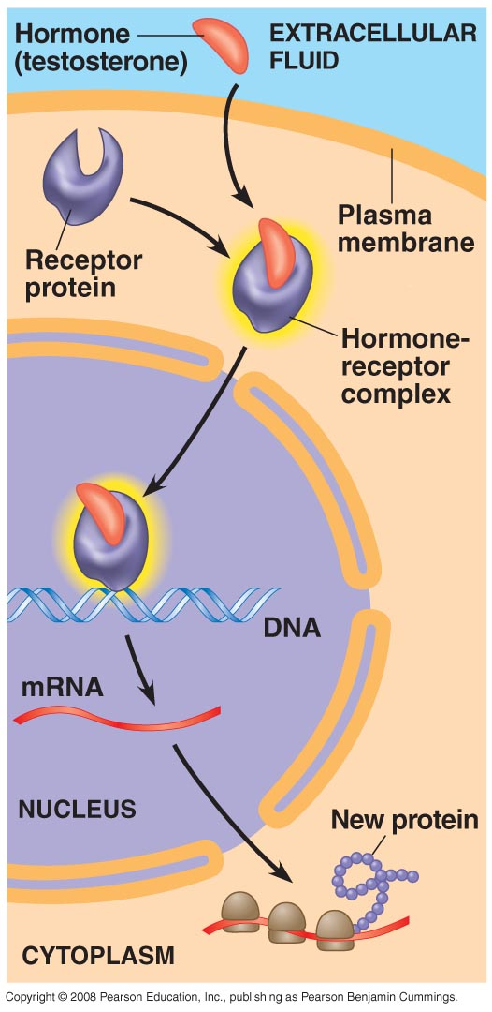
- Intracellular signal receptors are found in the cytosol or nucleus of target cells.
- To reach these receptors, a chemical messenger passes through the target cell’s plasma membrane.
- Such chemical messengers are either hydrophobic enough or small enough to cross the phospholipid interior of the plasma membrane.
- Hydrophobic messengers include the steroid and thyroid hormones of animals.
- Another chemical signaling molecule with an intracellular receptor is nitric oxide (NO), a gas whose small size allows it to pass between membrane phospholipids.
- Testosterone is secreted by the testis and travels through the blood to enter cells throughout the body.
- The cytosol of target cells contains receptor molecules that bind testosterone, activating the receptor.
- These activated proteins enter the nucleus and turn on specific genes that control male sex characteristics.
- How does the activated hormone-receptor complex turn on genes? These activated proteins act as transcription factors.
- Transcription factors control which genes are turned on—that is, which genes are transcribed into messenger RNA.
- mRNA molecules leave the nucleus and carry information that directs the synthesis (translation) of specific proteins at the ribosome.
- Some intracellular receptors (such as thyroid hormone receptors) are found in the nucleus and bind to the signal molecules there.
- Many intracellular receptor proteins are structurally similar, suggesting an evolutionary kinship.

Concept 11.3 Transduction: Cascades of molecular interactions relay signals from receptors to target molecules in the cell.
- The transduction stage of signaling is usually a multistep pathway that often greatly amplifies the signal.
- If some molecules in a pathway transmit a signal to multiple molecules of the next component in the series, the result can be large numbers of activated molecules at the end of the pathway.
- A small number of signal molecules can produce a large cellular response.
- Multistep pathways also provide more opportunities for coordination and regulation than do simpler systems.
Pathways relay signals from receptors to cellular responses.
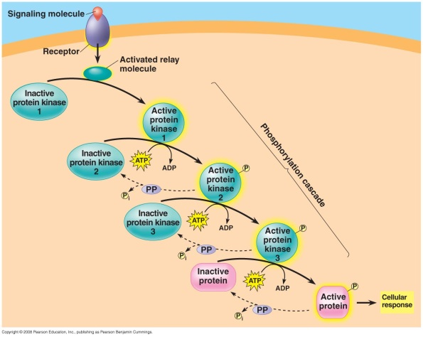
- The binding of a specific signaling molecule to a receptor in the plasma membrane triggers the first step in the chain of molecular interactions—the signal transduction pathway—that leads to a particular response within the cell.
- Signal transduction pathways act like falling dominoes. The signal-activated receptor activates another protein, which activates another, and so on, until the protein that produces the final cellular response is activated.
- The relay molecules that relay a signal from receptor to response are mostly proteins.
- The interaction of proteins is a major theme of cell signaling.
- In fact, protein interaction is a unifying theme of all cellular regulation.
- The original signal molecule is not passed along the pathway and may not even enter the cell.
- When the signal is relayed along a pathway, information is passed on.
- At each step, the signal is transduced into a different form, often by a conformational change in a protein.
- The conformational change is often brought about by phosphorylation.
Protein phosphorylation, a common mode of regulation in cells, is a major mechanism of signal transduction.
- The phosphorylation of proteins by a specific enzyme (a protein kinase) is a widespread cellular mechanism for regulating protein activity.
- Most protein kinases act on other substrate proteins, unlike tyrosine kinases, which act on themselves.
- Most phosphorylation occurs at either serine or threonine amino acids of the substrate protein (unlike tyrosine phosphorylation in tyrosine kinases).
- Many of the relay molecules in a signal transduction pathway are protein kinases that act on other protein kinases to create a “phosphorylation cascade.”
- Each protein phosphorylation leads to a conformational change because of the interaction between the newly added phosphate group and charged or polar amino acids on the protein.
- Phosphorylation of a protein typically converts it from an inactive form to an active form.
- Only rarely does phosphorylation decreases the activity of the protein.
- A single cell may have hundreds of different protein kinases, each specific for a different substrate protein.
- Fully 2% of our genes are thought to code for protein kinases.
- Together, they regulate a large proportion of the thousands of the proteins in a cell.
- Abnormal activity of protein kinases can cause abnormal cell growth and may contribute to the development of cancer.
- The responsibility for turning off a signal transduction pathway belongs to protein phosphatases.
- These enzymes rapidly remove phosphate groups from proteins, a process called dephosphorylation.
- By dephosphorylating and thus inactivating protein kinases, phosphatases provide the mechanism for turning off the signal transduction pathway when the initial signal is no longer present.
- Phosphatases also make the protein kinases available for reuse, enabling the cell to respond again to a signal.
- At any given moment, the activity of a protein regulated by phosphorylation depends on the balance between active kinase molecules and active phosphatase molecules.
- When the extracellular signal molecule is absent, active phosphatase molecules predominate, and the signaling pathway and cellular response are shut down.
- The phosphorylation/dephosphorylation system acts as a molecular switch in the cell, turning activities on and off as required.
Certain signal molecules and ions are key components of signaling pathways (second messengers).
- Many signaling pathways involve small, water-soluble, nonprotein molecules or ions called second messengers.
- The extracellular signaling molecule that binds to the membrane receptor is a pathway’s “first messenger.”
- Second messengers diffuse rapidly throughout the cell.
- Second messengers participate in pathways initiated by both G-protein-linked receptors and tyrosine-kinase receptors.
- Two of the most widely used second messengers are cyclic AMP and Ca²⁺.
- A large variety of relay proteins are sensitive to the cytosolic concentration of one or the other of these second messengers.
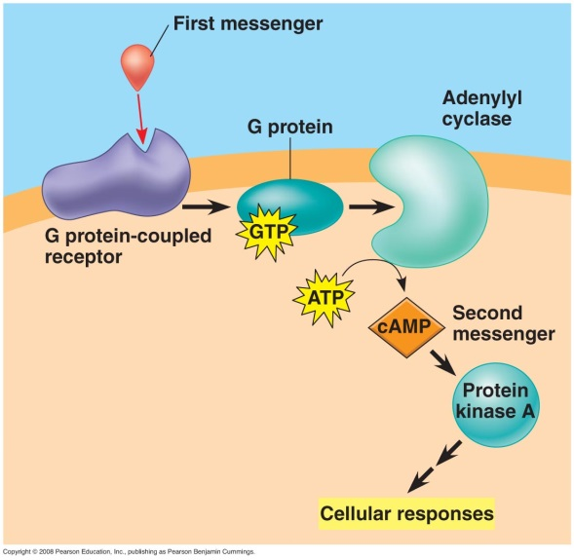
- Once Sutherland knew that epinephrine causes glycogen breakdown without entering the cell, he looked for a second messenger that transmits the signal from the plasma membrane to the metabolic machinery in the cytoplasm.
- Binding by epinephrine leads to increases in the cytosolic concentration of cyclic AMP, or cAMP.
- This increase occurs because the activated receptor activates adenylyl cyclase, which converts ATP to cAMP in response to epinephrine.
- When epinephrine outside the cell binds to a specific receptor protein, the normal cellular concentration of cAMP can be boosted 20-fold within seconds.
- cAMP is short-lived because phosphodiesterase converts it to AMP.
- Another surge of epinephrine is needed to reboost the cytosolic concentration of cAMP.
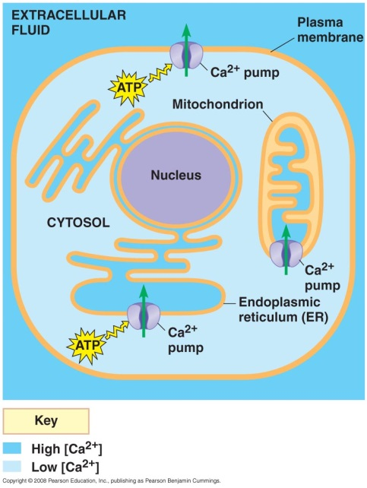
- Many hormones and other signal molecules trigger the formation of cAMP.
- G-protein-linked receptors, G proteins, and protein kinases are other components of cAMP pathways.
- cAMP diffuses through the cell and activates a serine/threonine kinase called protein kinase A.
- The activated kinase phosphorylates various other proteins, depending on cell type.
- Cell metabolism is also regulated by G-protein systems that inhibit adenylyl cyclase.
- These systems use a different signal molecule to activate a different receptor that activates an inhibitory G protein.
- Certain microbes cause disease by disrupting G-protein signaling pathways.
- For example, the cholera bacterium, Vibrio cholerae, may be present in water contaminated with human feces.
- This bacterium colonizes the small intestine and produces a toxin that modifies a G protein that regulates salt and water secretion.
- The modified G protein is unable to hydrolyze GTP to GDP and remains stuck in its active form, continuously stimulating adenylyl cyclase to make cAMP.
- The resulting high concentration of cAMP causes the intestinal cells to secrete large amounts of water and salts into the intestines, leading to profuse diarrhea and possible death from loss of water and salts.
- Treatments for certain human conditions involve signaling pathways.
- One pathway uses cyclic GMP, or cGMP, as a signaling molecule. Its effects include the relaxation of smooth muscle cells in artery walls.
- A compound was developed to treat chest pains. This compound inhibits the hydrolysis of cGMP to GMP, prolonging the signal and increasing blood flow to the heart muscle.
- Under the trade name Viagra, this compound is now widely used as a treatment for erectile dysfunction. Viagra causes dilation of blood vessels, allowing increased blood flow to the penis.
- Many signaling molecules in animals, including neurotransmitters, growth factors, and some hormones, induce responses in their target cells via signal transduction pathways that increase the cytosolic concentration of Ca²⁺.
- Calcium is even more widely used than cAMP as a second messenger.
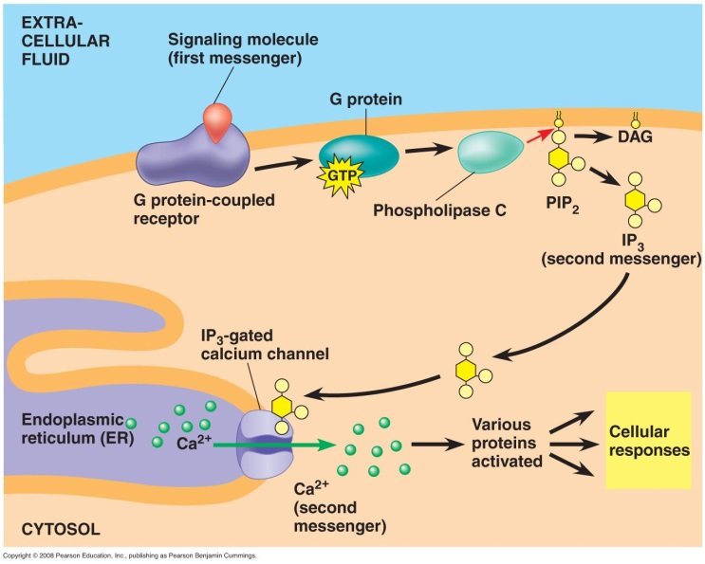
- In animal cells, increases in Ca²⁺ concentrations may cause contraction of muscle cells, secretion of certain substances, and cell division.
- In plant cells, increases in Ca²⁺ trigger responses such as the pathway for greening in response to light.
- Cells use Ca²⁺ as a second messenger in both G-protein pathways and tyrosine-kinase pathways.
- The Ca²⁺ concentration in the cytosol is typically much lower than the concentration outside the cell, often by a factor of 10,000 or more.
- Various proteins actively transport Ca²⁺ outside the cell or into the endoplasmic reticulum (ER) or other organelles.
- As a result, the concentration of Ca²⁺ in the ER is usually much higher than the concentration in the cytosol.
- Because the concentration of cytosolic Ca²⁺ is so low, small changes in the absolute numbers of ions cause a relatively large percentage change in the Ca²⁺ concentration.
- Signal transduction pathways trigger the release of Ca²⁺ from the cell’s ER.
- The pathways leading to calcium release involve still other second messengers, diacylglycerol (DAG) and inositol trisphosphate (IP₃).
- DAG and IP₃ are created when a phospholipase cleaves a specific membrane phospholipid.
- The phospholipase may be activated by a G protein or by a tyrosine-kinase receptor.
- IP₃ activates a gated calcium channel, releasing Ca²⁺ from the ER.
- Calcium ions activate the next protein in a signal transduction pathway.

Concept 11.4 Response: Cell signaling leads to regulation of cytoplasmic activities or transcription.
- Ultimately, a signal transduction pathway leads to the regulation of one or more cellular activities.
- The response may involve action in the nucleus or may occur in the cytoplasm.
- Many signaling pathways ultimately regulate protein synthesis, usually by turning specific genes on or off in the nucleus.
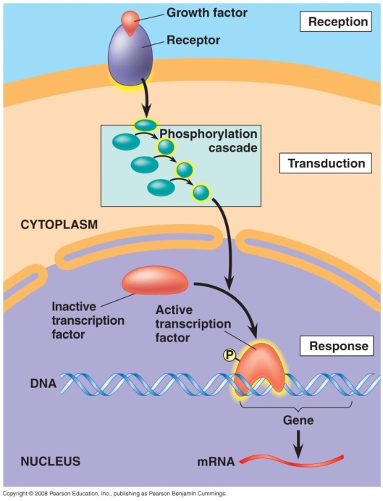
- Like an activated steroid receptor, the final activated molecule in a signaling pathway may function as a transcription factor.
- Often a transcription factor regulates several different genes.
- Signaling pathways may regulate the activity of proteins rather than their synthesis, directly affecting proteins that function outside of the nucleus.
- A signal may cause the opening or closing of an ion channel or a change in cell metabolism.
- For example, epinephrine helps regulate cellular energy metabolism by activating enzymes that catalyze the breakdown of glycogen.
- Signaling events may also affect cellular attributes such as overall cell shape.
- One example of this regulation can be found in the activities leading to the mating of yeast cells.
- In yeast, the mating process depends on the growth of localized projections in one cell toward a cell of the opposite mating type.
- Binding of the mating factor causes directional growth via activation of signaling-pathway kinases.
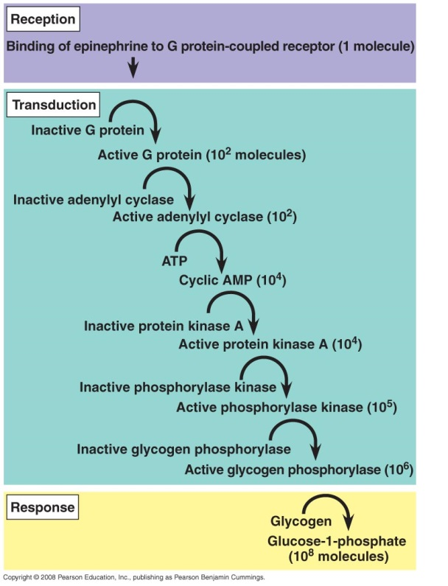
- These kinases affect the orientation of the growth of cytoskeletal microfilaments.
- Cell projections emerge from areas that receive the highest concentration of the mating factor and thus have the highest likelihood of reaching the cell of the opposite mating type, the source of the signaling molecule.
- Signal receptors and relay molecules participate in a variety of nuclear and cytoplasmic response pathways, some leading to cell division.
- The molecular messengers that produce these responses include growth factors and certain plant and animal hormones.
- Malfunctioning of growth factor pathways can contribute to the development of cancer.
Signaling pathways with multiple steps provide signal amplification, allow fine-tuning of the cell’s response, and contribute to the specificity of the response.
- Signaling pathways with multiple steps have two benefits.
- They amplify the signal and thus the response.
- They provide different points at which a cell’s response can be regulated.
- They allow cells to respond to signaling pathways in specific ways based on the
specific proteins present in the cell.
- Regulation allows coordination of signaling pathways as well as contributes to the specificity of the response.
- Finally, a crucial point in fine-tuning the response is the termination of the signal.
- Elaborate enzyme cascades amplify the cell’s response to a signal.
- At each catalytic step in a cascade, the number of activated products is much greater than in the preceding step.
- In the epinephrine-triggered pathway, binding by a small number of epinephrine molecules can lead to the release of hundreds of millions of glucose molecules.
- Various types of cells may receive the same signal but produce very different responses.
- For example, epinephrine triggers liver or striated muscle cells to break down glycogen, but it stimulates cardiac muscle cells to contract, leading to a rapid heartbeat.
- The explanation for this specificity is that different kinds of cells have different collections of proteins.
- This is because different kinds of cells turn on different sets of genes.
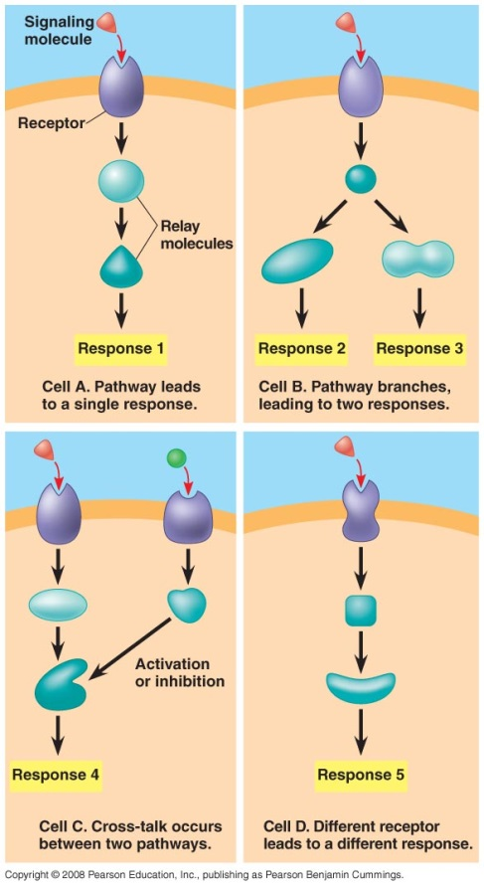
- The response of a particular cell to a signal depends on its particular collection of receptor proteins, relay proteins, and proteins needed to carry out the response.
- Two cells that respond differently to the same signal differ in one or more of the proteins that handle and respond to the signal.
- Different pathways may have some molecules in common.
- Cells may use the receptor protein, but differences in other proteins may lead to different responses.
- Cells may use differing receptor proteins for the same signaling molecule, leading to different responses.
- A signal may trigger a single pathway in one cell but trigger a branched pathway in another.
- Such branched pathways often involve receptor tyrosine kinases (which can activate multiple relay proteins) or second messengers (which can regulate numerous proteins).
- Two pathways triggered by separate signals may converge to modulate a single response.
- Branching of pathways and interactions between pathways are important for regulating and coordinating a cell’s response to incoming information.
- Using the same proteins in more than one pathway allows the cell to economize on the number of different proteins it must make.
Scaffolding proteins and signaling complexes contribute to signaling efficiency.
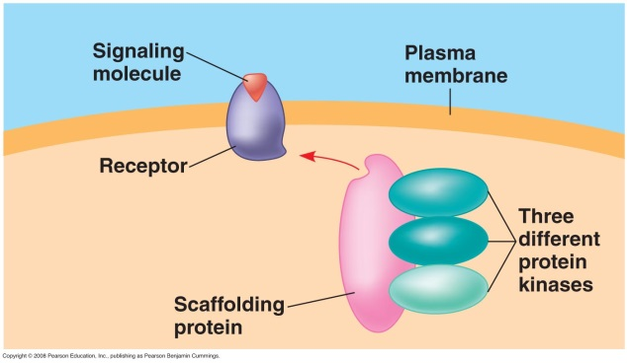
- Rather than relying on the diffusion of large relay molecules such as proteins, many signal pathways are linked together physically by scaffolding proteins.
- Scaffolding proteins may themselves be large relay proteins to which several other relay proteins attach.
- For example, one scaffolding protein isolated from mouse brain cells holds three protein kinases and carries these kinases with it when it binds to an appropriately activated membrane receptor, facilitating a specific phosphorylation cascade.
- Some scaffolding proteins in brain cells permanently hold together networks of signaling-pathway proteins at synapses.
- This hardwiring enhances the speed, accuracy, and efficiency of signal transfer between cells.
- When signaling pathways were first discovered, they were thought to be linear, independent pathways.
- In fact, some proteins participate in more than one pathway, either in different cell types or in the same cell at different times or under different conditions.
- Permanent or transient protein complexes are very important in the functioning of a cell.
- The importance of relay proteins that serve as branch or intersection points in signaling pathways is underscored when these proteins are defective or missing.
- For example, the inherited disorder Wiskott-Aldrich syndrome (WAS) is caused by the absence of a single relay protein.
- Symptoms of WAS include abnormal bleeding, eczema, and a predisposition to infections and leukemia, due largely to the absence of the protein in the cells of the immune system.
- The WAS protein is located just beneath the cell surface, where it interacts with the microfilaments of the cytoskeleton and with several signaling pathways, including those that regulate immune cell proliferation.
- When the WAS protein is absent, the cytoskeleton is not properly organized and signaling pathways are disrupted.
- As important as activating mechanisms are inactivation mechanisms.
- For a cell to remain alert and capable of responding to incoming signals, each molecular change in its signaling pathways must last only a short time.
- If signaling pathway components become locked into one state, whether active or inactive, the proper function of the cell can be disrupted.
- Binding of signal molecules to receptors must be reversible, allowing the receptors to return to their inactive state when the signal is released.
- By a variety of means, the relay molecules return to their inactive forms: The GTPase activity intrinsic to a G protein hydrolyzes its bound GTP; the enzyme phosphodiesterase converts cAMP to AMP; protein phosphatases inactivate phosphorylated kinases and other proteins; and so forth.
- As a result, the cell is soon ready to respond to a fresh signal.

Concept 11.5 Apoptosis (programmed cell death) integrates multiple cell-signaling pathways.
- Cells that are infected or damaged, or have reached the end of their functional lifespan, often enter a program of controlled cell suicide called apoptosis.
- During this process, cellular agents chop up the DNA and fragment the organelles and other cytoplasmic components.
- The cell shrinks and becomes lobed (called “blebbing”), and the cell’s parts are packaged up in vesicles that are engulfed and digested by specialized scavenger cells.
- Apoptosis protects neighboring cells from the damage that would result if a dying cell leaked out all its contents, including its many digestive and other enzymes.
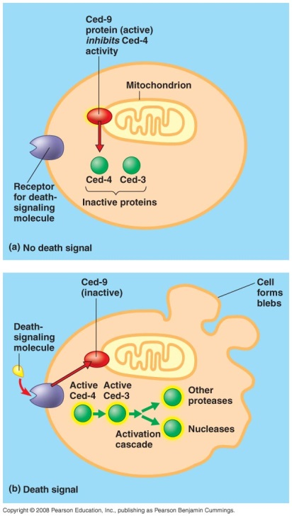
Apoptosis plays an important role in embryonic development.
- The molecular mechanisms underlying apoptosis were worked out in detail by researchers studying the embryonic development of a small soil worm, a nematode called Caenorhabditis elegans.
- Because the adult worm has only about a thousand cells, the entire ancestry of each cell is known.
- Cell suicide occurs exactly 131 times during the normal development of C. elegans, at precisely the same points in the cell lineage of each worm.
- In worms and other species, apoptosis is triggered by signals that activate a cascade of “suicide” proteins in the cells destined to die.
- Two key apoptosis genes, called ced-3 and ced-4, encode proteins essential for apoptosis.
- Proteins involved in apoptosis are continually present in cells but in inactive form; protein activity is regulated by gene activity.
- In C. elegans, a protein in the outer mitochondrial membrane, called Ced-9 (the product of the ced-9 gene), serves as a master regulator of apoptosis, acting as a brake in the absence of a signal promoting apoptosis.
- When the cell receives a death signal, the apoptotic pathway activates proteases and nucleases, enzymes that cut up the proteins and DNA of the cell.
- The main proteases of apoptosis are called caspases; in the nematode, the chief caspase is Ced-3.
Apoptosis is important in vertebrate development and maintenance.
- In humans and other mammals, several different pathways, involving about 15 different caspases, can carry out apoptosis.
- The pathway that is used depends on the type of cell and on the particular signal that triggers apoptosis.
- One major pathway involves mitochondrial proteins.
- Apoptotic proteins form molecular pores in the mitochondrial outer membrane, causing it to leak and release proteins that promote apoptosis.
- Cytochrome c, which functions in mitochondrial electron transport in healthy cells, acts as a cell death factor when released from mitochondria.
- The process of mitochondrial apoptosis in mammals uses proteins homologous to the nematode proteins Ced-3, Ced-4, and Ced-9.
- At key points in the apoptotic program, proteins act to integrate signals from several different sources and can send a cell down an apoptotic pathway.
- The signal may originate outside the cell, perhaps released by a neighboring cell.
- Two other types of signals originate from inside the cell.
- One alarm signal comes from the nucleus, generated when the DNA has suffered irreparable damage, and a second comes from the endoplasmic reticulum when excessive protein misfolding occurs.
- Mammalian cells make life-or-death “decisions” by somehow integrating the death signals and life signals they receive from these external and internal sources.
- A built-in cell suicide mechanism is essential to development and maintenance in all animals.
- The similarities between apoptosis genes in nematodes and mammals, as well as the observation that apoptosis occurs in multicellular fungi and even in single-celled yeasts, indicate that the basic mechanism evolved early in animal evolution.
- In vertebrates, apoptosis is essential for normal development of the nervous system, for normal operation of the immune system, and for normal morphogenesis of hands and feet in humans and paws in other mammals.
- A lower level of apoptosis in developing limbs accounts for the webbed feet of ducks and other water birds, in contrast to chickens and other land birds that have nonwebbed feet.
- In humans, the failure of appropriate apoptosis can result in webbed fingers and toes.
- Apoptosis is involved in certain degenerative diseases of the nervous system such as Parkinson’s disease and even Alzheimer’s disease.
- Cancer can also result from a failure of cell suicide.
- Some cases of human melanoma, for example, have been linked to faulty forms of the human version of the C. elegans Ced-4 protein.
- The signaling pathways that feed into apoptosis are quite elaborate; after all, the life-or-death question is the most fundamental one imaginable for a cell.

