Chapter 13
Meiosis and Sexual Life Cycles
Lecture Outline
Overview: Variations on a Theme
- Living organisms are distinguished by their ability to reproduce their own kind.
- Offspring resemble their parents more than they resemble less closely related individuals of the same species.
- The transmission of traits from one generation to the next is called heredity or inheritance.
- Offspring differ somewhat from their parents and siblings, which demonstrates variation.
- Farmers have bred plants and animals for desired traits for thousands of years, but the mechanisms of heredity and variation eluded biologists until the development of genetics in the 20th century.
- Genetics is the scientific study of heredity and hereditary variation.
- Genetics has revolutionized medicine and agriculture.
- Our ability to manipulate the genetic material, DNA, has raised some thorny social and ethical questions.

Concept 13.1 Offspring acquire genes from their parents by inheriting chromosomes.
- Parents endow their offspring with coded information in the form of genes.
- Your genome is made up of the genes that you inherited from your mother and your father.
- Genes program specific traits that emerge as we develop from fertilized eggs into adults.
- Genes are segments of DNA. Genetic information is transmitted as specific sequences of the four deoxyribonucleotides in DNA.
- This process is analogous to the symbolic information of language, in which words and sentences are translated into mental images.
- Cells translate genetic “sentences” into freckles and other features that have no resemblance to genes.
- Most genes program cells to synthesize specific enzymes and other proteins whose cumulative action produces an organism’s inherited traits.
- The transmission of hereditary traits has its molecular basis in the precise replication of DNA.
- The replication of DNA produces copies of genes that can be passed from parents to offspring.
- In plants and animals, reproductive cells called gametes transmit genes from one generation to the next.
- After fertilization (fusion of a sperm cell and an ovum), genes from both parents are present in the nucleus of the fertilized egg, or zygote.
- Almost all the DNA in a eukaryotic cell is subdivided into chromosomes in the nucleus.
- Tiny amounts of DNA are also found in the mitochondria and chloroplasts.
- Every living species has a characteristic number of chromosomes.
- Humans have 46 chromosomes in almost all of their cells.
- Each chromosome consists of a single DNA molecule associated with various proteins.
- Each chromosome has hundreds or thousands of genes, each at a specific location, or locus, along the length of the chromosome.
Like begets like, more or less: a comparison of asexual and sexual reproduction.
- Only organisms that reproduce asexually can produce offspring that are exact copies of themselves.
- In asexual reproduction, a single individual is the sole parent to donate genes to its offspring.
- Single-celled eukaryotes can reproduce asexually by mitotic cell division to produce two genetically identical daughter cells.
- An individual that reproduces asexually gives rise to a clone, a group of genetically identical individuals.
- Members of a clone may be genetically different as a result of mutation.
- In sexual reproduction, two parents produce offspring that have unique combinations of genes inherited from the two parents.
- Unlike a clone, offspring produced by sexual reproduction vary genetically from their siblings and their parents.

Concept 13.2 Fertilization and meiosis alternate in sexual life cycles.
- A life cycle is the generation-to-generation sequence of stages in the reproductive history of an organism.
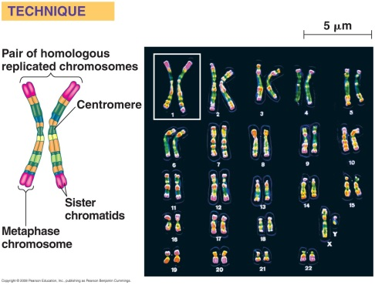
- A life cycle starts at the conception of an organism and continues until the organism produces its own offspring.
Human cells contain sets of chromosomes.
- In humans, each somatic cell (all cells other than the sperm or ovum) has 46 chromosomes.
- Each chromosome can be distinguished by its size, position of the centromere, and pattern of staining with certain dyes.
- Images of the 46 human chromosomes can be arranged in pairs in order of size to produce a karyotype display.
- The two chromosomes in a pair have the same length, centromere position, and staining pattern.
- These homologous chromosome pairs carry genes that control the same inherited characters.
- Two distinct sex chromosomes, the X and the Y, are an exception to the general pattern of homologous chromosomes in human somatic cells.
- The pattern of inheritance of the sex chromosomes determines an individual’s sex.
- Human females have a homologous pair of X chromosomes (XX); males have one X and one Y chromosome (XY).
- Most of the genes carried on the X chromosome are not found on the tiny Y chromosome, which has genes that are not found on the X chromosome.
- Only small parts of the X and Y chromosomes are homologous.
- The other 22 pairs of chromosomes are called autosomes.
- The occurrence of homologous pairs of chromosomes is a consequence of sexual reproduction.
- We inherit one chromosome of each homologous pair from each parent.
- The 46 chromosomes in each somatic cell are two sets of 23, a maternal set (from your mother) and a paternal set (from your father).
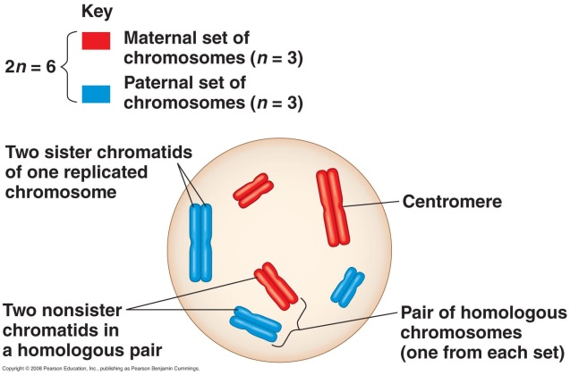
- The number of chromosomes in a single set is represented by n.
- Any cell with two sets of chromosomes is called a diploid cell and has a diploid number of chromosomes, abbreviated as 2n.
- Sperm cells or ova (gametes) have only one set of chromosomes—22 autosomes and an X (in an ovum) or 22 autosomes and an X or a Y (in a sperm cell).
- A gamete with a single chromosome set is a haploid cell, abbreviated as n.
- Any sexually reproducing species has characteristic haploid and diploid numbers of chromosomes.
- For humans, the haploid number of chromosomes is 23 (n = 23), and the diploid number is 46 (2n = 46).
- In the fruit fly, Drosophila, 2n = 8 and n = 4.
- In the domestic dog, 2n = 78 and n = 39.
- In a cell in which DNA synthesis has occurred, all the chromosomes are duplicated. Each duplicated chromosome consists of two identical sister chromatids.
- It is crucial to understand the differences among homologous chromosomes, sister chromatids, nonsister chromatids, and chromosome sets, as shown in Figure 13.4.
Let’s discuss the behavior of chromosome sets in the human life cycle.
- The human life cycle begins when a haploid sperm cell fuses with a haploid ovum.
- The union of these gametes, culminating in the fusion of their nuclei, is fertilization.
- The fertilized egg (zygote) is diploid because it contains two haploid sets of chromosomes bearing genes from the maternal and paternal family lines.
- As a person develops from a zygote to a sexually mature adult, mitosis generates all the somatic cells of the body.
- Each somatic cell contains a full diploid set of chromosomes.
- Gametes, which develop in the gonads (testes or ovaries), are not produced by mitosis.
- If gametes were produced by mitosis, the fusion of gametes would produce offspring with four sets of chromosomes after one generation, eight after a second, and so on.
- Instead, gametes undergo the process of meiosis, in which the chromosome number is halved.
- Human sperm or ova have a haploid set of 23 different chromosomes, one from each homologous pair.
- Fertilization restores the diploid condition by combining two haploid sets of chromosomes.
Organisms display a variety of sexual life cycles.
- Fertilization and meiosis alternate in all sexual life cycles.
- The timing of meiosis and fertilization varies among species.
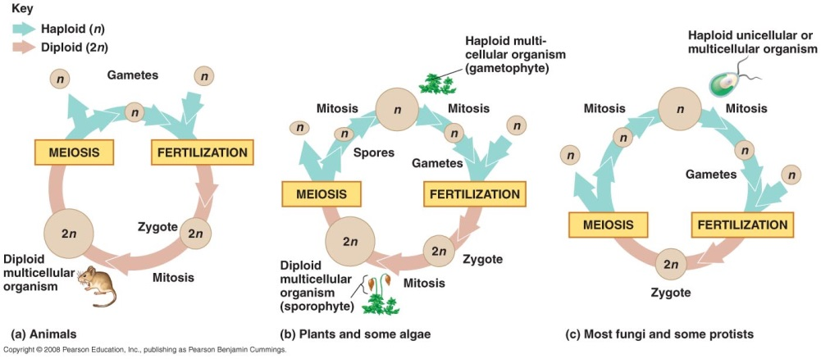
- These variations can be grouped into three main types of life cycles.
- Most animals, including humans, have the first type of life cycle, in which gametes are the only haploid cells.
- Gametes do not divide but fuse to form a diploid zygote that divides by mitosis to produce a multicellular diploid organism.
- Plants and some algae have a second type of life cycle called alternation of generations.
- This life cycle includes two multicellular stages, one haploid and one diploid.
- The multicellular diploid stage is called the sporophyte.
- Meiosis in the sporophyte produces haploid spores.
- Unlike a gamete, a haploid spore doesn’t fuse with another cell but rather divides by mitosis to form a multicellular haploid gametophyte stage.
- Gametes produced via mitosis by the gametophyte fuse to form the zygote, which grows into the sporophyte by mitosis.
- In this type of life cycle, the sporophyte generation produces a gametophyte as its offspring, and the gametophyte generation produces the next sporophyte generation.
- Most fungi and some protists have a third type of life cycle.
- Gametes fuse to form a zygote, which is the only diploid phase.
- The zygote undergoes meiosis to produce haploid cells.
- These haploid cells divide by mitosis to form either unicellular daughter cells or a haploid multicellular adult organism.
- The haploid adult produces gametes by mitosis.
- The only diploid stage in these species is a single-celled zygote.
- Either haploid or diploid cells can divide by mitosis, depending on the type of life cycle.
- Only diploid cells can undergo meiosis because haploid cells have a single set of chromosomes that cannot be further reduced.
- Although the three types of sexual life cycles differ in the timing of meiosis and fertilization, they share a fundamental feature: Each cycle of chromosome halving and doubling contributes to genetic variation among offspring.

Concept 13.3 Meiosis reduces the number of chromosome sets from diploid to haploid.
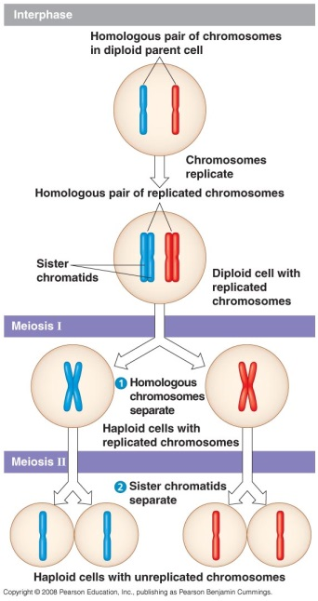
- Many steps of meiosis resemble steps in mitosis.
- Both meiosis and mitosis are preceded by the replication of chromosomes.
- In meiosis, there are two consecutive cell divisions, meiosis I and meiosis II, resulting in four daughter cells.
- The first division, meiosis I, separates homologous chromosomes.
- The second division, meiosis II, separates sister chromatids.
- The four daughter cells at the end of meiosis have only half as many chromosomes as the original parent cell.
- Meiosis I is preceded by interphase, in which the chromosomes are replicated to form sister chromatids.
- The two genetically identical sister chromatids make up one replicated chromosome.
- The sister chromatids are closely associated all along their length. This association is called sister chromatid cohesion.
- In contrast, the two chromosomes of a homologous pair are individual chromosomes that were inherited from different parents.
- Homologous chromosomes appear to be alike, but they may have different versions of genes, called alleles, at corresponding loci.
We can compare mitosis and meiosis.
- Meiosis halves the total number of chromosomes, reducing the number of sets of chromosomes from two (diploid) to one (haploid), with each daughter cell receiving one set. Mitosis conserves the number of chromosome sets.
- Meiosis produces cells that differ genetically from the parent cell and from each other. Mitosis produces daughter cells that are genetically identical to the parent cell and to each other.
- Three events unique to meiosis occur during meiosis I:
- Synapsis and crossing over
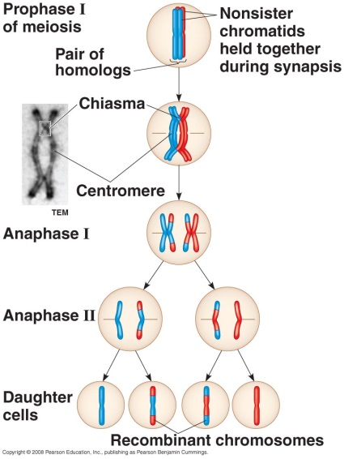
  - During prophase I, replicated homologs pair up and become physically connected along their lengths by a zipper-like protein structure, the synaptonemal complex, in a process called synapsis.
      - Crossing over, genetic rearrangement between nonsister chromatids, occurs during this stage.
  - Following disassembly of the synaptonemal complex in late prophase, the two homologs pull apart slightly but remain connected by at least one X-shaped region called a chiasma (plural, chiasmata).
      - Synapsis and crossing over do not occur during mitosis.

- Alignment of homologs on the metaphase plate
  - During metaphase I of meiosis, pairs of homologous chromosomes (rather than individual chromosomes, as in mitosis) line up on the metaphase plate.

- Separation of homologs
  - During anaphase I of meiosis, the replicated chromosomes of each homologous pair move toward opposite poles, while the sister chromatids of each replicated chromosome remain attached.
    - In anaphase of mitosis, the sister chromatids separate.
- During meiosis I, the sister chromatids are attached along their lengths by protein complexes called cohesins.
- In mitosis, enzymes remove the cohesins to allow the sister chromatids to move to opposite poles of the cell at the end of metaphase.
- In meiosis, sister chromatid cohesion is released in two steps.
- In metaphase I, homologs are held together by cohesion between sister chromatid arms in regions where DNA has been exchanged.
- In anaphase I, cohesins are cleaved along the arms, allowing homologs to separate.
- In anaphase II, cohesins are cleaved at the centromeres, allowing chromatids to separate.
- What prevents cohesin cleavage at the centromere while it occurs along sister chromatid arms at the end of metaphase I?
- A protein named “shugoshin” (Japanese for “guardian spirit”) protects cohesins from cleavage at the centromere during meiosis I, keeping the sister chromatids joined.
- Meiosis I is a reductional division because it halves the number of chromosome sets from two (the diploid state) to one (the haploid state). In contrast, meiosis II is an equational division.
- The mechanism for separating sister chromatids is virtually identical in both meiosis II and mitosis.
- The molecular basis of chromosome behavior during meiosis continues to be a focus of intense research interest.
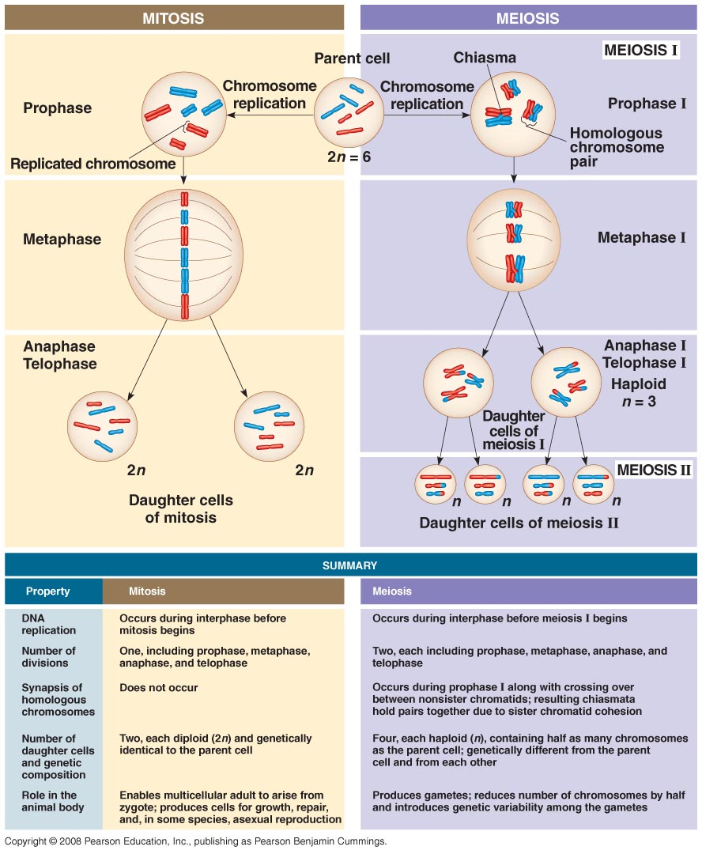
Concept 13.4 Genetic variation produced in sexual life cycles contributes to evolution.
- Mutations are the original source of genetic diversity.
- Once different versions of genes arise through mutation, reshuffling of alleles during meiosis and fertilization produce offspring with their own unique set of traits.
Sexual life cycles produce genetic variation among offspring.
- The behavior of chromosomes during meiosis and fertilization is responsible for most of the variation that arises in each generation.
- Three mechanisms contribute to genetic variation arising from sexual reproduction: independent assortment of chromosomes, crossing over, and random fertilization.
- Independent assortment of chromosomes contributes to genetic variability due to the random orientation of homologous pairs of chromosomes at the metaphase plate during meiosis I.
- There is a fifty-fifty chance that a particular daughter cell from meiosis I will get the maternal chromosome of a certain homologous pair and a fifty-fifty chance that it will receive the paternal chromosome.
- Each homologous pair of chromosomes segregates independently of every other homologous pair during metaphase I.
- Therefore, the first meiotic division results in independent assortment of maternal and paternal chromosomes into daughter cells.
- The number of combinations possible when chromosomes assort independently into gametes is 2^{n}, where n is the haploid number of the organism.
- If n = 3, there are 2³ = 8 possible combinations.
- For humans with n = 23, there are 2²³, or more than 8 million possible combinations of chromosomes.
- Crossing over produces recombinant chromosomes, which combine genes inherited from each parent.
- Crossing over begins very early in prophase I, as homologous chromosomes pair loosely along their lengths.
- Each gene on one homolog is aligned precisely with the corresponding gene on the other homolog.
- In a single crossover event, specific proteins orchestrate an exchange of the corresponding segments of two nonsister chromatids—one maternal and one paternal chromatid of a homologous pair.
- In crossing over, homologous portions of two nonsister chromatids trade places.
- As a result, individual chromosomes carry genes derived from two different parents.
- For humans, this occurs an average of one to three times per chromosome pair.
- In humans and most other organisms, crossing over may be essential for the lining up of homologous chromosomes during metaphase I.
- Chiasmata hold homologs together as the spindle forms in meiosis I.
- Crossing over, by combining DNA inherited from two parents into a single chromosome, is an important source of genetic variation.
- At metaphase II, nonidentical sister chromatids sort independently from one another, further increasing the number of genetic types of daughter cells that are formed by meiosis.
- The random nature of fertilization adds to the genetic variation arising from meiosis.
- Any sperm can fuse with any egg.
- The ovum is one of more than 8 million possible chromosome combinations.
- The successful sperm is one of more than 8 million possibilities.
- The resulting zygote could contain any one of more than 70 trillion possible combinations of chromosomes.
- Crossing over adds even more variation to this.
- Each zygote has a unique genetic identity.
- All three mechanisms reshuffle the various genes carried by individual members of a population.
Evolutionary adaptation depends on a population’s genetic variation.
- Charles Darwin recognized the importance of genetic variation in evolution.
- A population evolves through the differential reproductive success of its variant members.
- Those individuals best suited to the local environment leave the most offspring, transmitting their genes in the process.
- This natural selection results in adaptation, the accumulation of favorable genetic variations in a specific environment.
- If the environment changes or a population moves to a new environment, new genetic combinations that work best in the new conditions will produce more offspring, and these genes will increase.
- Formerly favored genes will decrease.
- Sex and mutation continually generate new genetic variability.
- Although Darwin realized that heritable variation makes evolution possible, he did not have a theory of inheritance.
- Gregor Mendel, a contemporary of Darwin’s, published a theory of inheritance that explained genetic variation and thus supported Darwin’s theory.
- Mendel’s work was largely unknown until 1900, after both Darwin and Mendel had been dead for more than 15 years.

