Lecture Outline Chapter 19 Viruses
Overview: A Borrowed Life
- Viruses are the simplest biological systems.
- Most viruses are little more than aggregates of nucleic acids and protein—genes in a protein coat.
- Are viruses living or nonliving?
- Viruses cannot reproduce or carry out metabolic activities outside of a host cell.
- Most virologists would probably agree that viruses are not alive but lead “a kind of borrowed life.”
- Molecular biology was born in the laboratories of microbiologists studying viruses that infect bacteria.
- Experiments with viruses provided key evidence that genes are made of nucleic acids.
- Viruses were critical in working out most of the major steps in DNA replication, transcription, and translation.
- Viruses have unique genetic mechanisms that help us understand viral disease.
- The study of viruses has led to the development of techniques that enable scientists to manipulate genes and transfer them from one organism to another.
- Viruses are used as agents of gene transfer in gene therapy.

Concept 19.1 A virus consists of a nucleic acid surrounded by a protein coat.
Researchers discovered viruses by studying a plant disease.
- The story of how viruses were discovered begins in 1883 with Adolf Mayer’s research on the cause of tobacco mosaic disease.
- This disease stunts tobacco plant growth and mottles plant leaves.
- Mayer learned that the disease was infectious when he found that he could transmit the disease by rubbing sap from diseased leaves onto healthy plants.
- He concluded that the disease must be caused by an extremely small bacterium.
- Ten years later, Dimitri Ivanowsky demonstrated that the sap was still infectious even after passing through a filter designed to remove bacteria.
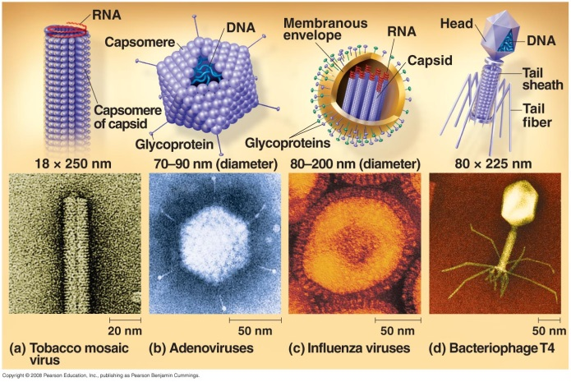
- In 1897, Martinus Beijerinck ruled out the possibility that the disease was due to a filterable toxin produced by a bacterium by demonstrating that the infectious agent could reproduce.
- The sap from one generation of infected plants could be used to infect a second generation of plants that could infect subsequent generations.
- Beijerinck also determined that the pathogen could reproduce only within the host, could not be cultivated on nutrient media, and was not inactivated by alcohol, which is generally lethal to bacteria.
- Beijerinck proposed a reproducing particle much smaller and simpler than a bacterium.
- In 1935, Wendell Stanley crystallized the pathogen, the tobacco mosaic virus (TMV).
A virus is a genome enclosed in a protective coat.
- Stanley’s discovery that some viruses can be crystallized was puzzling because not even the simplest cells can aggregate into regular crystals.
- Viruses are not cells, however, but infectious particles consisting of nucleic acid encased in a protein coat and, in some cases, a membranous envelope.
- The tiniest viruses are only 20 nm in diameter—smaller than a ribosome.
- The genome of viruses may consist of double-stranded DNA, single-stranded DNA, double-stranded RNA, or single-stranded RNA, depending on the kind of virus.
- A virus is called a DNA virus or an RNA virus, according to the kind of nucleic acid that makes up its genome.
- The viral genome is usually organized as a single linear or circular molecule of nucleic acid.
- The smallest viruses have only four genes; the largest have several hundred to a thousand.
- By comparison, bacterial genomes contain 200 to a few thousand genes.
- The capsid is the protein shell enclosing the viral genome.
- Capsids are built of a large number of protein subunits called capsomeres.
- The number of different kinds of proteins making up the capsid is usually small.
- The rod-shaped capsid of the tobacco mosaic virus has more than 1,000 copies of a single protein arranged in a helix.
- Rod-shaped viruses are commonly called helical viruses.
- Adenoviruses have 252 identical proteins arranged into a polyhedral capsid with 20 triangular facets—an icosahedron.
- These viruses are called icosahedral viruses.
- Some viruses have accessory structures to help them infect their hosts.
- A membranous envelope surrounds the capsids of flu viruses.
- These viral envelopes are derived from the membrane of the host cell.
- They contain host cell phospholipids and membrane proteins as well as proteins and glycoproteins of viral origin.
- Some viruses carry a few viral enzyme molecules within their capsids.
- The most complex capsids are found in viruses that infect bacteria, called bacteriophages or phages.
- The T-even phages (T2, T4, T6) that infect Escherichia coli have elongated icosahedral capsid heads that enclose their DNA and a protein tail piece that attaches the phage to the host and injects the phage DNA inside.
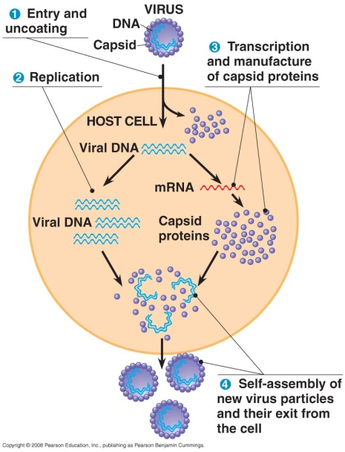
Concept 19.2 Viruses reproduce only in host cells.
- Lacking metabolic enzymes, ribosomes, and other equipment for making proteins, viruses are obligate intracellular parasites.
- Viruses can reproduce only within a host cell.
- An isolated virus is unable to reproduce—or do anything else, except infect an appropriate host.
- An isolated virus is merely a packaged set of genes in transit from one host cell to another.
- Each type of virus can infect and parasitize only a limited range of host cells, called its host range.
- This host specificity depends on the evolution of recognition systems by the virus.
- Viruses recognize host cells by a “lock and key” fit between proteins on the outside of the virus and specific receptor molecules on the host’s surface (which originally evolved for functions that benefit the host).
- Some viruses have a broad enough host range to infect several species, while others infect only a single species.
- West Nile and equine encephalitis viruses can infect mosquitoes, birds, horses, and humans.
- Measles virus can infect only humans.
- Most viruses of eukaryotes attack specific tissues.
- Human cold viruses infect only the cells lining the upper respiratory tract.
- The AIDS virus binds to only certain white blood cells.
Viral reproductive cycles have characteristic general features.
- A viral infection begins when the genome of the virus enters the host cell.
- The mechanism of genome entry varies with the type of virus and host cell.
- For example, T-even phages use their elaborate tail apparatus to inject DNA into a bacterium.
- Other viruses are taken up by endocytosis or by fusion of the viral envelope with the plasma membrane of the host.
- Once inside, the viral genome commandeers its host, reprogramming the cell to copy viral nucleic acid and manufacture proteins from the viral genome.
- The host provides nucleotides, ribosomes, tRNAs, amino acids, ATP, and other components for making the viral components dictated by the viral genes.
- Most DNA viruses use the DNA polymerases of the host cell to synthesize new genomes along the templates provided by the viral DNA.
- RNA viruses use special virus-encoded polymerases that can use RNA as a template.
- The nucleic acid molecules and capsomeres then self-assemble into viral particles.
- Tobacco mosaic virus RNA and capsomeres can be assembled to form complete viruses if the components are mixed together under the right conditions.
- The simplest type of viral reproductive cycle ends with the exit of viruses from the infected host cell, a process that usually damages or destroys the host cell.
- This cellular damage and death cause many of the symptoms associated with viral infection.
Phages reproduce using lytic or lysogenic cycles.
- Although phages are the best understood of all viruses, some of them are also among the most complex.
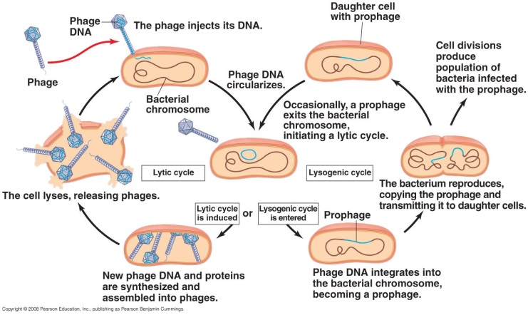
- Research on phages led to the discovery that some double-stranded DNA viruses can reproduce by two alternative mechanisms: the lytic cycle and the lysogenic cycle.
- In the lytic cycle, the phage reproductive cycle culminates in the death of the host.
- In the last stage, the bacterium lyses (breaks open) and releases the phages produced within the cell to infect others.
- Each of these phages can infect a healthy cell.
- Virulent phages reproduce only by a lytic cycle.
- While phages have the potential to wipe out a bacterial colony in just hours, bacteria have defenses against phages.
- Natural selection favors bacterial mutants with receptor sites that are no longer recognized by a particular type of phage.
- Bacteria produce restriction enzymes that recognize and cut up foreign DNA, including certain phage DNA.
- Their activity restricts the ability of the phage to infect the bacterium.
- Chemical modifications to the bacteria’s own DNA prevent its destruction by restriction enzymes.
- Natural selection favors phage mutants that are resistant to restriction enzymes.
- Instead of lysing their host cells, many phages coexist with them in a state called lysogeny.
- In the lysogenic cycle, the phage genome replicates without destroying the host cell.
- Temperate phages use both lytic and lysogenic cycles.
- The λ phage that infects E. coli demonstrates the cycles of a temperate phage.
- Infection of an E. coli cell by phage λ begins when the phage binds to the surface of the cell and injects its DNA.
- What happens next depends on the reproductive mode: lytic or lysogenic cycle.
- During a lytic cycle, the viral genes turn the host cell into a λ-producing factory, and the cell lyses and releases its viral products.
- During a lysogenic cycle, the λ DNA molecule is incorporated by genetic recombination into a specific site on the E. coli chromosome.
- Viral proteins break both circular DNA molecules and join them together.
- In the prophage stage, one of the viral genes codes for a protein that represses most other prophage genes.
- As a result, the phage genome is largely silent.
- Every time the host divides, it copies the phage DNA and passes the copies to daughter cells.
- The viruses thus propagate without killing the host cells on which they depend.
- A single infected cell can quickly give rise to a large population of bacteria carrying the virus in prophage form.
- The term lysogenic implies that prophages are capable of giving rise to active phages that lyse their host cells.
- That happens when the λ genome exits the bacterial chromosome and initiates a lytic cycle.
- The switch from the lysogenic to lytic mode may be triggered by an environmental signal such as certain chemicals or high-energy radiation.
- In addition to the gene preventing transcription, a few other prophage genes may be expressed during lysogeny.
- Expression of these genes may alter the host’s phenotype, sometimes with important medical consequences.
- For example, the three bacterial species that cause diphtheria, botulism, and scarlet fever contain prophage genes that cause the host bacteria to make toxins.
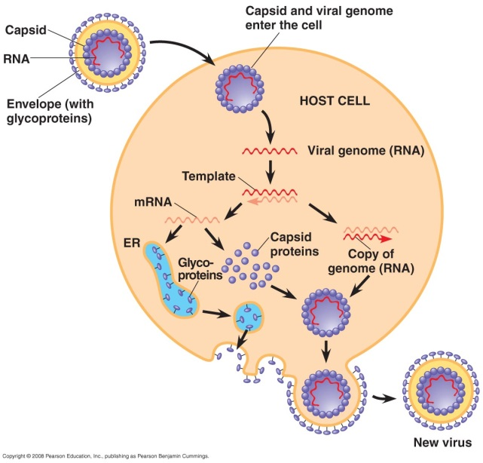
- The difference between the E. coli strain that resides in our intestines and the 0157:H7 strain that has caused several deaths by food poisoning appears to be the presence of prophages in the 0157:H7 strain.
Animal viruses are diverse in their modes of infection and replication.
- Many variations on the basic scheme of viral infection and reproduction are represented among animal viruses.
- One key variable is the type of nucleic acid that serves as a virus’s genetic material.
- The nature of the genome is the basis for the classification of viruses.
- Another variable is the presence or absence of a membranous envelope derived from the host cell membrane.
- Most animal viruses with RNA genomes have an envelope, as do some with DNA genomes.
- Viruses equipped with an outer envelope use the envelope to enter the host cell.
- Glycoproteins on the envelope bind to specific receptors on the host’s membrane.
- The envelope fuses with the host’s membrane, transporting the capsid and the viral genome inside.
- In the reproductive cycle of an enveloped virus with an RNA genome, viral glycoproteins for new envelopes are made by ribosomes bound to the ER of the host cell.
- The viral glycoproteins are then glycosylated by cellular enzymes in the ER and Golgi apparatus.
- These glycoproteins are transported to the cell surface, where they wrap themselves in membrane as they bud from the cell.
- The viral envelope is thus derived from the host’s plasma membrane, although viral genes specify some of the molecules in the membrane.
- These enveloped viruses do not necessarily kill the host cell.
- Some viruses have envelopes that are not derived from plasma membrane.
- The envelope of the herpesvirus is derived from the nuclear envelope of the host.
- These double-stranded DNA viruses reproduce within the cell nucleus using viral and cellular enzymes to replicate and transcribe their DNA.
- In some cases, copies of the herpesvirus DNA remain behind as mini-chromosomes in the nuclei of certain nerve cells.
- The mini-chromosomes remain there for life until triggered by physical or emotional stress to leave the genome and initiate active viral production.
- The infection of other cells by these new viruses causes cold or genital sores.
- The viruses that use RNA as the genetic material are quite diverse, especially those that infect animals.
- In some viruses with single-stranded RNA (class IV), the genome acts as mRNA and is translated into viral protein immediately after infection.
- In others (class V), the RNA genome serves as a template for complementary RNA strands, which function both as mRNA and as templates for the synthesis of additional copies of genome RNA.
- All viruses that require RNA → RNA synthesis to make mRNA use a viral enzyme that is packaged with the genome inside the capsid.
- Retroviruses (class VI) have the most complicated life cycles.
- Retroviruses carry an enzyme called reverse transcriptase that transcribes DNA from an RNA template.
- This provides RNA → DNA information flow.
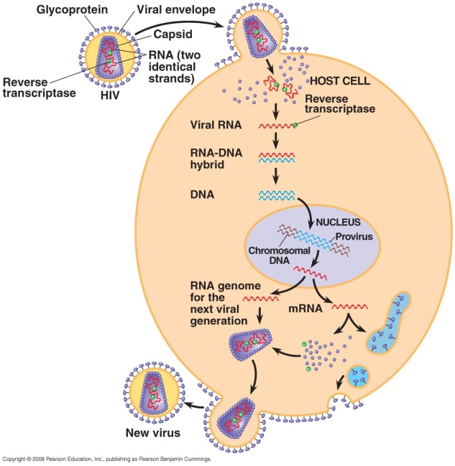
- Human immunodeficiency virus (HIV), the virus that causes AIDS (acquired immunodeficiency syndrome), is a retrovirus.
- HIV and other retroviruses are enveloped viruses that contain two identical molecules of single-stranded RNA and two molecules of reverse transcriptase.
- The reproductive cycle of HIV illustrates the pattern of infection and replication in a retrovirus.
- After HIV enters the host cell, reverse transcriptase molecules are released into the cytoplasm and catalyze the synthesis of viral DNA.
- The newly made viral DNA enters the cell’s nucleus and is inserted as a permanent provirus into a chromosome.
- The host’s RNA polymerase transcribes the proviral DNA into RNA molecules that can function both as mRNA for the synthesis of viral proteins and as genomes for new virus particles released from the cell.
Viruses may have evolved from other mobile genetic elements.
- Viruses do not fit our definition of living organisms.
- An isolated virus is biologically inert, and yet it has a genetic program written in the universal language of life.
- Although viruses are obligate intracellular parasites that cannot reproduce independently, it is hard to deny their evolutionary connection to the living world.
- Because viruses depend on cells for their own propagation, it is reasonable to assume that they evolved after the first cells appeared.
- Most molecular biologists favor the hypothesis that the earliest viruses were naked bits of nucleic acids that passed between cells via injured cell surfaces.
- The evolution of capsid genes may have facilitated the infection of undamaged cells.
- Candidates for the original sources of viral genomes include plasmids and transposons.
- Plasmids are small, circular DNA molecules that are separate from chromosomes.
- Plasmids, found in bacteria and in eukaryote yeast, can replicate independently of the rest of the cell and are occasionally transferred between cells.
- Transposons are DNA segments that can move from one location to another within a cell’s genome.
- Plasmids, transposons, and viruses are all mobile genetic elements.
- A viral genome usually has more in common with the genome of its host than with the genomes of viruses infecting other hosts.
- Some viral genes are essentially identical to the genes of their host.
- Some viruses, however, have genetic sequences that are similar to seemingly distantly related viruses.
- For example, some animal and plant viruses share similar sequences.
- This genetic similarity may reflect the persistence of groups of viral genes that were favored by natural selection early in the evolution of viruses and their eukaryotic hosts.
- The debate about the origin of viruses has been reinvigorated recently by reports of the largest known virus, the mimivirus (or mimicking microbe).
- Mimivirus is a double-stranded DNA virus with an icosahedral capsid that is 400 nm in diameter.
- Its genome contains 1.2 million bases and an estimated 1,000 genes.
- Some mimivirus genes appear to code for products previously thought to be hallmarks of cellular genomes.
- These products include proteins involved in translation, DNA repair, protein folding, and polysaccharide synthesis.
- Some scientists suggest that mimivirus evolved before the first cells. They suggest that natural selection then favored a reduced viral genome after cells appeared and the virus developed an exploitative relationship with them.
- Other scientists suggest that the mimivirus evolved more recently than cells and has simply been efficient at scavenging genes from its hosts.
- The ongoing evolutionary relationship between viruses and the genomes of their hosts is an association that makes viruses very useful model systems in molecular biology.

Concept 19.3 Viruses, viroids, and prions are formidable pathogens in animals and plants.
- The link between viral infection and the symptoms it produces is often obscure.
- Some viruses damage or kill cells by triggering the release of hydrolytic enzymes from lysosomes.
- Some viruses cause the infected cell to produce toxins that lead to disease symptoms.
- Others viruses have molecular components, such as envelope proteins, that are toxic.
- In some cases, viral damage is easily repaired (respiratory epithelium after a cold), but in others, infection causes permanent damage (nerve cells after polio).
- Many of the temporary symptoms associated with a viral infection result from the body’s own efforts at defending itself against infection.
- The immune system is a complex and critical part of the body’s natural defense mechanism against viral and other infections.
- Modern medicine has developed vaccines, harmless variants or derivatives of pathogenic microbes, that stimulate the immune system to mount defenses against the actual pathogen.
- Vaccination has eradicated smallpox.
- Effective vaccines are available against polio, measles, rubella, mumps, hepatitis B, and a number of other viral diseases.
- Medical technology can do little to cure viral diseases once they occur.
- Antibiotics, which can kill bacteria by inhibiting enzymes or processes specific to bacteria, are powerless against viruses, which have few or no enzymes of their own.
- Most antiviral drugs resemble nucleosides and interfere with viral nucleic acid synthesis.
- An example is acyclovir, which impedes herpesvirus reproduction by inhibiting the viral polymerase that synthesizes viral DNA.
- Azidothymidine (AZT) curbs HIV reproduction by interfering with DNA synthesis by reverse transcriptase.
- Currently, multidrug “cocktails” are the most effective treatment for HIV.
- These cocktails contain a combination of two nucleoside mimics and a protease inhibitor to interfere with an enzyme required for viral assembly.
New viral diseases are emerging.
- In recent years, several emerging viruses have risen to prominence.
- HIV, the AIDS virus, seemed to appear suddenly in the early 1980s.
- Later studies uncovered a case in the Belgian Congo as early as 1959.
- The deadly Ebola virus has caused hemorrhagic fevers in central Africa periodically since 1976.
- West Nile virus appeared for the first time in North America in 1999. It has since spread to all 48 contiguous U.S. states.
- A more recent viral disease is severe acute respiratory syndrome (SARS), which infected 8,000 people and killed about 700 in 2002 and 2003.
- Researchers identified the disease agent causing SARS as a coronavirus, a class IV virus with a single-stranded RNA genome.
- The emergence of these new viral diseases is due to three processes: mutation; the dissemination of a viral disease from a small, isolated population; and the spread of existing viruses from one species to another.
- First, the mutation of existing viruses is a major source of new viral diseases.
- RNA viruses tend to have high mutation rates because replication of their nucleic acid lacks proofreading.
- Some mutations create new viral strains with sufficient genetic differences from earlier strains that they can infect individuals who had acquired immunity to these earlier strains.
- This is the case in flu epidemics.
- Second, a viral disease can spread from a small, isolated population to become a widespread epidemic.
- For example, AIDS went unnamed and virtually unnoticed for decades before spreading around the world.
- Technological and social factors, including affordable international travel, blood transfusion technology, sexual promiscuity, and the abuse of intravenous drugs, allowed a previously rare disease to become a global scourge.
- A third source of new viral diseases is the spread of existing viruses from one host species to another.
- It is estimated that about three-quarters of new human diseases originated in other animals.
- For example, a species of bat has been identified as the likely natural reservoir of the SARS virus.
- Flu epidemics illustrate the effects of viruses moving between species.
- There are three types of influenza virus: types B and C, which infect only humans and have never caused an epidemic, and type A, which infects a range of animals.
- Influenza A strains have caused three major flu epidemics among humans in the last 100 years.
- The worst was the “Spanish flu” pandemic of 1918–1919, which killed 40 million people.
- This strain probably originated in birds and then passed between different species, undergoing mutations.
- In animals infected with multiple strains of flu virus, the different strains underwent genetic recombination, leading to the emergence of a virus capable of infecting human cells.
- Humans lacked immunity to this novel, virulent recombinant virus.
- Different strains of influenza A are given standardized names based on the viral surface proteins: hemagglutinin (H) and neuraminidase (N).
- There are 16 types of hemagglutinin, a protein that helps the flu virus attach to a host cell.
- There are 9 type of neuraminidase, an enzyme that helps release new viruses from infected cells.
- In 1997, 18 people in Hong Kong were infected with an H5N1 virus, previously seen only in wild birds.
- Despite a mass culling of Hong Kong’s domestic birds, H5N1 (or “avian flu”) has since killed more than 160 people.
- The overall mortality rate of this flu is greater than 50%. More than 100 million birds have died from the disease or been culled to prevent its spread.
- The avian flu virus has appeared in wild and domestic birds in Africa and Europe. It has also been found in pigs, tigers, and domestic cats and dogs.
- If H5N1 evolves to spread between humans, it could bring about a major human outbreak.
- Changes in host behavior or the environment can increase the viral traffic responsible for emerging diseases.
- New roads through remote areas may allow viruses to spread between previously isolated human populations.
- Destruction of forests to expand areas of cropland may bring humans into contact with other animals that may host viruses that can infect humans.
Plant viruses are serious agricultural pests.
- More than 2,000 types of viral diseases of plants are known.
- These diseases account for an annual loss of $15 billion worldwide.
- Plant viruses can stunt plant growth and diminish crop yields.
- Most plant viruses are RNA viruses with rod-shaped or polyhedral capsids.
- Plant viral diseases are spread by two major routes: horizontal and vertical transmission.
- In horizontal transmission, a plant is infected with the virus by an external source.
- Plants are more susceptible if their protective epidermis is damaged, perhaps by wind, chilling, injury, or insects.
- Insects are often carriers of viruses, transmitting disease from plant to plant.
  - In vertical transmission, a plant inherits a viral infection from a parent.
- This may occur by asexual propagation or in sexual reproduction via infected seeds.
  - Once a virus starts reproducing inside a plant cell, viral particles can spread throughout the plant by passing through plasmodesmata.
- These cytoplasmic connections penetrate the walls between adjacent cells.
- Proteins encoded by viral genes can alter the diameter of plasmodesmata to allow passage of viral proteins or genomes.
  - Agricultural scientists have focused their efforts on reducing the incidence and transmission of viral disease and on breeding resistant plant varieties.
Viroids and prions are the simplest infectious agents.
  - Viroids, smaller and simpler than even viruses, consist of tiny molecules of naked circular RNA that infect plants.
- The several hundred nucleotides of viroids do not encode for proteins but can be replicated by the host’s cellular enzymes.
  - These small RNA molecules can disrupt plant metabolism and stunt plant growth, perhaps by causing errors in the regulatory systems that control plant growth.
  - Viroids show that a single molecule can act as an infectious agent to spread disease.
  - Prions are infectious proteins that spread disease.
- They appear to cause several degenerative brain diseases, including scrapie in sheep, “mad cow disease,” and Creutzfeldt-Jakob disease in humans.
  - Prions are likely transmitted in food.
- Prions have two alarming characteristics: They are very slow acting, and their incubation period is about 10 years.
- Prions are virtually indestructible. They are not destroyed or deactivated by heating to normal cooking temperatures.
- There is no known cure for prion diseases. The only hope for developing effective treatments lies in understanding the process of infection.
- How can a nonreplicating protein be a transmissible pathogen?
- According to the leading hypothesis, a prion is a misfolded form of a normal brain protein.
- When the prion gets into a cell with the normal form of the protein, the prion can convert the normal protein to the prion version, creating a chain reaction that increases their numbers.
- Stanley Prusiner, the first scientist to propose this model of prion disease, was awarded the Nobel Prize in 1997.

