Chapter 6
A Tour of the Cell
Overview: The Fundamental Units of Life
- All organisms are made of cells.
- Many organisms are single-celled.
- The cell is the simplest collection of matter that can live.
- Even when arranged into higher levels of organization, such as tissues and organs, cells are an organism’s basic units of structure and function.
- Life at the cellular level arises from structural order, reflecting emergent properties and the correlation between structure and function.
- The movement of an animal cell depends on the intricate interplay of the structures that make up a cellular skeleton.
- Organisms interact with their environment; cells sense and respond to environmental fluctuations.
- Evolution is the unifying biological theme; all cells are related by their descent from earlier cells but have been modified in various ways during the history of life on Earth.

Concept 6.1 To study cells, biologists use microscopes and the tools of biochemistry.
- The discovery and early study of cells progressed with the invention of microscopes in 1590 and their improvement in the 17th century.
- Microscopes vary in magnification and resolving power, or resolution.
- Magnification is the ratio of an object’s image to its real size.
- Resolution is a measure of image clarity. It is the minimum distance two points can be separated and still be distinguished as two separate points.
- Resolution is limited by the shortest wavelength of the radiation used for imaging.
- In a light microscope (LM), visible light passes through the specimen and then through glass lenses.
- The lenses refract light so that the image is magnified into the eye or onto a video screen.
- The minimum resolution of an LM is about 200 nanometers (nm), the size of a small bacterium.
- LMs can magnify effectively to about 1,000 times the size of the actual specimen.
- At higher magnifications, the image blurs.
- Techniques developed in the 20th century have enhanced contrast, staining or labeling cell components so they stand out.
- Although an LM can resolve individual cells, it cannot resolve much of the internal anatomy, especially the organelles.
- To resolve smaller structures, scientists use an electron microscope (EM), which focuses a beam of electrons through the specimen or onto its surface.
- Because resolution is inversely related to the wavelength used, EMs (whose electron beams have shorter wavelengths than visible light) have finer resolution than LMs.
- Theoretically, the resolution of a modern EM could reach 0.002 nm, but the practical limit is closer to about 2 nm.
- The term cell ultrastructure refers to a cell’s anatomy revealed by an EM.
- Scanning electron microscopes (SEMs) are useful for studying surface structures.
- The sample surface is covered with a thin film of gold.
- The beam excites electrons on the surface of the sample.
- These secondary electrons are collected and focused on a screen, producing an image of the topography of the specimen.
- SEMs have great depth of field, resulting in an image that seems three-dimensional.
- Transmission electron microscopes (TEMs) are used to study the internal ultrastructure of cells.
- A TEM aims an electron beam through a very thin section of the specimen.
- To enhance contrast, the thin sections are stained with atoms of heavy metals.
- The image is focused and magnified by electromagnets.
- Although EMs reveal organelles that are impossible to resolve with LMs, the methods used to prepare cells for viewing under an EM kills them.
- LMs do not have as high a resolution as EMs, but they can be used to study live cells.
- Microscopes are important tools in cytology, the study of cell structures.
- Cytology combined with biochemistry, the study of molecules and chemical processes in metabolism, produced modern cell biology.
- Cell biologists can isolate organelles to study their functions.
- A centrifuge spins test tubes holding mixtures of disrupted cells at various speeds.
- The resulting forces cause a fraction of the cell components to settle to the bottom of the tube, forming a pellet.
- At lower speeds, the pellet consists of larger components; higher speeds yield a pellet with smaller components.
- An ultracentrifuge can spin at up to 130,000 revolutions per minute (rpm) and apply forces greater than 1 million times gravity (1,000,000 g).
- Cell fractionation prepares isolates of specific cell components so that the functions of these organelles can be determined, especially by the reactions or processes catalyzed by their proteins.
- For example, one cellular fraction was enriched in enzymes that function in cellular respiration.
- Electron microscopy revealed that this fraction is rich in mitochondria.
- This evidence helped cell biologists determine that mitochondria are the site of cellular respiration.
- Cytology and biochemistry complement each other in correlating cellular structure and function.

Concept 6.2 Eukaryotic cells have internal membranes that compartmentalize their functions.
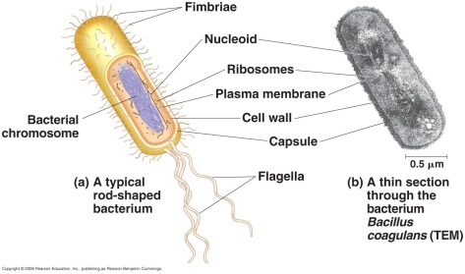
Prokaryotic and eukaryotic cells differ in size and complexity.
- Organisms of the domains Bacteria and Archaea consist of prokaryotic cells. Protists, fungi, animals, and plants consist of eukaryotic cells.
- All cells are surrounded by a selective barrier, the plasma membrane.
- The semifluid substance within the membrane is the cytosol, containing the organelles.
- All cells contain chromosomes that carry genes in the form of DNA.
- All cells have ribosomes, tiny complexes that make proteins based on instructions contained in genes.
- A major difference between prokaryotic and eukaryotic cells is the location of the DNA.
- In a eukaryotic cell, most of the DNA is in an organelle bounded by a double membrane, the nucleus.
- In a prokaryotic cell, the DNA is concentrated in the nucleoid, without a membrane separating it from the rest of the cell.
- The interior of a prokaryotic cell and the region between the nucleus and the plasma membrane of a eukaryotic cell is the cytoplasm.
- Within the cytoplasm of a eukaryotic cell are a variety of membrane-bound organelles with specialized form and function. These membrane-bound organelles are absent in prokaryotes.
- Eukaryotic cells are generally much larger than prokaryotic cells.
- The logistics of carrying out cellular metabolism set limits on cell size.
- At the lower limit, the smallest bacteria, mycoplasmas, are 0.1–1.0 µm in diameter.
- Most bacteria are 1–10 µm in diameter.
- Eukaryotic cells are typically 10–100 µm in diameter.
- Metabolic requirements also set an upper limit to the size of a single cell.
- As a cell increases in size, its volume increases faster than its surface area.
- Smaller objects have a higher ratio of surface area to volume.
- The plasma membrane functions as a selective barrier that allows the passage of oxygen, nutrients, and wastes for the whole volume of the cell.
- Rates of chemical exchange across the plasma membrane may be inadequate to maintain a cell with a very large cytoplasm.
- The need for a surface sufficiently large to accommodate the volume explains the microscopic size of most cells.
- Larger organisms do not generally have larger cells than smaller organisms, simply more cells.
- Cells that exchange a lot of material with their surroundings, such as intestinal cells, may have long, thin projections from the cell surface called microvilli, which increase the surface area without significantly increasing the cell volume.
Internal membranes compartmentalize the functions of a eukaryotic cell.
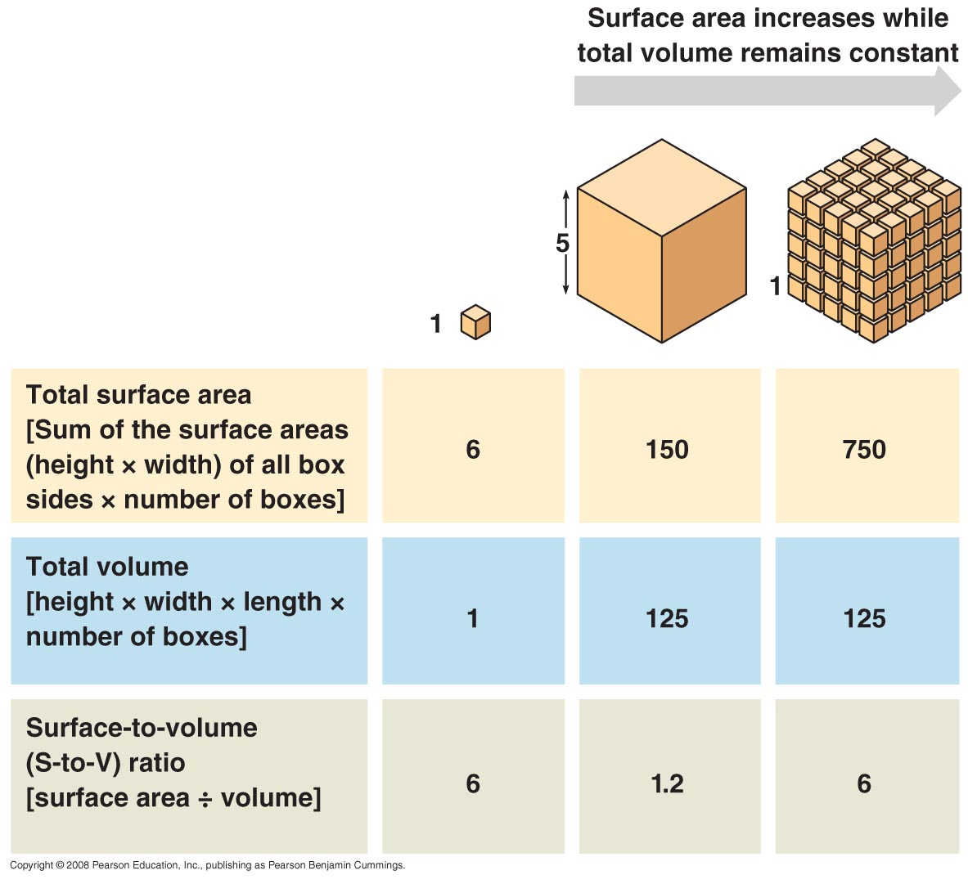
- A eukaryotic cell has extensive and elaborate internal membranes, which partition the cell into compartments.
- These membranes also participate directly in metabolism because many enzymes are built into membranes.
- The compartments created by membranes provide different local environments that facilitate specific metabolic functions, allowing several incompatible processes to go on simultaneously in a cell.
- The general structure of a biological membrane is a double layer of phospholipids.
- Other lipids and diverse proteins are embedded in the lipid bilayer or attached to its surface.
- Each type of membrane has a unique combination of lipids and proteins for its specific functions.
- For example, enzymes embedded in the membranes of mitochondria function in cellular respiration.

Concept 6.3 The eukaryotic cell’s genetic instructions are housed in the nucleus and carried out by the ribosomes.
- The nucleus contains most of the genes in a eukaryotic cell.
- Additional genes are located in mitochondria and chloroplasts.
- The nucleus averages about 5 µm in diameter.
- The nucleus is separated from the cytoplasm by a double membrane called the nuclear envelope.
- The two membranes of the nuclear envelope are separated by 20–40 nm.
- The envelope is perforated by pores that are about 100 nm in diameter.
- At the lip of each pore, the inner and outer membranes of the nuclear envelope are fused to form a continuous membrane.
- A protein structure called a pore complex lines each pore, regulating the passage of certain large macromolecules and particles.
- The nuclear side of the envelope is lined by the nuclear lamina, a network of protein filaments that maintains the shape of the nucleus.
- There is evidence that a framework of fibers called the nuclear matrix extends through the nuclear interior.
- Within the nucleus, the DNA and associated proteins are organized into discrete units called chromosomes, structures that carry the genetic information.
- Each chromosome is made up of material called chromatin, a complex of proteins and DNA.
- Stained chromatin appears through light microscopes and electron microscopes as a diffuse mass.
- As the cell prepares to divide, the chromatin fibers coil up and condense, becoming thick enough to be recognized as the familiar chromosomes.
- Each eukaryotic species has a characteristic number of chromosomes.
- A typical human cell has 46 chromosomes.
- A human sex cell (egg or sperm) has only 23 chromosomes.
- In the nucleus is a region of densely stained fibers and granules adjoining chromatin, the nucleolus.
- In the nucleolus, ribosomal RNA (rRNA) is synthesized and assembled with proteins from the cytoplasm to form large and small ribosomal subunits.
- The subunits pass through the nuclear pores to the cytoplasm, where they combine to form ribosomes.
- Recent studies have suggested that the nucleolus also helps regulate cellular processes such as cell division.
- The nucleus directs protein synthesis by synthesizing messenger RNA (mRNA).
- The mRNA is transported to the cytoplasm through the nuclear pores.
- Once in the cytoplasm, ribosomes translate mRNA’s genetic message into the primary structure of a specific polypeptide.
- Ribosomes, containing rRNA and protein, are the cellular components that carry out protein synthesis.
- Cell types that synthesize large quantities of proteins (such as pancreas cells) have large numbers of ribosomes and prominent nucleoli.
- Free ribosomes are suspended in the cytosol and synthesize proteins that function within the cytosol.
- Bound ribosomes are attached to the outside of the endoplasmic reticulum or nuclear envelope.
- Bound ribosomes synthesize proteins that are inserted into membranes, packaged into organelles such as ribosomes, or exported (secreted) from the cell.
- Cells that specialize in protein secretion—for instance, the cells of the pancreas that secrete digestive enzymes—frequently have a high proportion of bound ribosomes.

Concept 6.4 The endomembrane system regulates protein traffic and performs metabolic functions in the cell.
- Many of the internal membranes in a eukaryotic cell are part of the endomembrane system.
- The tasks of the endomembrane system include synthesis of proteins and their transport into membranes and organelles or out of the cell, metabolism and movement of lipids, and detoxification of poisons.
- These membranes are either directly continuous or connected via the transfer of vesicles, sacs of membrane.
- In spite of the connections, these membranes are diverse in function and structure.
- The thickness, molecular composition, and types of chemical reactions carried out by proteins in a given membrane may be modified several times during a membrane’s life.
- The endomembrane system includes the nuclear envelope, endoplasmic reticulum, Golgi apparatus, lysosomes, vacuoles, and plasma membrane.
The endoplasmic reticulum manufactures membranes and performs many other biosynthetic functions.
- The endoplasmic reticulum (ER) accounts for more than half the membranes in a eukaryotic cell.
- The ER includes a network of membranous tubules and sacs called cisternae.
- The ER membrane is continuous with the nuclear envelope, and the cisternal space of the ER is continuous with the space between the two membranes of the nuclear envelope.
- There are two connected regions of ER that differ in structure and function.
- Smooth ER looks smooth because it lacks ribosomes.
- Rough ER looks rough because ribosomes (bound ribosomes) are attached to the outside, including the outside of the nuclear envelope.
- Smooth ER is rich in enzymes and plays a role in a variety of metabolic processes, including synthesis of lipids, metabolism of carbohydrates, and detoxification of drugs and poisons.
- Enzymes of smooth ER synthesize lipids, including oils, phospholipids, and steroids.
- These include the sex hormones of vertebrates and adrenal steroids.
- In the smooth ER of the liver, enzymes help detoxify poisons and drugs such as alcohol and barbiturates.
- Frequent use of these drugs leads to the proliferation of smooth ER in liver cells, increasing the rate of detoxification.
- This proliferation of smooth ER increases tolerance to the target and other drugs, so higher doses are required to achieve the same effect.
- Smooth ER stores calcium ions.
- Muscle cells have a specialized smooth ER that pumps calcium ions from the cytosol into the ER lumen.
- When a nerve impulse stimulates a muscle cell, calcium ions rush from the ER into the cytosol, triggering contraction of the muscle cell.
- Rough ER is especially abundant in cells that secrete proteins.
- Certain cells in the pancreas secrete the hormone insulin into the bloodstream.
- As a polypeptide chain grows from a bound ribosome, it is threaded into the ER lumen through a pore formed by a protein complex in the ER membrane.
- As the new protein enters the ER lumen, it folds into its native shape.
- Most secretory polypeptides are glycoproteins, proteins to which a carbohydrate is attached.
- The carbohydrate is attached to the protein in the ER by specialized molecules built into the ER membrane.
- Secretory proteins are packaged in transport vesicles that bud from a specialized region called transitional ER.
- Transport vesicles carry proteins from one part of the cell to another.
- Rough ER is also a membrane factory for the cell.
- Membrane-bound proteins are synthesized directly into the ER membrane and anchored by their own hydrophobic portions.
- Enzymes in rough ER also synthesize phospholipids from precursors in the cytosol.
- As the ER membrane expands, membrane can be transferred as transport vesicles to other components of the endomembrane system.
The Golgi apparatus is the shipping and receiving center for cell products.
- Many transport vesicles from the ER travel to the Golgi apparatus for modification of their contents.
- The Golgi apparatus is a center of manufacturing, warehousing, sorting, and shipping.
- Some products of the ER are modified and stored and then sent on.
- The Golgi apparatus is especially extensive in cells specialized for secretion.
- The Golgi apparatus consists of flattened membranous sacs—cisternae—that look like a stack of pita bread.
- The membrane of each cisterna separates its internal space from the cytosol.
- One side of the Golgi apparatus, the cis face, is located near the ER. The cis face receives material by fusing with transport vesicles from the ER.
- The other side, the trans face, buds off vesicles that travel to other sites.
- Products from the ER are usually modified during their transit from the cis to the trans region of the Golgi apparatus.
- Various Golgi enzymes modify the carbohydrate portions of glycoproteins.
- Carbohydrates are first added to proteins in rough ER, often during the process of polypeptide synthesis.
- The carbohydrate on the resulting glycoprotein is modified as it passes through the rest of the ER and the Golgi.
- The Golgi removes some sugar monomers and substitutes others, producing a large variety of carbohydrates.
- The Golgi can also manufacture its own macromolecules, including pectin and other noncellulose polysaccharides.
- Golgi products that will be secreted depart from the trans face of the Golgi inside transport vesicles that eventually fuse with the plasma membrane.
- The Golgi apparatus is a dynamic structure.
- The Golgi manufactures and refines its products in stages, with different cisternae between the cis and trans regions containing unique teams of enzymes.
- According to the cisternal maturation model, the cisternae of the Golgi progress from the cis to the trans face, carrying and modifying their protein cargo as they move.
- Finally, the Golgi sorts and packages materials into transport vesicles.
- Molecular identification tags such as phosphate groups are added to products to aid in sorting.
- These tags act like ZIP codes on mailing labels to identify the product’s final destination.
- Transport vesicles budded from the Golgi may have external molecules on their membranes that recognize “docking sites” on the surface of specific organelles or on the plasma membrane, thus targeting them appropriately.
Lysosomes are digestive compartments.
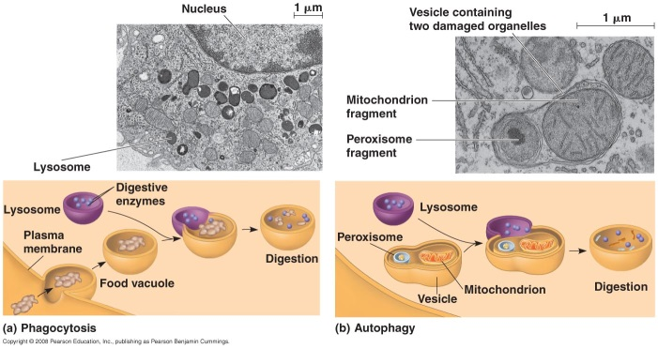
- A lysosome is a membrane-bound sac of hydrolytic enzymes that an animal cell uses to digest macromolecules.
- Lysosomal enzymes work best at acidic pH.
- The rupture of one or a few lysosomes has little impact on a cell because the lysosomal enzymes are not very active at the neutral pH of the cytosol.
- Massive rupture of many lysosomes can destroy a cell by autodigestion, however.
- Lysosomal enzymes and membrane are synthesized by rough ER and then transferred to the Golgi apparatus for further modification.
- Some lysosomes arise by budding from the trans face of the Golgi apparatus.
- Proteins on the inner surface of the lysosomal membrane are spared by digestion by their three-dimensional conformations, which protect vulnerable bonds from hydrolysis.
- Lysosomes carry out intracellular digestion in a variety of circumstances.
- Amoebas eat by engulfing smaller organisms by phagocytosis.
- The food vacuole formed by phagocytosis fuses with a lysosome, whose enzymes digest the food.
- As the polymers are digested, monomers pass to the cytosol to become nutrients for the cell.
- Human macrophages help defend the body by phagocytosing and destroying invasive bacteria.
- Lysosomes can play a role in recycling the cell’s organelles and macromolecules.
- This recycling, or autophagy, renews the cell.
- During autophagy, a damaged organelle or region of cytosol becomes surrounded by a double membrane of unknown origin.
- A lysosome fuses with the outer membrane of the vesicle, digesting the macromolecules and returning the organic monomers to the cytosol for reuse.
- The cells of people who have inherited lysosomal storage diseases lack a functioning hydrolytic enzyme normally present in lysosomes.
- The lysosomes become engorged with indigestible substrates, which begin to interfere with other cellular activities.
- In people who have Tay-Sachs disease, a lipid-digesting enzyme is missing or inactive, and the brain becomes impaired by an accumulation of lipids in the cells.
Vacuoles have diverse functions in cell maintenance.
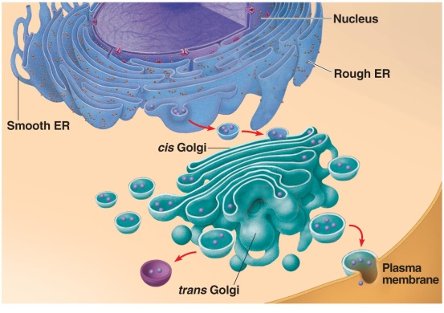
- Vesicles and vacuoles (larger versions) are membrane-bound sacs with varied functions.
- Food vacuoles are formed by phagocytosis and fuse with lysosomes.
- Contractile vacuoles, found in freshwater protists, pump excess water out of the cell to maintain the appropriate concentration of salts.
- A large central vacuole is found in many mature plant cells.
- The vacuolar membrane is selective in its transport of solutes into the central vacuole.
- As a result, the solution inside the vacuole, called cell sap, differs in composition from the cytosol.
- The functions of the central vacuole include stockpiling proteins or inorganic ions, disposing of metabolic by-products, holding pigments, and storing defensive compounds that protect the plant against herbivores.
- The vacuole has a major role in the growth of plant cells, which enlarge as their vacuoles absorb water, enabling the cell to become larger with little investment in new cytoplasm.
- Because of the large vacuole, the cytosol occupies only a thin layer between the plasma membrane and the central vacuole. The presence of a large vacuole increases the ratio of surface area to volume for the cell.

Concept 6.5 Mitochondria and chloroplasts change energy from one form to another.
- Mitochondria and chloroplasts are the organelles that convert energy to forms that cells can use for work.
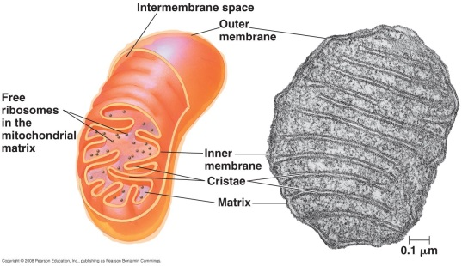
- Mitochondria are the sites of cellular respiration, generating ATP by extracting energy from sugars, fats, and other fuels with the help of oxygen.
- Chloroplasts, found in plants and algae, are the sites of photosynthesis.
- Chloroplasts convert solar energy to chemical energy and synthesize new organic compounds such as sugars from CO₂ and H₂O.
- Mitochondria and chloroplasts are not part of the endomembrane system.
- In contrast to organelles of the endomembrane system, each mitochondrion or chloroplast has two membranes separating the innermost space from the cytosol.
- Their membrane proteins are not made by ribosomes bound to the ER, but rather by free ribosomes in the cytosol and by ribosomes within the organelles themselves.
- Both mitochondria and chloroplasts have small quantities of DNA that direct the synthesis of the polypeptides produced by these internal ribosomes.
- Mitochondria and chloroplasts grow and reproduce as semiautonomous organelles.
- The peroxisome is an oxidative organelle that is not part of the endomembrane system.
- Like mitochondria and chloroplasts, the peroxisome imports its proteins primarily from the cytosol.
- Almost all eukaryotic cells have mitochondria.
- Even in exceptions, such as the human intestinal parasite Giardia and some other protists, recent studies have identified closely related organelles that may have evolved from mitochondria.
- Cells may have one very large mitochondrion or hundreds to thousands of individual mitochondria.
- The number of mitochondria is correlated with aerobic metabolic activity.
- A typical mitochondrion is 1–10 µm long.
- Mitochondria are dynamic: moving, changing shape, fusing, and dividing.
- Mitochondria have a smooth outer membrane and a convoluted inner membrane with infoldings called cristae.
- The inner membrane divides the mitochondrion into two internal compartments.
- The first compartment is the intermembrane space, a narrow region between the inner and outer membranes.
- The inner membrane encloses the mitochondrial matrix, a fluid-filled space with mitochondrial DNA, ribosomes, and enzymes.
- Some of the metabolic steps of cellular respiration are catalyzed by enzymes in the matrix.
- Other proteins that function in respiration, including the enzyme that makes ATP, are built into the inner membrane.
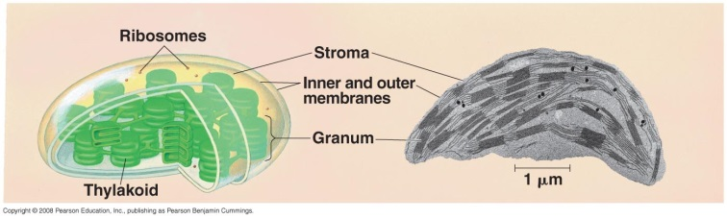
- The highly folded cristae present a large surface area for these enzymes.
- The chloroplast is one of several members of a related family of plant structures called plastids.
- Amyloplasts are colorless plastids that store starch in roots and tubers.
- Chromoplasts store pigments for fruits and flowers.
- Chloroplasts contain the green pigment chlorophyll as well as enzymes and other molecules that function in the photosynthetic production of sugar.
- Chloroplasts are 2–5 µm in diameter and are found in leaves and other green organs of plants and algae.
- The contents of the chloroplast are separated from the cytosol by an envelope consisting of two membranes separated by a narrow intermembrane space.
- Inside the innermost membrane is a fluid-filled space, the stroma, in which float membranous sacs, the thylakoids.
- The stroma contains chloroplast DNA, ribosomes, and enzymes.
- The thylakoids are flattened sacs that play a critical role in converting light to chemical energy. In some regions, thylakoids are stacked like poker chips into grana.
- The membranes of the chloroplast divide the chloroplast into three compartments: the intermembrane space, the stroma, and the thylakoid space.
- Like mitochondria, chloroplasts are dynamic structures.
- The shape of mitochondria is plastic, and they can reproduce themselves by pinching in two.
- Mitochondria and chloroplasts are mobile and move around the cell along tracks of the cytoskeleton.
Peroxisomes generate and degrade H₂O₂ in performing various metabolic functions.
- Peroxisomes, bound by a single membrane, contain enzymes that transfer hydrogen from various substrates to oxygen.
- A by-product of this process is hydrogen peroxide (H₂O₂).
- Some peroxisomes break fatty acids down to smaller molecules that are transported to mitochondria as fuel for cellular respiration.
- Peroxisomes in the liver detoxify alcohol and other harmful compounds by transferring hydrogen from these molecules to oxygen.
- The H₂O₂ formed by peroxisomes is itself toxic, but peroxisomes also contain an enzyme that converts H₂O₂ to water.
- The enzymes that produce hydrogen peroxide and those that dispose of it are sequestered in the same space, away from other cellular components that could otherwise be damaged.
- Specialized peroxisomes, glyoxysomes, convert the fatty acids in seeds to sugars, which the seedling can use as a source of energy and carbon until it is capable of photosynthesis.
- Peroxisomes do not bud from the endomembrane system, but by incorporating proteins and lipids from the cytosol, as well as lipids synthesized within the peroxisome itself.
- Peroxisomes split in two when they reach a certain size.

Concept 6.6 The cytoskeleton is a network of fibers that organizes structures and activities in the cell.
The cytoskeleton provides support, motility, and regulation.
- The cytoskeleton provides mechanical support to the cell and maintains the cell’s shape.
- This function is especially important in animal cells, which lack walls.
- The cytoskeleton provides anchorage for many organelles and cytosolic enzymes.
- The cytoskeleton is dynamic and can be dismantled in one part and reassembled in another to change the shape of the cell.
- The cytoskeleton also plays a major role in cell motility, including changes in cell location and limited movements of parts of the cell.
- The cytoskeleton interacts with motor proteins to produce motility.
- Cytoskeleton elements and motor proteins work together with plasma membrane molecules to move the whole cell along fibers outside the cell.
- Motor proteins bring about movements of cilia and flagella by gripping cytoskeletal components such as microtubules and moving them past each other.
- A similar mechanism causes muscle cells to contract.
- Inside the cell, vesicles can travel along “monorails” provided by the cytoskeleton.
- This is how vesicles containing neurotransmitter molecules migrate to the tips of axons.
- The vesicles that bud off from the ER travel to the Golgi apparatus along tracks built of cytoskeletal elements.
- The cytoskeleton manipulates the plasma membrane to form food vacuoles during phagocytosis.
- Cytoplasmic streaming in plant cells is caused by the cytoskeleton.
- The cytoskeleton also plays a role in the regulation of biochemical activities in the cell in response to mechanical stimulation.
- Cytoskeletal elements transmit forces exerted by extracellular molecules via cell surface proteins into the cell—and even into the nucleus.
- In an experiment, investigators used a micromanipulation device to pull on certain plasma membrane proteins attached to the cytoskeleton, leading to almost instantaneous rearrangements of nucleoli and other structures in the nucleus.
- In this way, cytoskeletal transmission of naturally occurring mechanical signals may help regulate and coordinate the cell’s response.
Three main types of fibers make up the cytoskeleton: microtubules, microfilaments, and intermediate filaments.
- Microtubules are the thickest of the three types of fibers; microfilaments (or actin filaments) are the thinnest; and intermediate filaments are fibers with diameters in a middle range.
- Microtubules are hollow rods about 25 nm in diameter and 200 nm to 25 µm in length.
- Microtubule fibers are constructed of the globular protein tubulin.
- Each tubulin molecule is a dimer consisting of two subunits.
- A tubulin dimer consists of two slightly different polypeptides: α-tubulin and β-tubulin.
- A microtubule changes in length by adding or removing tubulin dimers.
- The two ends of a microtubule are slightly different.
- The “plus” end can accumulate or release tubulin dimers at a much higher rate than the other end.
- Microtubules shape and support the cell and serve as tracks to guide motor proteins carrying organelles to their destination.
- Microtubules guide secretory vesicles from the Golgi apparatus to the plasma membrane.
- Microtubules are also responsible for the separation of chromosomes during cell division.
- In many animal cells, microtubules grow out from a centrosome near the nucleus.
- This region is considered to be a “microtubule-organizing center.”
- These microtubules resist compression to the cell.
- Within the centrosome is a pair of centrioles, each with nine triplets of microtubules arranged in a ring.
- Before an animal cell divides, the centrioles replicate.
- Although centrosomes with centrioles may help organize microtubule assembly in animal cells, they are not essential for this function.
- Yeast cells and plant cells lack centrosomes with centrioles but have well-organized microtubules.
- Other microtubule-organizing centers must play the role of centrosomes in these cells.
- A specialized arrangement of microtubules is responsible for the beating of cilia and flagella.
- Many unicellular eukaryotic organisms are propelled through water by cilia and flagella.
- The sperm of animals, algae, and some plants have flagella.
- When cilia or flagella extend from cells within a tissue layer, they can beat to move fluid over the surface of the tissue.
- For example, cilia lining the windpipe sweep mucus carrying trapped debris out of the lungs.
- In the reproductive tract, cilia lining the oviducts help move an egg toward the uterus.
- Cilia usually occur in large numbers on the cell surface.
- Cilia are about 0.25 µm in diameter and 2–20 µm long.
- There are usually just one or a few flagella per cell.
- Flagella are the same diameter as cilia but are 10–200 µm long.
- Cilia and flagella differ in their beating patterns.
- A flagellum has an undulatory movement that generates force in the same direction as the flagellum’s axis.
- Cilia move more like oars, with alternating power and recovery strokes that generate force perpendicular to the cilium’s axis.
- Cilia may also act as a kind of “antenna” for the cell.
- Membrane proteins on the cilium transmit molecular signals from the environment outside the cell to the cell’s nucleus, resulting in changes in the cell’s behavior.
- Such pathways involving cilia-based signaling appear to be crucial to brain function and to embryonic development.
- A growing number of human genetic diseases have been traced back to malfunctioning cilia.
- In spite of their differences, both cilia and flagella have the same ultrastructure.
- Both have a core of microtubules sheathed by an extension of the plasma membrane.
- Nine doublets of microtubules are arranged in a ring around a pair at the center. This “9 + 2” pattern is found in nearly all eukaryotic cilia and flagella.
- Flexible cross-linking proteins connect outer doublets to each other and to the two central microtubules.
- The cilium or flagellum is anchored in the cell by a basal body, whose structure is identical to that of a centriole.
- In many animals (including humans), the basal body of the fertilizing sperm’s flagellum enters the egg and becomes a centriole.
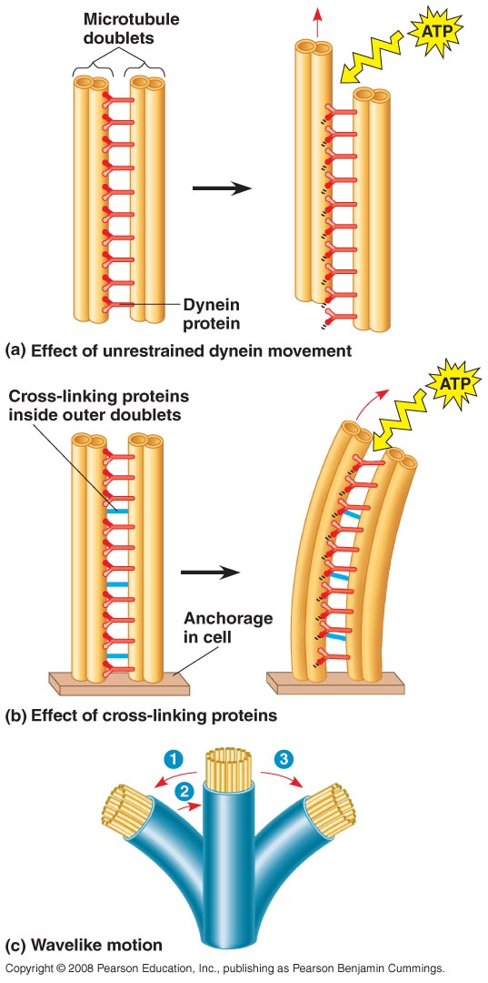
- The bending of cilia and flagella is driven by the arms of a motor protein, dynein.
- A dynein performs a complex cycle of movements caused by changes in the shape of the protein, powered by ATP.
- The mechanics of dynein-based bending involve a process that resembles walking.
- A typical dynein protein has two “feet” that “walk” along the microtubule of the adjacent doublet; one foot maintains contact while the other releases and reattaches one step farther along the microtubule.
- Without restraint on the movement of the microtubule doublets, one doublet continues to “walk” along and slide past the surface of the other, elongating the cilium or flagellum rather than bending it.
- For lateral movement of a cilium or flagellum, the dynein “walking” must have something to pull against, as when the muscles in your leg pull against your bones to move your knee.
- In cilia and flagella, the microtubule doublets seem to be held in place by the cross-linking proteins just inside the outer doublets and by the radial spokes and other structural elements.
- Thus, neighboring doublets cannot slide past each other very far.
- Instead, the forces exerted by dynein “walking” cause the doublets to curve, bending the cilium or flagellum.
- Microfilaments are solid rods about 7 nm in diameter.
- Microfilaments are also called actin filaments because they are built from molecules of actin, a globular protein.
- Each microfilament is built as a twisted double chain of actin subunits.
- Microfilaments can form structural networks because of their ability to branch.
- Microfilaments are present in all eukaryotic cells.
- The structural role of microfilaments in the cytoskeleton is to bear tension, resisting pulling forces within the cell.
- Cortical microfilaments form a three-dimensional network just inside the plasma membrane to help support the cell’s shape, giving the cell cortex the semisolid consistency of a gel.
- This consistency contrasts with the more fluid (sol) state of the interior cytoplasm.
- In animal cells specialized for transporting materials across the plasma membrane, such as intestinal cells, bundles of microfilaments make up the core of microvilli.
- Microfilaments are important in cell motility, especially as part of the contractile apparatus of muscle cells.
- In muscle cells, thousands of actin filaments are arranged parallel to one another.
- Thicker filaments composed of myosin interdigitate with the thinner actin fibers.
- Like dynein with microtubules, myosin acts as a microfilament-based motor protein, walking along the actin filaments to shorten the cell.
- In other cells, actin-myosin aggregates are less organized but still cause localized contraction.
- A contracting belt of microfilaments forms a cleavage furrow that divides the cytoplasm of animal cells during cell division.
- Localized contraction brought about by actin and myosin also drives amoeboid movement.
- Pseudopodia, cellular extensions, extend and contract through the reversible assembly and contraction of actin subunits into microfilaments.
- Microfilaments assemble into networks that convert sol to gel.
- According to a widely accepted model, filaments near the cell’s trailing edge interact with myosin, causing contraction.
- The contraction forces the interior fluid into the pseudopodium, where the actin network has been weakened.
- The pseudopodium extends until the actin reassembles into a network.
- Many cells in the animal body, including some white blood cells, also move by crawling.
- In plant cells, actin-myosin interactions and sol-gel transformations drive cytoplasmic streaming, which creates a circular flow of cytoplasm in the cell, speeding the distribution of materials within the cell.
- Intermediate filaments range in diameter from 8 to 12 nm, larger than microfilaments but smaller than microtubules.
- Intermediate filaments are a diverse class of cytoskeletal units, built from a family of proteins that includes the keratins.
- Like microfilaments, intermediate filaments are specialized for bearing tension.
- Intermediate filaments are more permanent fixtures of the cytoskeleton than are the other two classes.
- Even after cells die, intermediate filament networks often persist.
- The networks reinforce cell shape and fix organelle location.
- The nucleus sits within a cage made of intermediate filaments, fixed in location by branches of the filaments that extend into the cytoplasm.
- Other intermediate filaments make up the nuclear lamina that lines the interior of the nuclear envelope.
- When the shape of the entire cell is correlated with function, intermediate filaments support that shape.
- The axons of nerve cells are strengthened by one class of intermediate filament.
- Various kinds of intermediate filaments function as the framework of the entire cytoskeleton.

Concept 6.7 Extracellular components and connections between cells help coordinate cellular activities.
Plant cells are encased by cell walls.
- Cell walls are found in prokaryotes, fungi, and some protists.
- In plants, the cell wall protects the cell, maintains its shape, prevents excessive uptake of water, and supports the plant against the force of gravity.
- The thickness of plant cell walls ranges from 0.1 µm to several micrometers.
- The chemical composition of the cell wall differs with species and among cell types within a plant.
- The basic design of cell walls consists of microfibrils of cellulose synthesized by an enzyme called cellulose synthase.
- The cellulose microfibrils are secreted to the extracellular space, where they are embedded in a matrix of proteins and other polysaccharides.
- This is the basic design of steel-reinforced concrete or fiberglass.
- A young plant cell secretes a relatively thin and flexible wall called the primary cell wall.
- In actively growing cells, the cellulose fibrils are oriented at right angles to the direction of cell expansion, possibly affecting the growth pattern.
- David Ehrhardt and colleagues found that cortical microtubules guide cellulose synthase as it synthesizes and deposits the fibrils.
- By orienting the deposition of cellulose, microtubules affect the growth pattern of the cells.
- Between the primary walls of adjacent cells is a middle lamella, a thin layer with sticky polysaccharides called pectins that glues cells together.
- When a plant cell stops growing, it strengthens its wall by secreting hardening substances into the primary wall or by adding a secondary cell wall between the plasma membrane and the primary wall.
- The secondary wall may be deposited in several layers.
- It has a strong and durable matrix that provides support and protection.
- Wood consists mainly of secondary walls.
- Plant cell walls are perforated by channels between adjacent cells called plasmodesmata.
The extracellular matrix of animal cells provides support, adhesion, movement, and regulation.
- Though lacking cell walls, animal cells do have an elaborate extracellular matrix (ECM).
- The primary constituents of the ECM are glycoproteins, especially collagen fibers, embedded in a network of glycoprotein proteoglycans.
- Collagen accounts for about half the total protein in the human body.
- A proteoglycan molecule consists of a small core protein with many carbohydrate chains covalently attached, so that it may be up to 95% carbohydrate.
- Large proteoglycan complexes can form when hundreds of proteoglycans become noncovalently attached to a single long polysaccharide molecule.
- In many cells, fibronectins in the ECM connect to integrins, cell-surface receptor proteins that span the membrane and bind on their cytoplasmic side to proteins attached to microfilaments of the cytoskeleton.
- The interconnections from the ECM to the cytoskeleton via the fibronectin-integrin link permit the integration of changes inside and outside the cell.
- The ECM can regulate cell behavior.
- Embryonic cells migrate along specific pathways by matching the orientation of their microfilaments to the “grain” of fibers in the ECM.
- The ECM can influence the activity of genes in the nucleus via a combination of chemical and mechanical signaling pathways.
- Mechanical signaling involves fibronectin, integrins, and microfilaments of the cytoskeleton.
- Changes in the cytoskeleton may in turn trigger chemical signaling pathways inside the cell, leading to changes in the set of proteins being made by the cell and thus changes in the cell’s function.
- This may coordinate the behavior of all the cells within a tissue.
Intercellular junctions help integrate cells into higher levels of structure and function.
- Neighboring cells in tissues, organs, and organ systems often adhere, interact, and communicate through direct physical contact.
- Plant cells are perforated with plasmodesmata, channels allowing cytosol to pass between cells.
- Water and small solutes can pass freely from cell to cell.
- In certain circumstances, proteins and RNA can be exchanged.
- Macromolecules being transported to neighboring cells reach the plasmodesmata by moving along fibers of the cytoskeleton.
- Animals have three main types of intercellular links: tight junctions, desmosomes, and gap junctions.
- All three types of intercellular junctions are especially common in epithelial tissue, which lines the external and internal surfaces of the body.
- In tight junctions, membranes of adjacent cells are fused, forming continuous belts around cells that prevent leakage of extracellular fluid.
- Desmosomes (or anchoring junctions) fasten cells together into strong sheets, much like rivets.
- Intermediate filaments of keratin reinforce desmosomes.
- Gap junctions (or communicating junctions) provide cytoplasmic channels between adjacent cells.
- Special membrane proteins surround these pores.
- Ions, sugars, amino acids, and other small molecules can pass.
- In embryos, gap junctions facilitate chemical communication during development.

