CHAPTER 12
THE CELL CYCLE

Introduction
- The ability of organisms to reproduce their kind is one characteristic that best distinguishes living things from nonliving matter.
- The continuity of life from one cell to another is based on the reproduction of cells via cell division.
- This division process occurs as part of the cell cycle, the life of a cell from its origin in the division of a parent cell until its own division into two.

A. The Key Roles of Cell Division
1. Cell division functions in reproduction, growth, and repair
- The division of a unicellular organism reproduces an entire organism, increasing the population.
- Cell division on a larger scale can produce progeny for some multicellular organisms.
- This includes organisms that can grow by cuttings or by fission.
- Cell division is also central to the development of a multicellular organism that begins as a fertilized egg or zygote.
- Multicellular organisms also use cell division to repair and renew cells that die from normal wear and tear or accidents.
- Cell division requires the distribution of identical genetic material - DNA - to two daughter cells.
- What is remarkable is the fidelity with which DNA is passed along, without dilution, from one generation to the next.
- A dividing cell duplicates its DNA, allocates the two copies to opposite ends of the cell, and then splits into two daughter cells.

2. Cell division distributes identical sets of chromosomes to daughter cells
- A cell’s genetic information, packaged as DNA, is called its genome.
- In prokaryotes, the genome is often a single long DNA molecule.
- In eukaryotes, the genome consists of several DNA molecules.
- A human cell must duplicate about 3 m of DNA and separate the two copies such that each daughter cell ends up with a complete genome.
- DNA molecules are packaged into chromosomes.
- Every eukaryotic species has a characteristic number of chromosomes in the nucleus.
- Human somatic cells (body cells) have 46 chromosomes.
- Human gametes (sperm or eggs) have 23 chromosomes, half the number in a somatic cell.
- Each eukaryotic chromosome consists of a long, linear DNA molecule.
- Each chromosome has hundreds or thousands of genes, the units that specify an organism’s inherited traits.
- Associated with DNA are proteins that maintain its structure and help control gene activity.
- This DNA-protein complex, chromatin, is organized into a long thin fiber.
- After the DNA duplication, chromatin condenses, coiling and folding to make a smaller package.
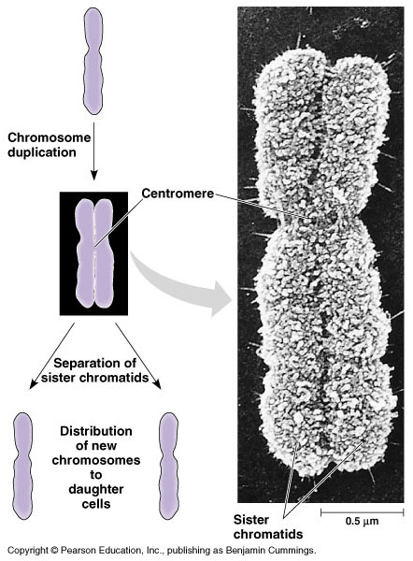
- Each duplicated chromosome consists of two sister chromatids which contain identical copies of the chromosome’s DNA.
- As they condense, the region where the strands connect shrinks to a narrow area, the centromere.
- Later, the sister chromatids are pulled apart and repackaged into two new nuclei at opposite ends of the parent cell.
- The process of the formation of the two daughter nuclei, mitosis, is usually followed by division of the cytoplasm, cytokinesis.
- These processes take one cell and produce two cells that are the genetic equivalent of the parent.

- Each of us inherited 23 chromosomes from each parent: one set in an egg and one set in sperm.
- The fertilized egg or zygote underwent trillions of cycles of mitosis and cytokinesis to produce a fully developed multicellular human.
- These processes continue every day to replace dead and damaged cells.
- Essentially, these processes produce clones — cells with the same genetic information.
- In contrast, gametes (eggs or sperm) are produced only in gonads (ovaries or testes).
- In the gonads, cells undergo a variation of cell division, meiosis, which yields four daughter cells, each with half the chromosomes of the parent.
- In humans, meiosis reduces the number of chromosomes from 46 to 23.
- Fertilization fuses two gametes together and doubles the number of chromosomes to 46 again.

B. The Mitotic Cell Cycle
1. The mitotic phase alternates with interphase in the cell cycle: an overview
- The mitotic (M) phase of the cell cycle alternates with the much longer interphase.
- The M phase includes mitosis and cytokinesis.
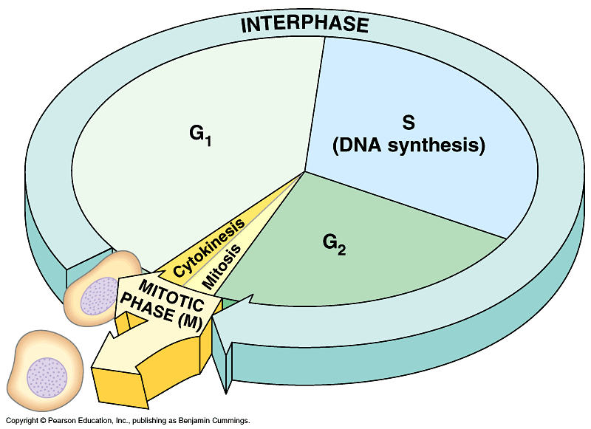
- Interphase accounts for 90% of the cell cycle.
- During interphase the cell grows by producing proteins and cytoplasmic organelles, copies its chromosomes, and prepares for cell division.
- Interphase has three subphases:
- The G₁ phase (“first gap”) centered on growth.
- The S phase (“synthesis”), when the chromosomes are copied.
- The G₂ phase (“second gap”), where the cell completes preparations for cell division,
- Then the cell divides (M).
- The daughter cells may then repeat the cycle.
- Mitosis is a continuum of changes.
- For description, mitosis is usually broken into five subphases:
- Prophase.
- Prometaphase.
- Metaphase.
- Anaphase.
- Telophase.
- By late interphase, the chromosomes have been duplicated but are loosely packed.
- The centrosomes have been duplicated and begin to organize microtubules into an aster (“star”).
- In prophase, the chromosomes are tightly coiled, with sister chromatids joined together.
- The nucleoli disappear.
- The mitotic spindle begins to form and appears to push the centrosomes away from each other toward opposite ends (poles) of the cell.
- During prometaphase, the nuclear envelope fragments and microtubules from the spindle interact with the chromosomes.
- Microtubules from one pole attach to one of two kinetochores, special regions of the centromere, while microtubules from the other pole attach to the other kinetochore.
- The spindle fibers push the sister chromatids until they are all arranged at the metaphase plate, an imaginary plane equidistant between the poles, defining metaphase.
- At anaphase, the centromeres divide, separating the sister chromatids.
- Each is now pulled toward the pole to which it is attached by spindle fibers.
- By the end, the two poles have equivalent collections of chromosomes.
- At telophase, the cell continues to elongate as free spindle fibers from each centrosome push off each other.
- Two nuclei begin to form, surrounded by the fragments of the parent’s nuclear envelope.
- Chromatin becomes less tightly coiled.
- Cytokinesis, division of the cytoplasm, begins.

2. The mitotic spindle distributes chromosomes to daughter cells: a closer look
- The mitotic spindle, fibers composed of microtubules and associated proteins, is a major driving force in mitosis.
- As the spindle assembles during prophase, the elements come from partial disassembly of the cytoskeleton.
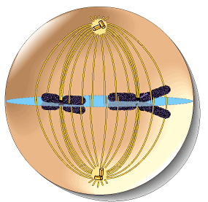
- The spindle fibers elongate by incorporating more subunits of the protein tubulin.
- Assembly of the spindle microtubules starts in the centrosome.
- The centrosome (microtubule-organizing center) of animals has a pair of centrioles at the center, but the function of the centrioles is somewhat undefined.
- As mitosis starts, the two centrosomes are located near the nucleus.
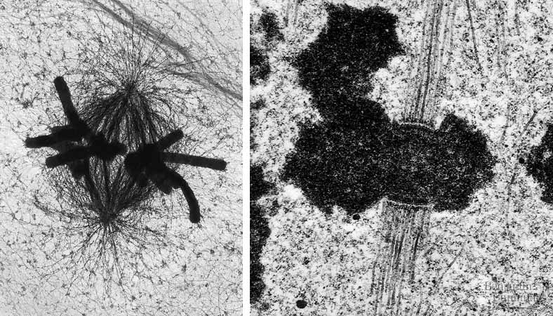
- As the spindle fibers grow from them, the centrioles are pushed apart.
- By the end of prometaphase they develop as the spindle poles at opposite ends of the cell.
- Each sister chromatid has a kinetochore of proteins and chromosomal DNA at the centromere.
- The kinetochores of the joined sister chromatids face in opposite directions.
- During prometaphase, some spindle microtubules attach to the kinetochores.
- When a chromosome’s kinetochore is “captured” by microtubules, the chromosome moves toward the pole from which those microtubules come.
- When microtubules attach to the other pole, this movement stops and a tug-of-war ensues.
- Eventually, the chromosome settles midway between the two poles of the cell, the metaphase plate.
- Other microtubules from opposite poles interact as well, elongating the cell.
- One hypothesis for the movement of chromosomes in anaphase is that motor proteins at the kinetochore “walk” the attached chromosome along the microtubule toward the opposite pole.
- The excess microtubule sections depolymerize.
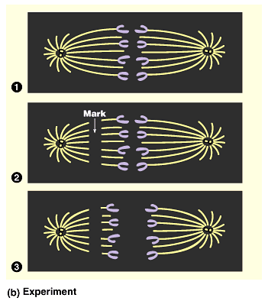
- Experiments support the hypothesis that spindle fibers shorten during anaphase from the end attached to the chromosome, not the centrosome.
- Nonkinetichore microtubules are responsible for lengthening the cell along the axis defined by the poles.
- These microtubules interdigitate across the metaphase plate.
- During anaphase motor proteins push microtubules from opposite sides away from each other.
- At the same time, the addition of new tubulin monomers extends their length.
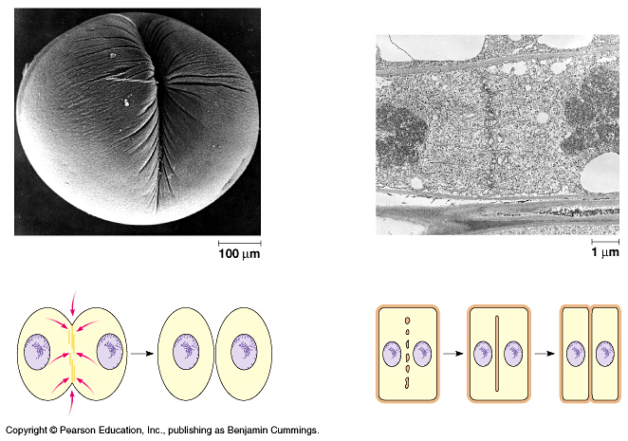
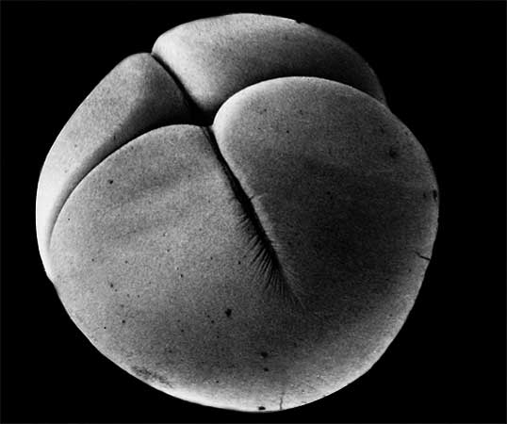
3. Cytokinesis divides the cytoplasm: a closer look
- Cytokinesis, division of the cytoplasm, typically follows mitosis.
- In animals, the first sign of cytokinesis (cleavage) is the appearance of a cleavage furrow in the cell surface near the old metaphase plate.
- On the cytoplasmic side of the cleavage furrow a contractile ring of actin microfilaments and the motor protein myosin form.
- Contraction of the ring pinches the cell in two.
- Cytokinesis in plants, which have cell walls, involves a completely different mechanism.
- During telophase, vesicles from the Golgi coalesce at the metaphase plate, forming a cell plate.
- The plate enlarges until its membranes fuse with the plasma membrane at the perimeter, with the contents of the vesicles forming new wall material in between.
4. Mitosis in eukaryotes may have evolved from binary fission in bacteria
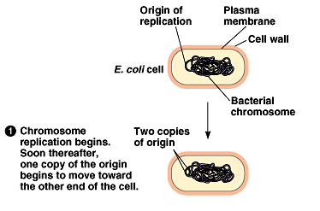
- Prokaryotes reproduce by binary fission, not mitosis.
- Most bacterial genes are located on a single bacterial chromosome which consists of a circular DNA molecule and associated proteins.
- While bacteria do not have as many genes or DNA molecules as long as those in eukaryotes, their circular chromosome is still highly folded and coiled in the cell.
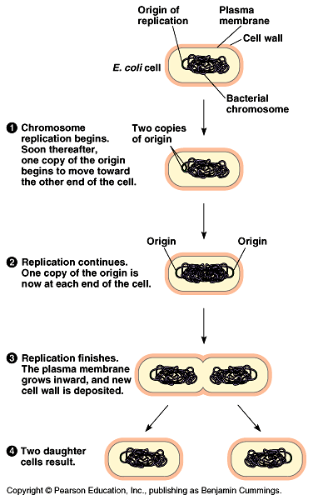
- In binary fission, chromosome replication begins at one point in the circular chromosome, the origin of replication site.
- These copied regions begin to move to opposite ends of the cell.
- The mechanism behind the movement of the bacterial chromosome is still an open question.
- A previous hypothesis proposed that this movement was driven by the growth of new plasma membrane between the two origin regions.
- Recent observations have shown more directed movement, reminiscent of the poleward movement of eukaryotic chromosomes.
- However, mitotic spindles or even microtubules are unknown in bacteria.
- As the bacterial chromosome is replicating and the copied regions are moving to opposite ends of the cell, the bacterium continues to grow until it reaches twice its original size.
- Cell division involves inward growth of the plasma membrane, dividing the parent cell into two daughter cells, each with a complete genome.
- It is quite a jump from binary fission to mitosis.
- Possible intermediate evolutionary steps are seen in the division of two types of unicellular algae.
- In dinoflagellates, replicated chromosomes are attached to the nuclear envelope.
- In diatoms, the spindle develops within the nucleus
C. Regulation of the Cell Cycle
- The timing and rates of cell division in different parts of an animal or plant are crucial for normal growth, development, and maintenance.
- The frequency of cell division varies with cell type.
- Some human cells divide frequently throughout life (skin cells), others have the ability to divide, but keep it in reserve (liver cells), and mature nerve and muscle cells do not appear to divide at all after maturity.
- Investigation of the molecular mechanisms regulating these differences provide important insights into how normal cells operate, but also how cancer cells escape controls.

1. A molecular control system drives the cell cycle
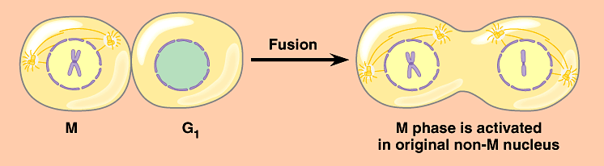
- The cell cycle appears to be driven by specific chemical signals in the cytoplasm.
- Fusion of an S phase cell and a G₁ phase cell induces the G₁ nucleus to start S phase.
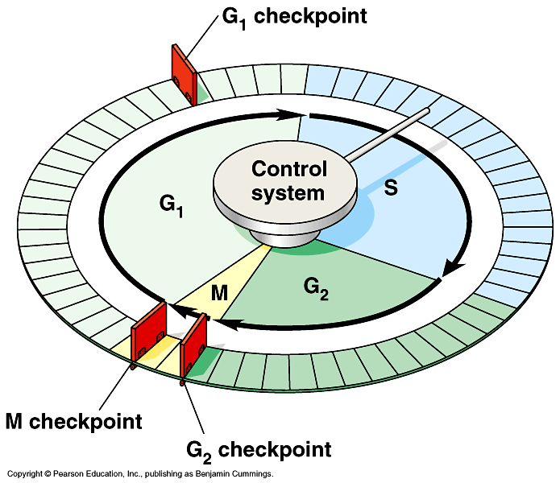
- Fusion of a cell in mitosis with one in interphase induces the second cell to enter mitosis.
- The distinct events of the cell cycle are directed by a distinct cell cycle control system.
- These molecules trigger and coordinate key events in the cell cycle.
- The control cycle has a built-in clock, but it is also regulated by external adjustments and internal controls.
- A checkpoint in the cell cycle is a critical control point where stop and go signals regulate the cycle.
- Many signals registered at checkpoints come from cellular surveillance mechanisms.
- These indicate whether key cellular processes have been completed correctly.
- Checkpoints also register signals from outside the cell.
- Three major checkpoints are found in the G₁, G₂, and M phases.
- For many cells, the G₁ checkpoint, the restriction point in mammalian cells, is the most important.
- If the cell receives a go-ahead signal, it usually completes the cell cycle and divides.
- If it does not receive a go-ahead signal, the cell exits the cycle and switches to a nondividing state, the G₀ phase.
- Most human cells are in this phase.
- Liver cells can be “called back” to the cell cycle by external cues (growth factors), but highly specialized nerve and muscle cells never divide.
- Rhythmic fluctuations in the abundance and activity of control molecules pace the cell cycle.
- Some molecules are protein kinases that activate or deactivate other proteins by phosphorylating them.
- The levels of these kinases are present in constant amounts, but these kinases require a second protein, a cyclin, to become activated.
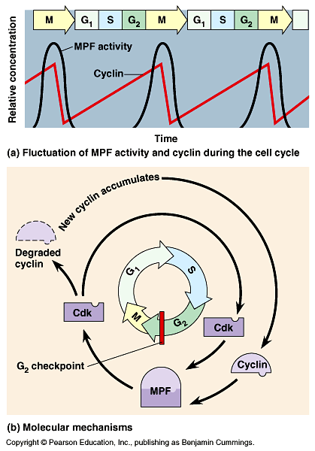
- Levels of cyclin proteins fluctuate cyclically.
- The complex of kinases and cyclin forms cyclin-dependent kinases (Cdks).
- Cyclin levels rise sharply throughout interphase, then fall abruptly during mitosis.
- Peaks in the activity of one cyclin-Cdk complex, MPF, correspond to peaks in cyclin concentration.
- MPF (“maturation-promoting factor” or “M-phase-promoting-factor”) triggers the cell’s passage past the G₂ checkpoint to the M phase.
- MPF promotes mitosis by phosphorylating a variety of other protein kinases.
- MPF stimulates fragmentation of the nuclear envelope.
- It also triggers the breakdown of cyclin, dropping cyclin and MPF levels during mitosis and inactivating MPF.
- The key G₁ checkpoint is regulated by at least three Cdk proteins and several cyclins.
- Similar mechanisms are also involved in driving the cell cycle past the M phase checkpoint.

2. Internal and external cues help regulate the cell cycle
- While research scientists know that active Cdks function by phosphorylating proteins, the identity of all these proteins is still under investigation.
- Scientists do not yet know what Cdks actually do in most cases.
- Some steps in the signaling pathways that regulate the cell cycle are clear.
- Some signals originate inside the cell, others outside.
- The M phase checkpoint ensures that all the chromosomes are properly attached to the spindle at the metaphase plate before anaphase.
- This ensures that daughter cells do not end up with missing or extra chromosomes.
- A signal to delay anaphase originates at kinetochores that have not yet attached to spindle microtubules.
- This keeps the anaphase-promoting complex (APC) in an inactive state.
- When all kinetochores are attached, the APC activates, triggering breakdown of cyclin and inactivation of proteins uniting sister chromatids together.
- A variety of external chemical and physical factors can influence cell division.
- Particularly important for mammalian cells are growth factors, proteins released by one group of cells that stimulate other cells to divide.
- For example, platelet-derived growth factors (PDGF), produced by platelet blood cells, bind to tyrosine-kinase receptors of fibroblasts, a type of connective tissue cell.
- This triggers a signal-transduction pathway that leads to cell division.
- Each cell type probably responds specifically to a certain growth factor or combination of factors.
- The role of PDGF is easily seen in cell culture.
- Fibroblasts in culture will only divide in the presence of a medium that also contains PDGF.
- In a living organism, platelets release PDGF in the vicinity of an injury.
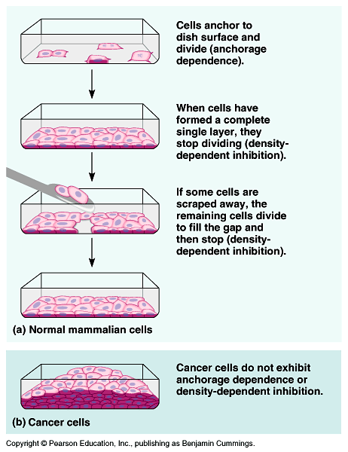
- The resulting proliferation of fibroblasts helps heal the wound.
- Growth factors appear to be important in density-dependent inhibition of cell division.
- Cultured cells normally divide until they form a single layer on the inner surface of the culture container.
- If a gap is created, the cells will grow to fill the gap.
- At high densities, the amount of growth factors and nutrients is insufficient to allow continued cell growth.
- Most animal cells also exhibit anchorage dependence for cell division.
- To divide they must be anchored to a substratum, typically the extracellular matrix of a tissue.
- Control appears to be mediated by connections between the extracellular matrix and plasma membrane proteins and cytoskeletal elements.
- Cancer cells are free of both density-dependent inhibition and anchorage dependence.

3. Cancer cells have escaped from cell cycle controls
- Cancer cells divide excessively and invade other tissues because they are free of the body’s control mechanisms.
- Cancer cells do not stop dividing when growth factors are depleted either because they manufacture their own, have an abnormality in the signaling pathway, or have a problem in the cell cycle control system.
- If and when cancer cells stop dividing, they do so at random points, not at the normal checkpoints in the cell cycle.
- Cancer cell may divide indefinitely if they have a continual supply of nutrients.
- In contrast, nearly all mammalian cells divide 20 to 50 times under culture conditions before they stop, age, and die.
- Cancer cells may be “immortal”.
- Cells (HeLa) from a tumor removed from a woman (Henrietta Lacks) in 1951 are still reproducing in culture.
- The abnormal behavior of cancer cells begins when a single cell in a tissue undergoes a transformation that converts it from a normal cell to a cancer cell.
- Normally, the immune system recognizes and destroys transformed cells.
- However, cells that evade destruction proliferate to form a tumor, a mass of abnormal cells.
- If the abnormal cells remain at the originating site, the lump is called a benign tumor.
- Most do not cause serious problems and can be removed by surgery.
- In a malignant tumor, the cells leave the original site to impair the functions of one or more organs.
- This typically fits the colloquial definition of cancer.
- In addition to chromosomal and metabolic abnormalities, cancer cells often lose attachment to nearby cells, are carried by the blood and lymph system to other tissues, and start more tumors in a event called metastasis.
- Treatments for metastasizing cancers include high-energy radiation and chemotherapy with toxic drugs.
- These treatments target actively dividing cells.
- Researchers are beginning to understand how a normal cell is transformed into a cancer cell.
- The causes are diverse.
- However, cellular transformation always involves the alteration of genes that influence the cell cycle control system.

