**Name Period**

**Chapter 22: Descent with Modification: A Darwinian View of Life**

As you study this chapter, read several paragraphs at a time to catch the flow of ideas and understand the reasoning that is being described. In some places, the text describes a narrative or story of events that led to Darwin’s theory of evolution. Therefore, first read the narrative to absorb the big picture and then return to answer the few questions that accompany this material.

***Overview***

1. Define *evolution* broadly and then give a narrower definition, as discussed in the overview.

***Concept 22.1 The Darwinian revolution challenged the traditional view of a young Earth inhabited by unchanging species***

3. Explain the role of *fossils* in *rock strata* as a window to life in earlier times.

5. *James Hutton* and *Charles Lyell* were geologists whose ideas strongly influenced Darwin’s thinking. What were the ideas each of them contributed?

***James Hutton***

***Charles Lyell***

6. What is the importance of the principle of *uniformitarianism*?

7. *Jean-Baptiste de Lamarck* proposed a mechanism for how life changes over time. Explain the two principles of his mechanism.

**use and disuse**

**inheritance of acquired characteristics**

8. Although Lamarck’s mechanism of evolution does not explain the changes in species over time, his thinking has been influential. What is considered to be the great importance of his ideas?

***Concept 22.2 Descent with modification by natural selection explains the adaptations of organisms and the unity and diversity of life***

9. Charles Darwin proposed that the mechanism of evolution is *natural selection* and that it explains how *adaptations* arise. What are *adaptations*? Give two examples of adaptations.

10. Explain the process of *natural selection*.

11. Let’s try to summarize Darwin’s observations that drive changes in species over time:

|  |  |
| --- | --- |
| **Observation** | **Cite an Example** |
| 1. Variations in traits exist. |  |
| 2. These variations (traits) are heritable. |  |
| 3. Species overproduce. |  |
| 4. There is competition for resources;  not all offspring survive. |  |

12. From these four observations, which two inferences did Darwin make?

13. It is important to remember that differences in heritable traits can lead to *differential reproductive success*. This means that the individuals who have the necessary traits to promote survival in the current environment will leave the most offspring. What can this *differential reproductive success* lead to over time?

14. To demonstrate your understanding of this section, complete the following sentences:

**do not evolve. evolve.**

***Concept 22.3 Evolution is supported by an overwhelming amount of scientific evidence***

15. Use Figure 22.13 to explain how John Endler’s work with guppies demonstrated observable evolutionary change.

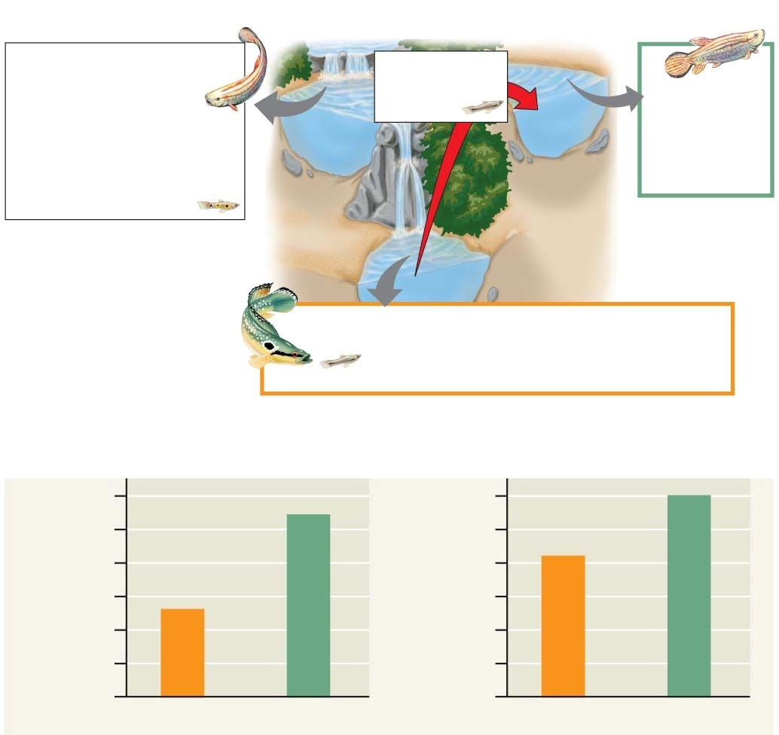

16. What is the role of *3TC* in inhibiting HIV reproduction?

17. Explain the evolution of drug resistance to *3TC*.

18. Do antibiotics cause bacteria to become resistant? Explain your response.

19. Let’s make a list of the four evidences for evolution that are described in this concept.

|  |
| --- |
| **Evidence for Evolution** |
|  |
|  |
|  |
|  |

20. How does the fossil record give evidence for evolution?

21. What is meant by each of the following terms? Give an example of each.

|  |  |
| --- | --- |
| **Term** | **Example** |
| *Homologous structures* |  |
| *Vestigial structures* |  |
| *Analogous structures*  (see p. 465) |  |

22. How do *homologous structures* give evidence for evolution?

23. What is summarized in an *evolutionary tree*?

24. Figure 22.19 shows an evolutionary tree. What is indicated by each branch point? Mark each branch point.

25. What is indicated by the hatch marks?

26. Use the tree below to answer this question: Are crocodiles more closely related to lizards or to birds? Explain your response.

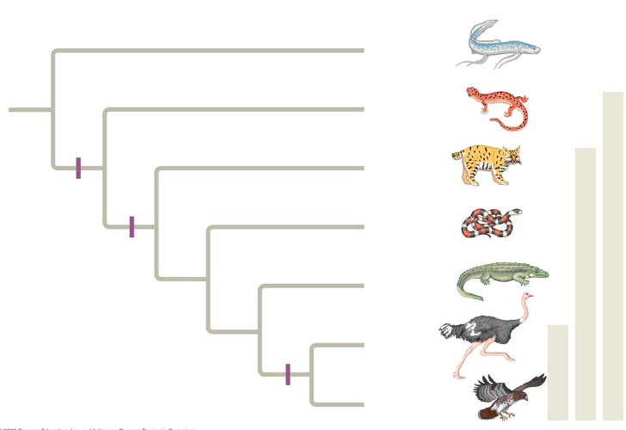

27. On the evolutionary tree, label the vertical lines to the right, and annotate the key feature that marks each group.

28. Organisms that are only distantly related can resemble each other. Explain *convergent evolution*, and describe how *analogous structures* can arise.

29. *Convergent evolution* might be summarized like this: *Similar problem, similar solution*. Can you give two examples of convergent evolution

30. What is *biogeography*? How is it affected by *continental drift* and the presence of *endemic species*?