The fields of hospitality and tourism are prospering industries. In this course students will learn how to apply management skills to an industry setting. To broaden their culinary interests, students will also study creative dishes from around the world. If available, students will begin job shadowing and performing tasks in a restaurant/hotel setting.

In this class students explore the different careers that the fields of culinary, hospitality and tourism offer. With the assistance of field trips and guest speakers, they will learn to understand the scientific principles of nutrition, the relationship of nutrition to health and wellbeing, and careers related to food preparation, food safety and sanitation, meal management, food purchasing, and food in culture. Students also study the science behind food and nutrition, food around a wide range of careers, dietetics and nutrition, as well as food service, management of time and materials, and hospitality.

Food and Nutrition

Students in this course receive a more in-depth instruction of sanitation, nutrition, food preparation, presentation, and hospitality and tourism careers. Students will learn to manage communication with their team and with catering clients as well as other management skills that are important to the industry. Students will participate in various cooking/food preparation competitions to earn money and scholarships. This course will ultimately prepare students to enter into 

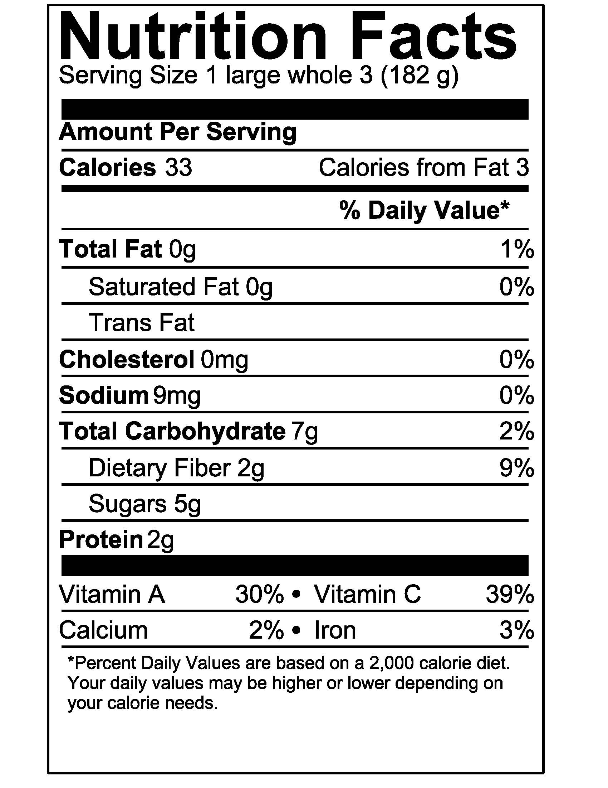

\*Disclaimer: Courses are subject to change based on the needs of the students and/or the availability of course materials. Job shadowing/internships are not guaranteed and will only be offered if and when available.

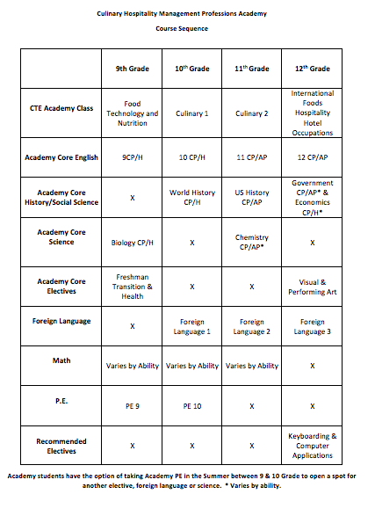

International Foods/ Hospitality Hotel Occupations

Culinary Arts 1

entry-level positions in food service, hospitality, and tourism.



explore various aspects of hospitality and tourism careers by participating in industry tours and interviews.

In this course students will continue to explore the science, nutrition, and preparation of different foods from many different cultures. Students will learn the basics of sanitation, food preparation, and presentation through practice. Students will practice management of teams and work space. They will begin to work towards participating in culinary competitions where they can earn money and scholarships for presenting their projects to industry professionals. Students will work towards a ServSafe certificate and food handler’s card that prepares and certifies them to enter into a culinary occupation at local restaurants. Students also

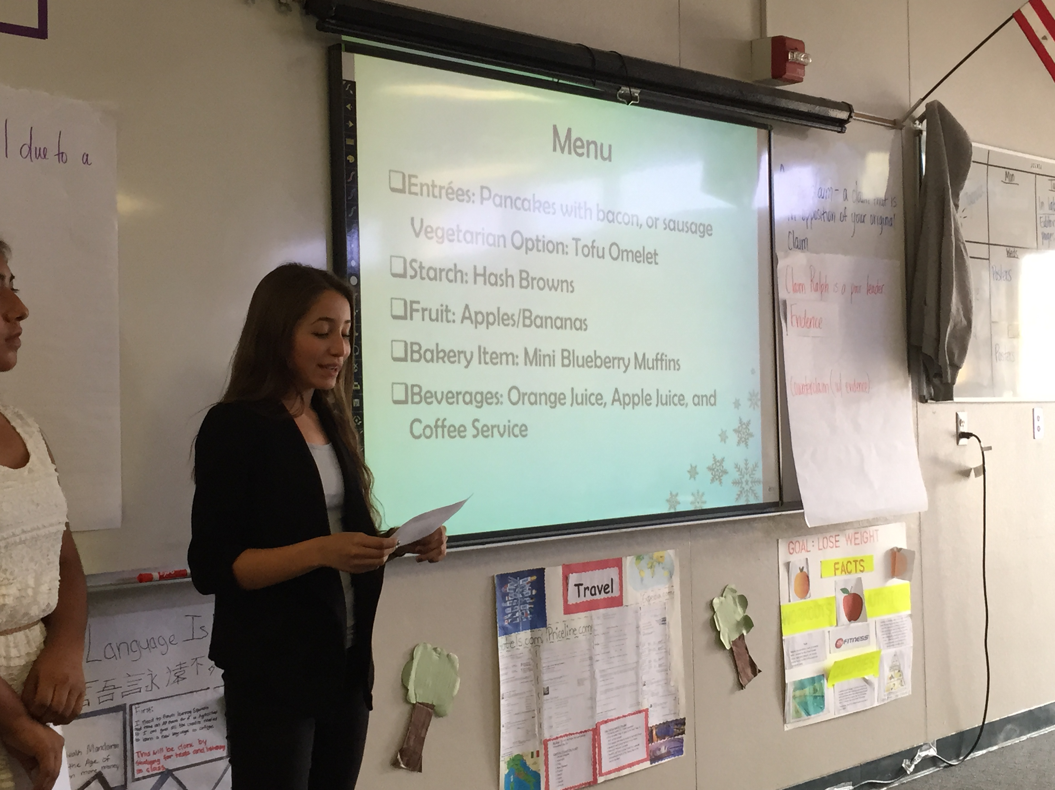

Culinary Arts 2