Personal Mission Statement Overview

When working on anything, it is always best to have an end, or a goal, in mind. This is especially true for your life, and if you have ever thought about what you want to be when you grow up, then you are already familiar this principle. One way to get you thinking about the future is to create a Personal Mission Statement, which is like a credo or motto that states what your life is all about. In a way, it is like a blueprint for your life. Many countries have constitutions which function just like mission statements. Companies like Apple, Amazon, and Cocoa Cola have mission statements, but they work best with people.

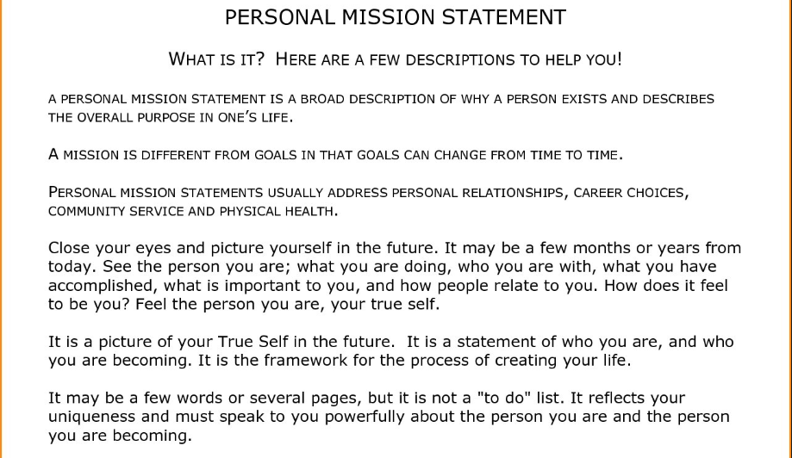

PERSONAL MISSION STATEMENT DEVELOPMENT

To create your Personal Mission Statement, please complete the following items and type responses on Google Docs:

**I. Personal Inventory**

A. List Your Strengths

B. List Your Weaknesses/Growth Areas

C. List Your Talents & Abilities

D. List Your Hobbies & Interests

List things you love to do. It could be singing, dancing, playing sports or

video games, reading, drawing…anything you absolutely love to do!

**II. Vision for the Future**

Write a brief paragraph about the following prompt:

**“When I Grow Up, I Want to...”**

(What is your dream college and why? What career do you envision and why? Where is your ideal place to live and why? What are your plans for a family? How will you make a positive impact on the lives of others?)

**III. Discovery Questions**

1. Think of a person who has made a positive difference in your life. Who is that person, and what qualities, or characteristics, does the person have that you would like to develop yourself?
2. Imagine 20 years from now—you are surrounded by the most important people in your life. Who are they, and what are you all doing?
3. If a steel beam, six inches wide, were stretched across two skyscrapers hundreds of feet in the air, for what reason would you be willing to walk across from one side to the other? A thousand dollars? A million dollars? Not for all the money in the world? Your pet? Your brother or sister? To become famous? Something or someone else? Think carefully!
4. If you could spend one day in a great library studying anything you wanted, what would you study and why?
5. Describe a time when you were deeply moved or inspired.
6. Five years from now your local television station does a story about you, and they want to interview three people: a parent, a sibling, and a friend. What would each one of them say about you?
7. Think of something that represents you…a symbol, a particular song, a famous quote, an animal. Why and how does it represent you?
8. If you could spend an hour with any person who ever lived, who would that be, why would you choose that person, and what would you ask him or her?

**IV. Values & Purpose Assessment (Circle any that apply)**

**THINGS THAT MATTER MOST TO ME:**

Family Wealth Hobbies Service Athletics Fitness

Education Reading Health Creativity Social Media Music/Art

Friendships Beauty Spirituality Fulfillment Community Creating Memories

Popularity School Charity Wisdom Contribution Fun/Enjoyment

Nature Experiences Pets Relationships Video Games Technology

**THE PRINCIPLES I WILL USE TO GUIDE MY LIFE ARE…**

Responsibility Innovation Respect Commitment Patriotism Trust Grit

Humility Diversity Empathy Courage Organization Passion Choice

Consideration Cooperation Change Compassion Character Gratitude Love Competence Hard Work Service Honesty Challenge Faith Service

Integrity Honor Learning Humor Purpose Obedience Loyalty

**I WILL MAKE A CONTRIBUTION AND ENJOY LIFE BY/THROUGH…**

Creativity Leadership Athletics Charity Dance Engineering

Persistence Friendliness Writing Building Public Speaking Reading

Teaching Mathematics Patience Selling Science Communication

Humor Art/Music Reasoning Analysis Vision Mechanical Ability

Positivity Organization Enthusiasm Counseling Technical Ability Strategic Thinking

**MY KEY PERSONAL AND PROFESSIONAL ROLES ARE…**

Family Member Student Friend Leader Community Member

Church Member Volunteer Classmate Team Member ___________________

**MY RESPONSIBILITIES ARE/WILL BE...**

Inspire Work Entertain Empower Support Share

Direct Serve Develop Counsel Enjoy Comfort Others

Earn Learn Help Teach Lead Discover

Impact Love Model Invent Study Build Friendships Facilitate Change Maximize My Potential Succeed Reach My Goals

**V. Personal Mission Statement Rough Draft**

Your draft should include…

**VALUES:** What kind of person do I want to be?

**BEHAVIORS:** What is it I want to do/experience in my life?

**TANGIBLES & INTANGIBLES** What do I want to earn in my life?

**I WILL LIVE WITH PURPOSE IN THE FOLLOWING KEY ROLES OF LIFE:**

As a *_________________*, I will ________­­­______, _______________, and ______________.

As a_________________, I will ________­­­_______, _______________, and ______________.

As a_________________, I will ________­­­_______, _______________, and _________________.

The things that **matter most** to me are ______________, _________, _________, _________, and _____________.

The **principles** I will use to guide my life are_________, _________, _________, _________, and _______.

I will **make a contribution** and enjoy life by using my **talents** of _________, _________, and _____________.

I will **live with purpose** in the following key **roles** of life:

As a **[role],** I will **[responsibilities]** _________, _________, and _________.

**VI. Final Project Poster**

A. Mission Statement

Values

Behaviors

Tangibles & Intangibles

Goals/Purpose

B. Acrostic

1. Name

2. Important character traits

C. Collage

1. Hobbies & Interests

2. Values

3. Goals for the Future

D. Life Quote

**VII. Essay**

As a culmination of the Personal Mission Statement activity, use the following prompt to write a 5-paragraph essay:

**Who am I now, and who do I wish to become in the future?**

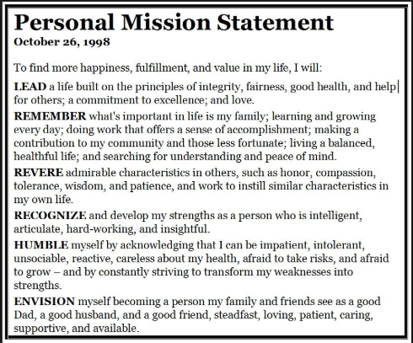

Personal Mission Statement Scoring Rubric

/08 Personal Inventory

_____Strengths

_____Weaknesses

_____Talents & Abilities

_____Hobbies & Interests

/03 Vision for the Future

/24 Discovery Questions

_____Q1

_____Q2

_____Q3

_____Q4

_____Q5

_____Q6

_____Q7

_____Q8

/05 Values & Purpose Assessment

/35 Project

/15 Mission Statement

/05 Acrostic

/05 Quote

/10 Collage

/25 Essay

/20 Content

/05 Introduction

/10 Body

/05 Conclusion

/05 Mechanics

Spelling

_____Punctuation

_____Grammar

