**Chapter 40**

**Basic Principles of Animal Form and Function**

***Lecture Outline***

**Overview: Diverse Forms, Common Challenges**

• Despite their great diversity, all animals must solve a common set of problems.

o All animals must obtain oxygen, nourish themselves, fight off infection, and produce offspring.

o Animals of diverse evolutionary histories and varying complexity must meet these same general challenges of life.

• Natural selection has fit anatomical structure to function by selecting, over many generations, the best of the available variations in a population that meets the animal’s needs.

o The solution to the challenges of survival frequently results in a close match of form to function.

o Examining **anatomy** (biological form) often provides clues to **physiology** (biological function)**.**

• Consider the outer ears of the jackrabbit, which are thin and very large.

• These ears provide the hare with an acute sense of hearing, thereby reducing the risk of predation.

• Researchers have also noted that a jackrabbit’s large ears turn pale when the air temperature exceeds 40°C, its normal body temperature.

• The color change reflects a temporary narrowing of blood vessels as an adaptive response to a hot environment.

o With their blood supply reduced, the ears can absorb heat without overheating the rest of the body.

o When the air temperature cools, blood flow inreases, and the large ears help release excess heat.

**Concept 40.1 Animal form and function are correlated at all levels of organization**

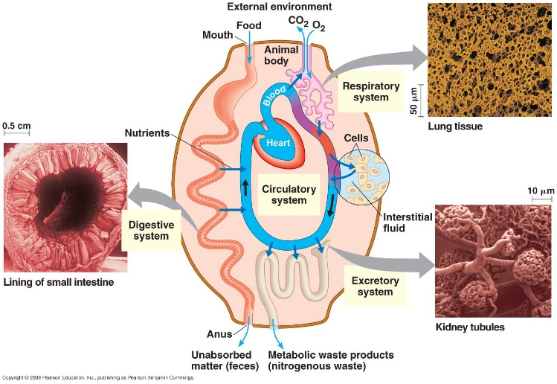• An animal’s size and shape are fundamental aspects of form that significantly affect the way the animal interacts with its environment.

o Using the terms “body plan” and “design” to refer to animal size and shape does not mean that animal body form is a product of conscious invention.

o The body plan or design of an animal results from a pattern of development programmed by the genome, itself the product of millions of years of evolution due to natural selection.

***Physical constraints limit the range of possible animal sizes and shapes.***

* Physical laws that govern strength, diffusion, movement, and heat exchange limit the range of animal forms.

• Similarly, the laws of hydrodynamics constrain the shapes that are possible for aquatic organisms that swim very fast.

o Water is a thousand times denser than air and far more viscous.

o Any bump on the body surface that causes drag impedes a swimmer more than a flyer or runner.

• Tunas, sharks, penguins, dolphins, and seals are all fast swimmers, and all have the same basic fusiform shape, tapered at both ends.

o This shape minimizes drag in water.

• The similar forms of speedy fishes, birds, and marine mammals are a consequence of convergent evolution in the face of the universal laws of hydrodynamics.

o Convergence occurs because natural selection shapes similar adaptations when diverse organisms face the same environmental challenge, such as overcoming drag during swimming.

• Physical laws also constrain the maximum size of animals.

• As body dimensions increase, a thicker skeleton is required to maintain adequate support.

• In addition, as bodies increase in size, the muscles required for locomotion represent an increasing fraction of the total body mass.

• At a certain size, mobility becomes limited.

o By considering the fraction of body mass in leg muscles and the effective force such muscles generate, scientists can estimate the maximum running speed for a wide range of body plans.

o For instance, the dinosaur *Tyrannosaurus rex*, over 6 meters tall, probably reached top speeds of 30 km/hr, about the speed of a fast human.

***Body size and shape affect interactions with the environment.***

• An animal’s size and shape have a direct effect on how the animal exchanges materials with

its surroundings.

• As a requirement for maintaining the fluid integrity of the plasma membrane of its cells, an animal’s body must be arranged so that all of its living cells are bathed in an aqueous medium.

• Exchange with the environment occurs as dissolved substances diffuse and are transported across the plasma membranes between the cells and their aqueous surroundings.

• The rates of exchange of nutrients, wastes, and gases are proportional to the membrane surface area, while the amount of material that must be exchanged is proportional to cell volume.

o For example, a single-celled protist living in water has a sufficient surface area of plasma membrane to service its entire volume of cytoplasm.

o Surface-to-volume ratio is one of the physical constraints on the size of single-celled protists.

• Multicellular animals are composed of microscopic cells, each with its own plasma membrane across which exchange must occur.

• This exchange works only if all the cells of the animal have access to a suitable aqueous environment, inside or outside the body

For example, a hydra, built like a sac, has a body wall only two cell layers thick.

o Because its gastrovascular cavity opens to the exterior, both outer and inner layers of cells are bathed in water.

• Another way to maximize exposure to the surrounding medium is to have a flat body.

o For instance, a parasitic tapeworm may be several meters long, but because it is very thin,

most of its cells are bathed in the intestinal fluid of the worm’s vertebrate host from

which it obtains nutrients.

• Although two-layered sacs and flat shapes are designs that put a large surface area in contact with the environment, these solutions do not permit much complexity in internal organization.

• The bodies of most animals are composed of compact masses of cells, with outer surfaces

that are relatively small compared to the animal’s volume.

• Most organisms have extensively folded or branched internal surfaces specialized for exchange with the environment.

o In humans, the digestive, respiratory, and circulatory systems have exchange surfaces within the body that are 25 times the area of the skin.

• Internal body fluids link exchange surfaces with body cells.

o In vertebrates, **interstitial fluid** fills the spaces between cells.

o Complex body plans also include a circulatory fluid such as blood.

o Exchange between the interstitial fluid and circulatory fluids enables cells throughout the body to obtain nutrients and get rid of wastes.

• Although exchange with the environment is a problem for animals whose cells are mostly internal, complex forms have distinct benefits.

o A specialized outer covering can protect against predators; sensory organs can provide detailed information about the animal’s surroundings; specialized filtration systems can adjust the composition of the internal fluids that bathe animal body cells; and internal digestive organs can break down food gradually, controlling the release of stored energy.

• Through exchange, a complex animal can maintain a stable internal environment while living in a variable external environment.

o A complex body form is especially well suited to life on land, where the external environment may be variable.

***Animals are multicellular organisms with their specialized cells grouped into tissues.***

• Life is characterized by hierarchical levels of organization, each with emergent properties.

• In most animals, combinations of various **tissues** make up functional units called **organs**, and groups of organs work together as **organ systems**.

o For example, the skin is an organ of the integumentary system, which protects against infection and helps regulate body temperature.

o Organs may contain tissues that have different physiological roles. Organs such as the pancreas may belong to more than one organ system.

• Tissues are classified into four main categories: epithelial tissue, connective tissue, muscle tissue, and nervous tissue.

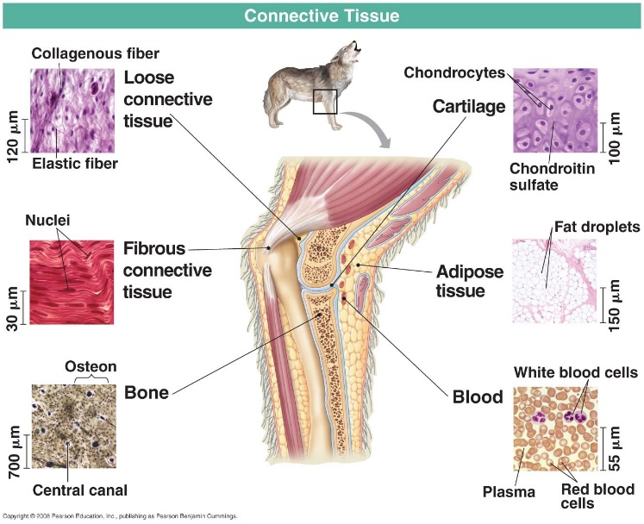• Occurring in sheets of tightly packed cells, **epithelial tissue** covers the outside of the body and lines organs and cavities within the body.

The cells of an epithelium are closely joined, and in many epithelia, the cells are riveted together by tight junctions.

• The epithelium functions as a barrier protecting against mechanical injury, invasive microorganisms, and fluid loss.

• The cells of epithelial tissue also form active interfaces with the environment.

o For example, the epithelia that line the nasal passages function in olfaction.

• The shape of cells on the exposed surface may be *cuboidal* (like dice), *columnar* (like bricks on end), or *squamous* (flat like floor tiles).

• Epithelia are classified by the number of cell layers and the shape of the cells on the free surface.

o A *simple epithelium* has a single layer of cells, and a *stratified epithelium* has multiple tiers of cells.

o A *pseudostratified epithelium* is single-layered but appears stratified because the cells vary in length.

• **Connective tissue** functions mainly to bind and support other tissues.

• Connective tissues have a sparse population of cells scattered through an extracellular matrix.

• The matrix generally consists of a web of fibers embedded in a uniform foundation that may be liquid, jellylike, or solid.

• The variation in matrix structure is reflected in the six major types of connective tissue in vertebrates: loose connective tissue, cartilage, fibrous connective tissue, adipose tissue, blood, and bone.

• There are three kinds of connective tissue fibers, which are all proteins: collagenous fibers, elastic fibers, and reticular fibers.

• *Collagenous fibers* provide strength with flexibility.

o Collagenous fibers are made of collagen, the most abundant protein in the animal kingdom.

o Collagenous fibers are nonelastic and do not tear easily when pulled lengthwise.

• *Elastic fibers* are long threads of elastin that are easily stretched but also resilient.

o Elastin fiber has a rubbery quality that complements the nonelastic strength of collagenous fibers.

• *Reticular fibers* are very thin and branched.

o Composed of collagen and continuous with collagenous fibers, reticular fibers form a tightly woven fabric that joins connective tissue to adjacent tissues.

• The connective tissue that holds many tissues and organs together contains scattered cells of varying functions.

o **Fibroblasts** secrete the protein ingredients of the extracellular fibers.

o **Macrophages** are amoeboid cells that roam the maze of fibers, engulfing bacteria and the debris of dead cells by phagocytosis.

• **Muscle tissue** is responsible for body movement.

• All muscle cells consist of filaments containing the proteins actin and myosin.

• Muscle is the most abundant tissue in most animals, and muscle contraction accounts for most of the energy-consuming cellular work in active animals.

• The three types of muscle tissue in the vertebrate body are skeletal muscle, cardiac muscle, and smooth muscle.

**Nervous tissue** senses stimuli and transmits signals in the form of nerve impulses from one part of the animal to another.

• The functional unit of nervous tissue is the **neuron,** or nerve cell, which includes extensions called axons that are uniquely specialized to transmit nerve impulses.

• Nervous tissues also include **glial cells,** or **glia**, which nourish, insulate, and replenish neurons.

• In many animals, nervous tissue is concentrated in a brain, an information-processing center.

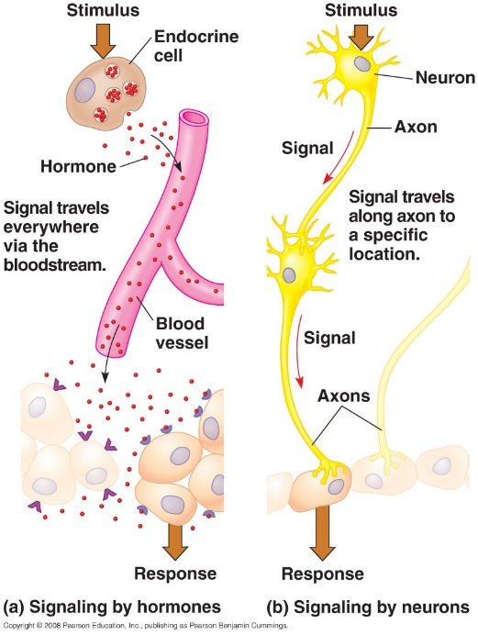***The nervous and endocrine systems provide animal bodies with coordination and control.***

• Animals require coordination of tissues, organs, and organ systems.

• Coordination of activity across the body requires communication.

• Animal bodies have two major systems for control and coordination: the endocrine system and the nervous system.

o In the endocrine system, signals released into the bloodstream by endocrine cells reach all locations in the body.

o In the nervous system, neurons transmit signals, called nerve impulses, between specific locations.

• The endocrine system broadcasts chemical signals called **hormones** throughout the body.

• Different hormones cause distinct effects, and only cells that have receptors for a particular hormone respond.

• A hormone may have an effect in a single location or in sites throughout the body.

o For example, only cells of the thyroid gland have the receptor for thyroid-stimulating hormone (TSH).

o Upon binding TSH, thyroid cells release thyroid hormone, which acts directly on cells in nearly every tissue to increase oxygen consumption and heat production.

• Hormones are relatively slow-acting and long-lasting.

• In the nervous system, nerve impulses travel to specific target cells along a dedicated communication line, consisting mainly of neuron extensions called axons.

o Only four types of cells receive nerve impulses: other neurons, muscle cells, endocrine cells, and exocrine cells.

• The nervous system conveys information by the *pathway* the signal takes.

o For example, a person can distinguish different musical notes because each note’s

frequency activates different neurons connecting the ear to the brain.

• Nerve impulses travel within axons, sometimes over long distances, as changes in voltage.

o Passing signals from one neuron to another involves very short-range chemical signals.

• Nervous transmission is extremely fast and short-lived. Nerve impulses take only a fraction of a second to reach the target and last only a fraction of a second.

• Because the two major communication systems of the body differ in signal type, transmission, speed, and duration, they are adapted to different functions.

o The endocrine system is well suited for coordinating gradual changes that affect the entire body, such as growth and development, reproduction, metabolic processes, and digestion.

o The nervous system is well suited for directing immediate and rapid responses to the environment, especially in controlling fast locomotion and behavior.

Both systems contribute to maintaining a stable internal environment.

**Concept 40.2 Feedback control maintains the internal environment in many animals**

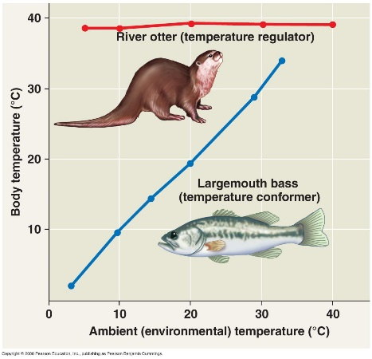• Faced with environmental fluctuations, animals must manage their internal environments.

Animals may be regulators or conformers for a particular environmental variable.

• An animal is a **regulator** for a particular environmental variable if it uses internal control mechanisms to moderate internal change while external conditions fluctuate.

o For example, a river otter is a regulator for temperature, keeping its body at a temperature that is largely independent of the water in which it swims.

• An animal is a **conformer** for a particular environmental variable if it allows its internal condition to vary as external conditions fluctuate.

o For example, a largemouth bass conforms to the temperature of the lake it swims in.

o Some animals conform to constant environments. For example, many marine invertebrates let their internal solute concentration conform to the relatively stable solute concentration (salinity) of the ocean.

• Regulating and conforming represent extremes on a continuum of how animals deal with environmental fluctuations.

• An animal may maintain homeostasis while regulating some internal conditions and allowing others to conform to the environment.

o For example, most freshwater fishes regulate their internal solute concentration but allow their internal temperature to conform to external water temperature.

• **Homeostasis** is a general process by which organisms maintain a “steady state” or internal balance.

• Through homeostasis, animals maintain a relatively constant internal environment, even when the external environment varies.

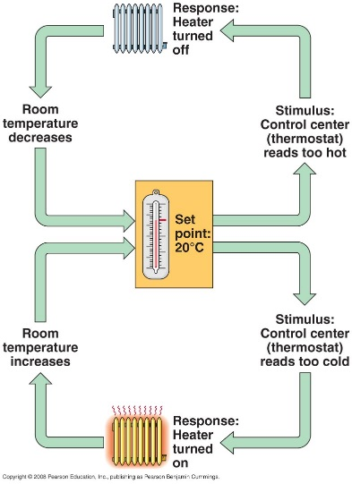• Animal bodies achieve homeostasis by maintaining a variable, such as body temperature or solute concentration, at or near a particular value or **set point**.

• Fluctuations in the variable above or below the set point serve as the **stimulus**.

• A receptor, or **sensor**, detects the stimulus.

o Upon receipt of a signal from the sensor, a *control center* generates output that triggers a

**response**, a physiological activity that helps return the variable to the set point.

• Homeostasis in animals relies largely on **negative feedback**, a control mechanism that

reduces or “damps” the stimulus.

• Homeostasis limits—but does not eliminate—changes in the internal environment.

• Additional fluctuation occurs if a variable has a *normal range* rather than a single set point.

• Although positive feedback loops also occur in animals, they do not usually contribute to homeostasis.

• Unlike negative feedback, **positive feedback** is a control mechanism that amplifies rather than reduces the stimulus.

o Positive feedback loops in animals do not play a major role in homeostasis, but instead help drive processes to completion.

For example, during childbirth, the pressure of the baby’s head against receptors near the opening of the mother’s uterus stimulates uterine contractions.

o These contractions cause greater pressure against the uterine opening, heightening the contractions, which cause still greater pressure.

o Positive feedback brings childbirth to completion, a very different sort of process from maintaining a steady state.

• While some aspects of the internal environment are maintained at a set point or within a normal group, *regulated change* is essential to normal body functions.

o Some regulated changes are associated with a particular stage of life, such as the changes in hormone levels that occur with puberty.

o In some cases, the changes are cyclical, such as the variation in hormone levels during menstrual cycles.

• In many organisms, cyclic alterations in metabolism reflect a circadian rhythm, a set of physiological changes that occur roughly every 24 hours.

o For example, your body temperature typically undergoes a cyclic rise and fall of more than 0.6°C in every 24-hour period.

o A circadian rhythm is intrinsic to the body, although the biological clock is normally coordinated with the cycle of light and darkness in the environment.

• The normal range of homeostasis may change by **acclimatization**, a process by which an animal adjusts to changes in its external environment.

• When a mammal moves from sea level to a much higher elevation, changes that occur over several days facilitate activity at lowered concentrations of oxygen.

o The lower oxygen concentration in the air stimulates the animal to breathe more rapidly and deeply.

o It loses more CO2 through exhalation, raising blood pH above its set point.

o As the animal acclimatizes, changes in kidney function result in excretion of more alkaline urine, returning blood pH to its normal range.

o Other changes during acclimatization include increased production of red blood cells, which carry oxygen.

• Acclimatization, which is a temporary change during an animal’s lifetime, is different from adaptation, a process of change brought about by natural selection acting over many generations.

**Concept 40.3 Homeostatic processes for thermoregulation involve form, function, and behavior**

• **Thermoregulation** is the process by which animals maintain their internal temperature within a tolerable range.

• Thermoregulation is critical to survival because most biochemical and physiological processes are very sensitive to changes in body temperature.

• The rates of most enzyme-mediated reactions increase by a factor of 2 or 3 for every 10°C

temperature increase, until proteins start to lose activity.

o For example, the oxygen carrier hemoglobin becomes less effective at binding oxygen as temperature increases.

• The properties of membranes also change with temperature, becoming increasingly fluid or rigid as temperatures rise or fall.

Although different species of animals are adapted to different environmental temperatures, each species has an optimal temperature range.

• Thermoregulation helps keep body temperature within the optimal range, enabling cells to function effectively as external temperature fluctuates.

***Ectotherms and endotherms manage their heat budgets very differently.***

• Internal metabolism and the external environment are the sources of heat for thermoregulation.

• **Endothermic** animals, such as birds and mammals, use metabolic heat to regulate their body temperature.

• **Ectothermic** animals, such as snakes and most fishes, gain most of their heat from the external environment.

• Animals that are mainly endothermic are called endotherms, while those that are mainly ectothermic are called ectotherms.

o Endothermy and ectothermy are not mutually exclusive thermoregulatory strategies.

o A bird is an endotherm but may warm itself in the sun on a cold morning, just as a lizard does.

• Endothermy and ectothermy are not mutually exclusive modes of thermoregulation.

o A bird is mainly endothermic, but it may warm itself in the sun on a cold morning, much as an ectothermic lizard does.

• Endothermic animals can maintain stable body temperatures in the face of temperature fluctuations in the external environment.

o Many endotherms—but few ectotherms—are active at below-freezing temperatures.

o In a cold environment, an endotherm can generate enough heat to keep its body substantially warmer than its surroundings.

o In a hot environment, an endotherm has mechanisms to cool its body.

• Because their heat source is primarily the external environment rather than internal metabolism, ectotherms require much less food than endotherms of equivalent size.

o Ectotherms usually tolerate larger fluctuations in their internal temperatures.

o Many ectotherms adjust their body temperature by behavioral means—by seeking out shade or basking in the sun.

• Ectothermy is an extremely effective and successful strategy in most of Earth’s environments,

as evidenced by the abundance and diversity of ectothermic animals.

***Animals can have either a variable or constant body temperature.***

• An animal with a body temperature that varies with its environment is called a *poikilotherm*.

• A *homeotherm* is an animal that maintains a relatively stable internal temperature.

• There is no fixed relationship between the source of body heat and the stability of body temperature.

o For example, many ectothermic marine fishes and invertebrates live in water with very stable temperature. Their body temperature varies less than that of endotherms.

o Some endotherms have variable body temperatures. Bats and hummingbirds sometimes enter an inactive state with lowered temperature.

• It is a common misconception that ectotherms are “cold-blooded” and endotherms are

“warm-blooded.”

Biologists avoid the terms *cold-blooded* and *warm-blooded* because they are misleading.

o Ectotherms do not necessarily have low body temperatures.

o While sitting in the sun, many ectothermic lizards have higher body temperatures than mammals.

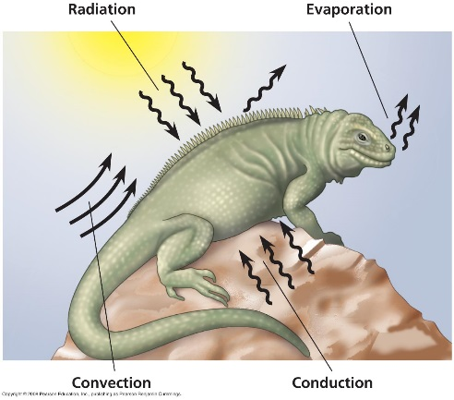

***Animals regulate the exchange of heat with their environment.***

• Animals exchange heat with their external environment through four physical processes:

radiation, evaporation, convection, and conduction.

• Heat is always transferred from a hotter object to a cooler object.

• The essence of thermoregulation is maintaining rates of heat gain that equal rates of heat loss.

• Animals accomplish thermoregulation through mechanisms that reduce heat exchange overall or mechanisms that favor heat exchange in a particular direction.

• In mammals, several of these mechanisms involve the **integumentary system**, including the skin, hair, and nails.

• A major thermoregulatory adaptation in mammals and birds is **insulation**: hair, feathers, or fat layers.

o Insulation reduces the flow of heat between an animal and its environment and lowers the energy cost of keeping warm.

• The insulating power of a layer of fur or feathers depends mostly on how much air the layer traps.

o Land mammals and birds react to cold by raising their fur or feathers to trap a thicker layer of air.

o Human “goose bumps” are a vestige of our hair-raising ancestors.

o Hair loses most of its insulating power when wet. To repel water that would reduce the insulating capacity of feathers or fur, animals secrete oily substances.

• Marine mammals swim in water colder than their body core temperature, and many species spend at least part of the year in near-freezing polar seas.

o Transfer of heat to water occurs 50 to 100 times more rapidly than heat transfer to air.

• Just under the skin, marine mammals have a very thick layer of insulating blubber.

• The skin temperature of a marine mammal is close to water temperature. However, blubber insulation is so effective that marine mammals can maintain body core temperatures of 36–

38°C without requiring more food energy than an equivalent-sized land mammal.

• Many endotherms and ectotherms can alter the amount of blood flow between the body core and the skin.

• Elevated blood flow in the skin results from *vasodilation*, an increase in the diameter of superficial blood vessels near the body surface.

o Vasodilation is triggered by nerve signals that relax the muscles of the vessel walls.

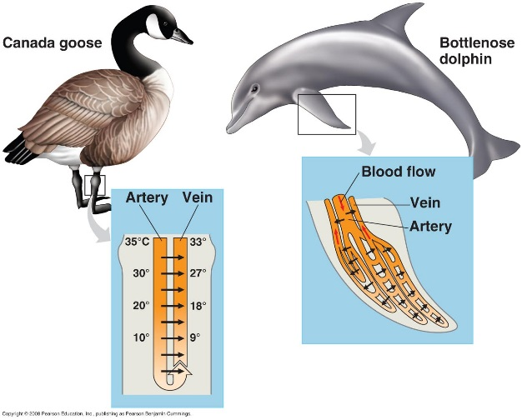o In endotherms, vasodilation usually warms the skin, increasing the transfer of body heat to a cool environment.

• The reverse process, *vasoconstriction***,** reduces blood flow and heat transfer by decreasing the diameter of superficial vessels.

• Another circulatory adaptation is **countercurrent exchange**, the transfer of heat or solutes in between fluids that flow in opposite directions.

• In a countercurrent heat exchanger, arteries and veins are located adjacent to each other.

As warm blood moves from the body core through the arteries, heat transfers to the colder venous blood returning from the extremities.

• Heat transfer occurs along the entire length of the exchanger.

• Some bony fishes, sharks, and insects also use countercurrent heat exchange.

o Such fishes include large, powerful fishes such as bluefin tuna, swordfish, and great white sharks.

o By keeping the main swimming muscles several degrees warmer than the surface tissues, this adaptation allows vigorous, sustained activity.

• Many endothermic insects (bumblebees, honeybees, and some moths) have a countercurrent exchanger that maintains a high temperature in the thorax, where the flight muscles are located.

• In some species, blood can either go through the heat exchanger or bypass it.

o The relative amount of blood that flows through the two paths varies, adjusting the rate of

heat loss as the animal’s physiological state or environment changes.

o In some insects, the countercurrent mechanism can be “shut down” to allow heat to be

shed during hot weather.

• Many mammals and birds live in places where thermoregulation requires cooling as well as warming.

• If the environmental temperature is above body temperature, evaporation is the only way to keep body temperature from rising.

• Terrestrial animals lose water by evaporation across the skin and respiratory surfaces.

• Water absorbs considerable heat when it evaporates; this heat is carried away from the body surface with the water vapor.

• Some animals have adaptations to augment evaporative cooling.

o Panting is important in birds and many mammals.

o Some birds have a pouch richly supplied with blood vessels in the floor of the mouth.

Birds flutter the pouch to increase evaporation.

o Sweating or bathing moistens the skin and enhances evaporative cooling.

o Many terrestrial mammals have sweat glands controlled by the nervous system.

***Many endotherms and ectotherms use behavioral responses to control body temperature.***

• Many ectotherms can maintain a constant body temperature by simple behaviors, such as hibernating or migrating to a more suitable climate.

• All amphibians are ectothermic organisms that control body temperature mainly by behavior—by moving to a location where solar heat is available or by seeking shade.

• Reptiles other than birds also thermoregulate behaviorally.

o When cool, they seek warm places, orient themselves toward a heat source, and expand the body surface exposed to the heat source.

o When hot, they move to cool places or turn away from the heat source.

• Many terrestrial invertebrates use similar behavioral mechanisms.

• The desert locust must reach a certain temperature to become active, and on cold days it orients in a direction that maximizes the absorption of sunlight.

• Honeybees use a thermoregulatory mechanism that depends on social behavior.

In cold weather, honeybees increase their heat production and huddle together to retain heat.

• Honeybees expend considerable energy to keep warm during long periods of cold weather.

o This is the main function of the honey stored in the hive.

o Honeybees also cool the hive in hot weather by transporting water to it and fanning it with their wings to promote evaporation and convection.

***Endotherms vary heat production to counteract constant heat loss.***

• Because endotherms generally maintain their body temperatures above environmental temperatures, they must counteract constant heat loss by varying heat production *(thermogenesis)*.

• For example, endotherms may increase thermogenesis through muscle activity such as moving or shivering.

o Shivering helps chickadees, which weigh only 20 g, remain active with a body temperature of 40°C in environmental temperatures as low as -40°C, as long as they have adequate food.

• Certain mammalian hormones can cause mitochondria to increase their metabolic activity and produce heat instead of ATP.

o This *nonshivering thermogenesis* takes place throughout the body.

• Some mammals have *brown fat* in the neck and between the shoulders that is specialized for rapid heat production.

o In humans, brown fat is absent in adults but plays an important role in infants, for whom it represents about 5% of total body weight.

• Through shivering and nonshivering thermogenesis, mammals and birds may increase their metabolic heat production to five or ten times the minimal levels characteristic during warm weather.

• A few large reptiles can become endothermic in particular circumstances.

o For example, female Burmese pythons that are incubating eggs increase their metabolic rate by shivering, generating enough heat to elevate egg temperatures by 6°C during incubation.

• The smallest endotherms are flying insects such as bees and moths, which can fly even on cold days or at night.

o These insects elevate their body temperature by shivering before taking off.

o They contract their flight muscles in synchrony to produce only slight wing movements but considerable heat.

***Animals can acclimatize to a new range of environmental temperatures.***

• Many animals can adjust to a new range of environmental temperatures by a physiological response called acclimatization.

• Ectotherms and endotherms acclimatize differently.

• In birds and mammals, acclimatization often includes adjusting the amount of insulation.

• Acclimatization responses in ectotherms often include adjustments at the cellular level.

o Cells may increase the production of certain enzymes or produce enzyme variants with different temperature optima.

o Membranes change the proportions of saturated and unsaturated lipids to remain fluid at different temperatures.

Some ectotherms produce “antifreeze” compounds, to prevent ice formation in body

cells.

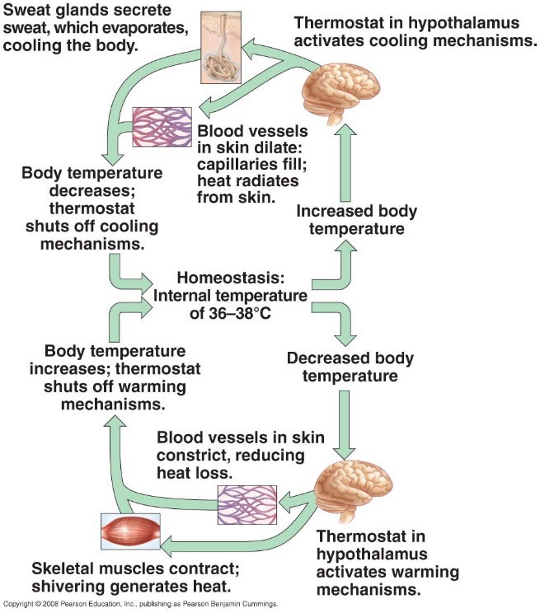

***The regulation of body temperature in humans is a complex system facilitated by feedback mechanisms.***

• Nerve cells that control the rmoregulation (and other aspects of homeostasis) are concentrated in a brain region called the **hypothalamus**.

• A group of nerve cells in the hypothalamus functions as a thermostat.

• If the hypothalamus detects a decrease in the temperature of the blood below the set point, it inhibits heat loss mechanisms and activates heat-saving mechanisms such as vasoconstriction of superficial vessels and erection of fur, while stimulating heat-generating mechanisms such as shivering and nonshivering thermogenesis.

• If the thermostat in the brain detects a rise in the temperature of the blood above the set point, it shuts down heat retention mechanisms and promotes body cooling by vasodilation, sweating, or panting.

• In response to certain bacterial and viral infections, mammals and birds develop fever, an elevated body temperature.

o Fever reflects a change in the set point for the biological thermostat.

• Although only endotherms develop fever, ectotherms exhibit a related response.

o The desert iguana responds to bacterial infection by seeking a warmer environment.

o Similar observations have been made with fishes, amphibians, and even cockroaches.

**Concept 40.4 Energy requirements are related to animal size, activity, and environment**

• All organisms require chemical energy for growth, repair, activity, and reproduction.

• The flow of energy through an animal—its **bioenergetics**—determines how much food it

needs and is related to the animal’s size, activity, and environment.

o Studying an animal’s bioenergetics tells us a great deal about the animal’s adaptations.

o Food is digested by enzymatic hydrolysis, and energy-containing food molecules are absorbed by body cells.

• Organisms can be classified by how they obtain chemical energy.

o Plants use light energy to build energy-rich organic molecules from water and CO2, and then use those organic molecules for fuel.

o In contrast, animals are heterotrophs and must obtain their chemical energy from food, which contains organic molecules synthesized by other organisms.

• Most fuel molecules are used to generate ATP by the catabolic processes of cellular respiration and fermentation.

• The chemical energy of ATP powers cellular work, enabling cells, organs, and organ systems to perform the many functions that keep an animal alive.

• After the energetic needs of staying alive are met, any remaining food molecules can be used in biosynthesis.

• Biosynthesis includes body growth and repair; synthesis of storage material such as fat; and production of reproductive structures, including gametes.

Because the production and use of ATP generate heat, an animal continuously loses heat to its surroundings.

***Metabolic rate may be measured.***

• The amount of energy an animal uses in a unit of time is called its **metabolic rate**—the sum of all the energy-requiring biochemical reactions that occur during a given time interval.

• Energy is measured in joules (J) or in calories (cal) or kilocalories (kcal). (A kilocalorie is

1,000 calories.The term *Calorie,* with a capital *C*, as used by many nutritionists, is actually a

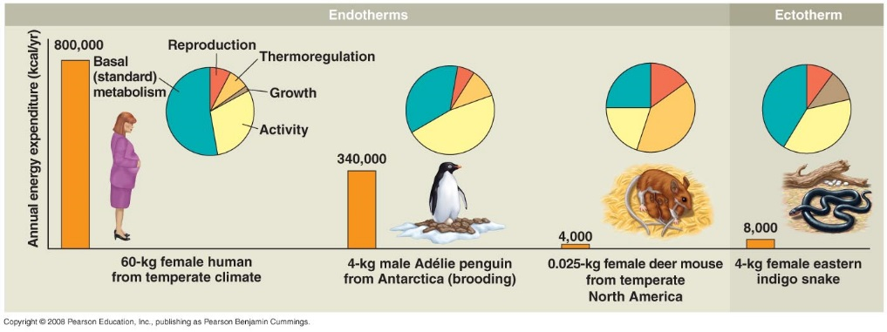kilocalorie.)

• Metabolic rate can be determined in several ways.

• Because nearly all the chemical energy used in cellular respiration eventually appears as heat,

metabolic rate can be measured by monitoring an animal’s heat loss.

o A small animal can be placed in a calorimeter, which is a closed, insulated chamber

equipped with a device that records the animal’s heat loss.

• A more indirect way to measure metabolic rate is to determine the amount of oxygen

consumed or carbon dioxide produced by an animal’s cellular respiration.

o There are devices that measure changes in oxygen consumed or carbon dioxide produced as activity changes.

• Over long periods, the rate of food consumption, the energy content of food, and the chemical energy lost in waste products can be used to estimate metabolic rate.

o A gram of protein or carbohydrate contains about 4.5–5 kcal, and a gram of fat contains 9 kcal.

***Every animal has a range of metabolic rates.***

• Minimal metabolic rates power the basic functions that support life, such as cell maintenance, breathing, and heartbeat.

• The metabolic rate of a nongrowing endotherm at rest, with an empty stomach and experiencing no stress, is called the **basal metabolic rate** (**BMR**).

• In ectotherms, body temperature changes with the temperature of the surroundings, and so does metabolic rate.

• Therefore, the minimal metabolic rate of an ectotherm must be determined at a specific temperature.

• The metabolic rate of a resting, fasting, nonstressed ectotherm is called its **standard metabolic rate** (**SMR**).

• Comparisons of minimal metabolic rates reveal that endothermy and ectothermy have different energy costs.

• The BMR for humans averages about 1,600–1,800 kcal per day for adult males and about

1,300–1,500 kcal per day for adult females.

• In contrast, SMR calculations reveal that an American alligator at rest consumes only about

60 kcal per day at 200C.

o This is less than 1/200th the energy used by a comparably sized adult human.

• Metabolic rate is affected by many other factors as well, including age, sex, size, activity, temperature, and nutrition.

***Body size influences metabolic rate.***

• Larger animals have more body mass and therefore require more chemical energy.

The relationship between overall metabolic rate and body mass is constant across a wide range of sizes and forms.

o From bacteria to blue whales, metabolic rate is roughly proportional to body mass to the three-quarter power (*m*3/4).

• One hypothesis for the inverse relationship between metabolic rate and mass is that the smaller the size of an endotherm, the greater the energy cost of maintaining a stable body temperature.

o The smaller the animal, the higher its surface-to-volume ratio, and thus the greater loss of heat to (or gain from) the surroundings.

o Each gram of a mouse, for instance, requires about 20 times as many calories as a gram of an elephant, even though the whole elephant uses far more calories than the whole mouse.

• A smaller animal’s higher metabolic rate demands a faster rate of oxygen delivery.

• Correlated with its higher metabolic rate per gram, the smaller animal has a higher breathing rate, blood volume (relative to its size), and heart rate (pulse). It also eats more food per unit of body mass.

• Trade-offs shape the evolution of body plans. As body size becomes smaller, each gram of tissue increases in energy cost.

o As body size becomes larger, energy costs per gram of tissue decrease, but an ever-larger fraction of body tissue is required for exchange, support, and locomotion.

***For both ectotherms and endotherms, activity has a large effect on metabolic rate.***

• Any behavior consumes energy beyond the BMR or SMR.

• Maximal metabolic rates (the highest rates of ATP utilization) occur during peak activity, such as lifting heavy weights, all-out running, or high-speed swimming.

• In most terrestrial animals, the average daily rate of energy consumption is 2 to 4 times BMR (for endotherms) or SMR (for ectotherms).

o Humans in most developed countries have an unusually low average daily metabolic rate of about 1.5 times BMR—an indication of relatively sedentary lifestyles.

***Energy budgets reveal how animals use energy and materials.***

• Different species of animals use the energy and materials in food in different ways, depending on their environment, behavior, size, and thermoregulation.

• For example, the typical annual energy “budgets” of four vertebrates reinforce three important concepts in bioenergetics.

1. A small animal has a much greater energy demand per kilogram than does a large animal of the same class.

2. An ectotherm requires much less energy per kilogram than does an endotherm of equivalent size.

3. Size and energy strategy have a great influence on how the total annual energy expenditure is distributed among energetic needs.

• A 60-kg human female spends a large fraction of her energy budget for BMR and comparatively less little for activity and body temperature regulation.

o The cost of nine of pregnancy and several months of breast-feeding amounts to only 5–

8% of the mother’s annual energy requirements.

o Growth amounts to about 1% of her annual energy budget.

A 4-kg male Adélie penguin spends the largest fraction of his energy expenditures for activity because he must swim to catch his food.

o Because the penguin is well insulated and fairly large, he has relatively low costs of thermoregulation despite living in the cold Antarctic environment.

o His reproductive costs, about 6% of annual energy expenditures, come mainly from incubating eggs and bringing food to his chicks.

• A 25-g (0.025-kg) female deer mouse spends a large fraction of her energy budget on temperature regulation.

o Because of the high surface-to-volume ratio that goes with small size, mice lose body heat rapidly to the environment and must constantly generate metabolic heat to maintain their body temperature.

• An ectothermic, 4-kg eastern indigo snake has no thermoregulation costs.

o Like most reptiles, she grows continuously throughout life.

o In one year, she can add 750 g of new body tissue and produce about 650 g of eggs.

o Through the python’s economical ectothermic strategy, she expends only 1/40th the

energy expended by the same-sized endothermic penguin.

***Animals may conserve energy through torpor.***

• Some animals deal with severe conditions by an adaptation called **torpor**, a physiological state in which activity is low and metabolism decreases.

• Many small mammals and birds exhibit a daily torpor that is adapted to their feeding patterns.

o For example, some bats feed at night and go into torpor during daylight hours.

o Chickadees and hummingbirds feed during the day and go into torpor on cold nights.

▪ The body temperature of a hummingbird may drop by 25°C at night.

• All endotherms that use daily torpor are relatively small.

• When active, these endotherms have high metabolic rates and thus very high rates of energy consumption.

• **Hibernation** is long-term torpor that is an adaptation to winter cold and food scarcity.

• When vertebrate endotherms enter torpor or hibernation, their body temperatures decrease.

o Some hibernating mammals cool to 1–2°C, and a few drop slightly below 0°C in a supercooled, unfrozen state.

• Metabolic rates during hibernation may be twenty times lower than if animals tried to maintain normal body temperatures.

o Hibernators can survive for very long periods on limited supplies of energy stored in body tissues or as food cached in a burrow.

• The circadian clock no longer seems to operate during hibernation.

• *Estivation*, or summer torpor, is also characterized by slow metabolism or inactivity and allows animals to survive long periods of high temperatures and scarce water supplies.