Chapter 7 Notes

Overview: Life at the Edge

* The plasma membrane separates the living cell from its surroundings.
* This thin barrier, 8 nm thick, controls traffic into and out of the cell.
* Like all biological membranes, the plasma membrane is **selectively permeable**, allowing some substances to cross more easily than others.
* The formation of a membrane that encloses a solution different from the surrounding solution while still permitting the uptake of nutrients and the elimination of waste products was a key event in the evolution of life.
* The ability of the cell to discriminate in its chemical exchanges with its environment is fundamental to life.
* It is the plasma membrane and its component molecules that make this selectivity possible.

Concept 7.1 Cellular membranes are fluid mosaics of lipids and proteins.

* The main macromolecules in membranes are lipids and proteins, but carbohydrates are also important.
* The most abundant lipids are phospholipids.
* Phospholipids and most other membrane constituents are **amphipathic molecules**, which have both hydrophobic and hydrophilic regions.

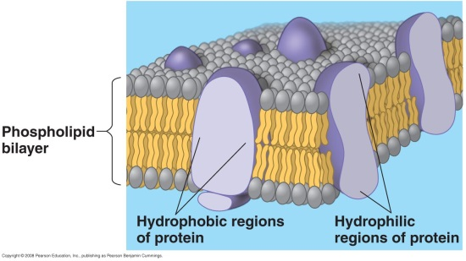Membrane models have evolved to fit new data.

* The arrangement of phospholipids and proteins in biological membranes is described by the **fluid mosaic model**.
* In this model, the membrane is a fluid structure with a “mosaic” of various proteins embedded in or attached to a double layer (bilayer) of phospholipids.
* Models of membranes were developed long before membranes were first seen with electron microscopes in the 1950s.
* In 1915, membranes isolated from red blood cells were chemically analyzed and found to be composed of lipids and proteins.
* In 1925, E. Gorter and F. Grendel reasoned that cell membranes must be phospholipid bilayers.
* The molecules in the bilayer are arranged such that the hydrophobic fatty acid tails are sheltered from water while the hydrophilic phosphate groups interact with water.
* Actual membranes adhere more strongly to water than do artificial membranes composed only of phospholipids.
* In 1935, Hugh Davson and James Danielli proposed a sandwich model in which the phospholipid bilayer lies between two layers of globular proteins.
* Early images from electron microscopes seemed to support the Davson-Danielli model, and until the 1960s, it was widely accepted as the structure of the plasma membrane and internal membranes.
* Further investigation revealed two problems.

1. Not all membranes are alike.

* Membranes with different functions differ in chemical composition and structure.
* The plasma membrane is 7–8 nm thick and has a three-layered structure in electron micrographs, while the inner membrane of the mitochondrion is only 6 nm thick and looks like a row of beads.
* Mitochondrial membranes also have a higher percentage of proteins and differ in the specific kinds of phospholipids and other lipids.

2. Measurements showed that membrane proteins are not very soluble in water.

* Membrane proteins are amphipathic, with both hydrophobic and hydrophilic regions.
* If membrane proteins were at the membrane surface, their hydrophobic regions would be in contact with water.
* In 1972, S. J. Singer and G. L. Nicolson proposed that the membrane proteins are dispersed and individually inserted into the phospholipid bilayer with their hydrophilic regions protruding into the cytosol.
* In this fluid mosaic model, the hydrophilic regions of proteins and phospholipids are in maximum contact with water, and the hydrophobic regions are in a nonaqueous environment within the membrane.
* The membrane is a mosaic of protein molecules bobbing in a fluid bilayer of phospholipids.
* A specialized preparation technique, freeze-fracture, splits a membrane along the middle of the phospholipid bilayer.
* When a freeze-fracture preparation is viewed with an electron microscope, protein particles are interspersed in a smooth matrix, thus supporting the fluid mosaic model.
* Membranes may be “more mosaic than fluid,” with multiple proteins associated in specialized patches to carry out common functions.
* The membrane may also contain more proteins than previously thought.

Membranes are fluid.

* 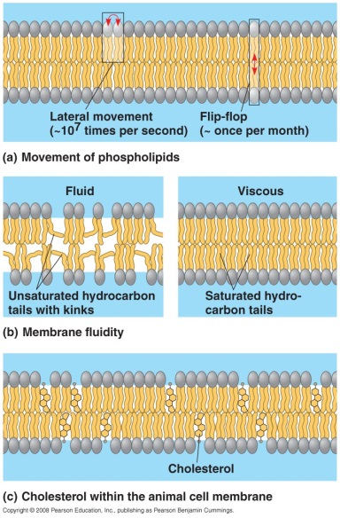Membrane molecules are held in place by relatively weak hydrophobic interactions.
* Most of the lipids and some proteins drift laterally in the plane of the membrane but rarely flip-flop from one phospholipid layer to the other.
* The lateral movements of phospholipids are rapid, about 2 µm per second.
* Adjacent phospholipids switch positions about 107 times per second.
* A phospholipid can travel the length of a typical bacterial cell in 1 sec.
* Some large membrane proteins drift within the phospholipid bilayer, although they move more slowly than the phospholipids.
* Some proteins move in a very directed manner, perhaps guided or driven by motor proteins attached to the cytoskeleton.
* Other proteins never move and are anchored to the cytoskeleton.
* Membrane fluidity is influenced by temperature.
* As temperatures cool, membranes switch from a fluid state to a solid state as the phospholipids pack more closely.
* Membrane fluidity is also influenced by the components of the membrane.
* embranes rich in unsaturated fatty acids are more fluid that those dominated by saturated fatty acids because kinks in the unsaturated fatty acid tails at the locations of the double bonds prevent tight packing.
* The steroid cholesterol is wedged between phospholipid molecules in the plasma membrane of animal cells.
* At warm temperatures (such as 37°C), cholesterol restrains the movement of phospholipids and reduces fluidity.
* At cool temperatures, cholesterol maintains fluidity by preventing tight packing.
* 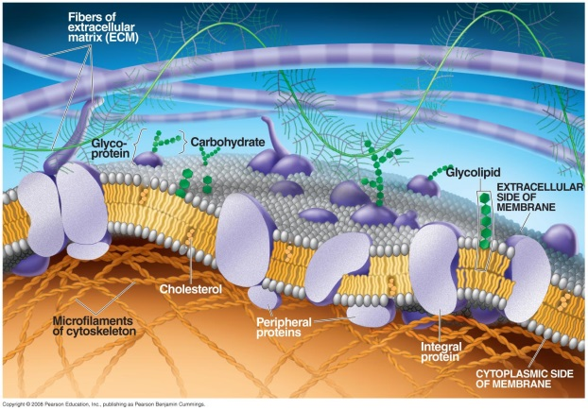Thus, cholesterol acts as a “temperature buffer” for the membrane, resisting changes in membrane fluidity as temperature changes.
* To work properly with active enzymes and appropriate permeability, membranes must be about as fluid as salad oil.
* Cells can alter the lipid composition of membranes to compensate for changes in fluidity caused by changing temperatures.
* For example, cold-adapted organisms such as winter wheat increase the percentage of unsaturated phospholipids in their membranes in the autumn.
* This adaptation prevents membranes from solidifying during winter.

Membranes are mosaics of structure and function.

* A membrane is a collage of different proteins embedded in the fluid matrix of the lipid bilayer.
* For example, more than 50 kinds of proteins have been found in the plasma membranes of red blood cells.
* Proteins determine most of the membrane’s specific functions.
* The plasma membrane and the membranes of the various organelles each have unique collections of proteins.
* There are two major populations of membrane proteins: integral and peripheral.
* **Integral proteins** penetrate the hydrophobic core of the lipid bilayer, often completely spanning the membrane (as *transmembrane* proteins).
* Other integral proteins extend partway into the hydrophobic core.
* The hydrophobic regions embedded in the membrane’s core consist of stretches of nonpolar amino acids, usually coiled into helices.
* The hydrophilic regions of integral proteins are in contact with the aqueous environment.
* Some integral proteins have a hydrophilic channel through their center that allows passage of hydrophilic substances.
* **Peripheral proteins** are not embedded in the lipid bilayer at all.
* Instead, peripheral proteins are loosely bound to the surface of the membrane, often to integral proteins.
* On the cytoplasmic side of the membrane, some membrane proteins are attached to the cytoskeleton.
* On the exterior side of the membrane, some membrane proteins attach to the fibers of the extracellular matrix.
* These attachments combine to give animal cells a stronger framework than the plasma membrane itself could provide.
* 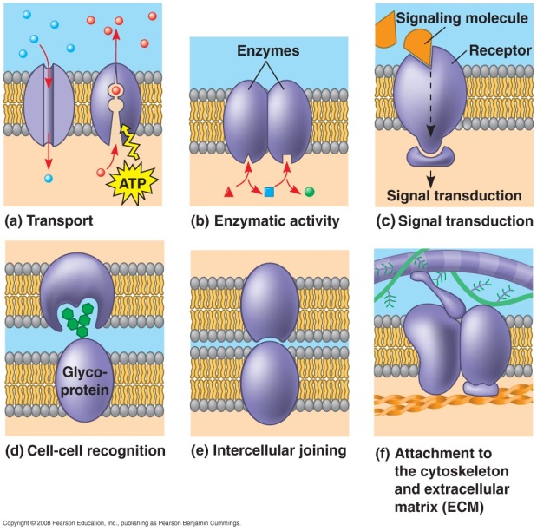The proteins of the plasma membrane have six major functions:

1. Transport of specific solutes into or out of cells
2. Enzymatic activity, sometimes catalyzing one of a number of steps of a metabolic pathway
3. Signal transduction, relaying hormonal messages to the cell
4. Cell-cell recognition, allowing other proteins to attach two adjacent cells together
5. Intercellular joining of adjacent cells with gap or tight junctions
6. Attachment to the cytoskeleton and extracellular matrix, maintaining cell shape and stabilizing the location of certain membrane proteins

Membrane carbohydrates are important for cell-cell recognition.

* Cell-cell recognition, the ability of a cell to distinguish one type of neighboring cell from another, is crucial to the functioning of an organism.
* Cell-cell recognition is important in the sorting and organizing of cells into tissues and organs during development.
* Recognition is also the basis for the rejection of foreign cells by the immune system.
* Cells recognize other cells by binding to surface molecules, often carbohydrates, on the plasma membrane.
* Membrane carbohydrates are usually branched oligosaccharides with fewer than 15 sugar units.
* Membrane carbohydrates may be covalently bonded to lipids, forming **glycolipids**, or more commonly to proteins, forming **glycoproteins**.
* The oligosaccharides on the extracellular side of the plasma membrane vary from species to species, from individual to individual, and even from cell type to cell type within an individual.
* This variation distinguishes each cell type.
* The four human blood groups (A, B, AB, and O) differ in the external carbohydrates on red blood cells.

Membranes have distinct inside and outside faces.

* The inside and outside faces of membranes may differ in lipid composition.
* Each protein in the membrane has a directional orientation in the membrane.
* The asymmetrical arrangement of proteins, lipids, and their associated carbohydrates in the plasma membrane is determined as the membrane is built by the endoplasmic reticulum (ER) and Golgi apparatus.
* Membrane lipids and proteins are synthesized in the ER.
* Carbohydrates are added to proteins in the ER, and the resulting glycoproteins are further modified in the Golgi apparatus.
* Glycolipids are also produced in the Golgi apparatus.
* Transmembrane proteins, membrane glycolipids, and secretory proteins are transported in vesicles to the plasma membrane.
* When a vesicle fuses with the plasma membrane, releasing secretory proteins from the cell, the outside layer of the vesicle becomes continuous with the cytoplasmic (inner) layer of the plasma membrane.
* Molecules that originate on the *inside* face of the ER end up on the *outside* face of the plasma membrane.

Concept 7.2 Membrane structure results in selective permeability.

* The fluid mosaic model helps explain how membranes regulate the cell’s molecular traffic.
* A steady traffic of small molecules and ions moves across the plasma membrane in both directions.
* For example, sugars, amino acids, and other nutrients enter a muscle cell, and metabolic waste products leave.
* The muscle cell takes in oxygen and expels carbon dioxide.
* The muscle cell also regulates the concentrations of inorganic ions, such as Na+, K+, Ca2+, and Cl−, by shuttling them one way or the other across the membrane.
* Substances do not move across the barrier indiscriminately; membranes are selectively permeable.
* The cell is able to take up many varieties of small molecules and ions and exclude others.
* Substances that move through the membrane do so at different rates.
* Movement of a molecule through a membrane depends on the interaction of the molecule with the hydrophobic core of the membrane.
* Nonpolar molecules, such as hydrocarbons, CO2, and O2, are hydrophobic and can dissolve in the lipid bilayer and cross easily, without the assistance of membrane proteins.
* The hydrophobic core of the membrane impedes the direct passage of ions and polar molecules, which are hydrophilic.
* Polar molecules, such as glucose and other sugars, and even water, an extremely small polar molecule, cross the lipid bilayer slowly.
* An ion, whether a charged atom or a molecule, and its surrounding shell of water also have difficulty penetrating the hydrophobic core of the membrane.
* Proteins assist and regulate the transport of ions and polar molecules.
* Cell membranes *are* permeable to specific ions and a variety of polar molecules, which can avoid contact with the lipid bilayer by passing through **transport proteins** that span the membrane.
* Some transport proteins called *channel proteins* have a hydrophilic channel that certain molecules or ions can use as a tunnel through the membrane.
* The passage of water through the membrane can be greatly facilitated by channel proteins known as **aquaporins**.
* Each aquaporin allows entry of as many as 3 *billion* (109) water molecules per second, passing single file through its central channel, which fits 10 at a time.
* Without aquaporins, only a tiny fraction of these water molecules would diffuse through the same area of the cell membrane in a second, so the channel protein greatly increases the rate of water movement.
* Some transport proteins called *carrier proteins* bind to molecules and change shape to shuttle them across the membrane.
* Each transport protein is specific for the substance that it translocates.
* For example, the glucose transport protein in the liver carries glucose into the cell but does not transport fructose, its structural isomer.
* The glucose transporter causes glucose to pass through the membrane 50,000 times as fast as it would diffuse through on its own.

Concept 7.3 Passive transport is diffusion of a substance across a membrane with no energy investment.

* 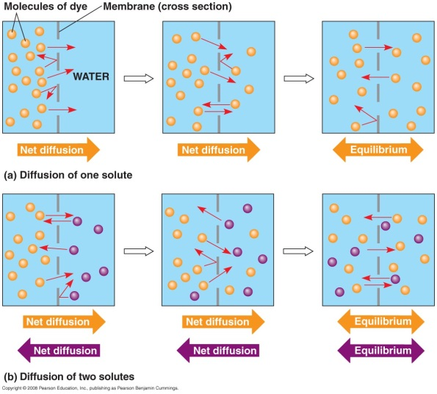**Diffusion** is the tendency of the molecules of any substance to spread out in the available space.
* Diffusion is driven by the intrinsic kinetic energy (thermal motion or heat) of molecules.
* The movements of individual molecules are random. However, the movement of a *population* of molecules may be directional.
* Imagine a permeable membrane separating a solution with dye molecules from pure water.
* Assume that this membrane has microscopic pores and is permeable to the dye molecules.
* Each dye molecule wanders randomly, but there is a *net* movement of the dye molecules across the membrane to the side that began as pure water.
* The net movement of dye molecules across the membrane continues until both sides have equal concentrations of the dye.
* At this dynamic equilibrium, as many molecules cross one way as cross in the other direction.
* In the absence of other forces, a substance diffuses from where it is more concentrated to where it is less concentrated, down its **concentration gradient**.
* No work must be done to move substances down the concentration gradient; diffusion is a spontaneous process, needing no input of energy.
* Each substance diffuses down its *own* concentration gradient, independent of the concentration gradients of other substances.
* The diffusion of a substance across a biological membrane is **passive transport** because it requires no energy from the cell to make it happen.
* The concentration gradient itself represents potential energy and drives diffusion.
* Because membranes are selectively permeable, the interactions of the molecules with the membrane play a role in the diffusion rate.
* In the case of water, aquaporins allow water to diffuse very rapidly across the membranes of certain cells.

Osmosis is the passive transport of water.

* 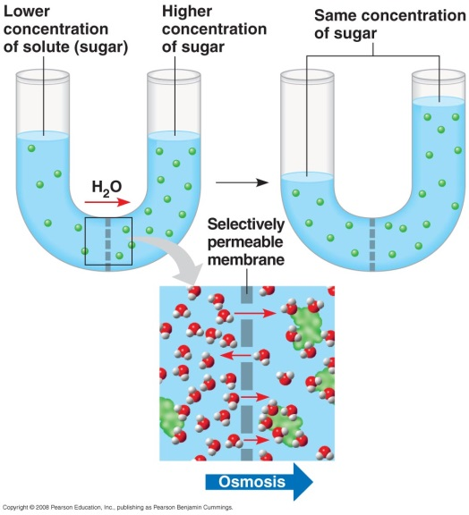Imagine that two sugar solutions differing in concentration are separated by a membrane that allows water through, but not sugar. How does this affect the *water* concentration?
* In a dilute solution like most biological fluids, solutes do not affect the water concentration significantly.
* However, the clustering of water molecules around the hydrophilic solute molecules makes some of the water unavailable to cross the membrane.
* It is the difference in the *free* water concentration that is important.
* In the end, the effect is the same: Water diffuses across the membrane from the region of lower solute concentration to the region of higher solute concentration until the solute concentrations on both sides of the membrane are equal.
* The diffusion of water across a selectively permeable membrane is called **osmosis**.
* The movement of water across cell membranes and the balance of water between the cell and its environment are crucial to organisms.
* Both solute concentration and membrane permeability affect **tonicity**, the ability of a solution to cause a cell to gain or lose water.
* The tonicity of a solution depends in part on its concentration of solutes that cannot cross the membrane (nonpenetrating solutes) relative to the concentration of solutes in the cell itself.
* If there are more nonpenetrating solutes in the surrounding solution, water tends to leave the cell, and vice versa.
* If a cell without a cell wall, such as an animal cell, is immersed in an environment that is **isotonic** to the cell, there is no *net* movement of water across the plasma membrane.
* Water flows across the membrane, but at the same rate in both directions.
* If the cell is immersed in a solution that is **hypertonic** to the cell (containing nonpenetrating solutes), the cell loses water to its environment, shrivels, and probably dies.
* For example, an increase in the salinity (saltiness) of a lake can kill aquatic animals.
* If the lake water becomes hypertonic to the animals’ cells, the cells may shrivel and die.
* Taking up too much water can be just as hazardous to an animal cell as losing water.
* If the cell is immersed in a solution that is **hypotonic** to the cell, water enters the cell faster than it leaves, and the cell swells and lyses (bursts) like an overfilled water balloon.

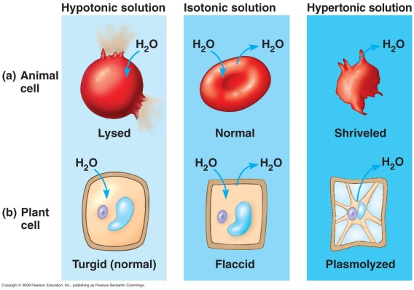Cell survival depends on the balance between water uptake and loss.

* Organisms without rigid cell walls have osmotic problems in either a hypertonic or a hypotonic environment.
* Water balance is not a problem if such a cell lives in isotonic surroundings, however.
* Seawater is isotonic to many marine invertebrates.
* The cells of most terrestrial animals are bathed in extracellular fluid that is isotonic to the cells.
* Animals and other organisms without rigid cell walls living in hypertonic or hypotonic environments must have adaptations for **osmoregulation**, the control of water balance.
* The protist *Paramecium* is hypertonic to the pond water in which it lives.
* In spite of a cell membrane that is less permeable to water than other cells, water continually enters the *Paramecium* cell.
* To solve this problem, *Paramecium* cells have a specialized organelle, the contractile vacuole, that functions as a bilge pump to force water out of the cell.
* The cells of plants, prokaryotes, fungi, and some protists have walls.
* A plant cell in a solution hypotonic to the cell contents swells due to osmosis until the elastic cell wall exerts a back-pressure on the cell that opposes further uptake.
* At this point the cell is **turgid** (very firm), a healthy state for most plant cells.
* Turgid cells contribute to the mechanical support of the plant.
* If a plant cell and its surroundings are isotonic, there is no movement of water into the cell. The cell becomes **flaccid** (limp), and the plant may wilt.
* The cell wall provides no advantages when a plant cell is immersed in a hypertonic solution.
* As the plant cell loses water, its volume shrinks.
* Eventually, the plasma membrane pulls away from the wall. This **plasmolysis** is usually lethal.
* The walled cells of bacteria and fungi also plasmolyze in hypertonic environments.

Specific proteins facilitate the passive transport of water and selected solutes.

* Many polar molecules and ions that are normally impeded by the lipid bilayer of the membrane diffuse passively with the help of transport proteins that span the membrane.
* The passive movement of molecules down their concentration gradient via transport proteins is called **facilitated diffusion**.
* Most transport proteins are very specific: They transport only particular substances but not others.
* Two types of transport proteins facilitate the movement of molecules or ions across membranes: channel proteins and carrier proteins.
* 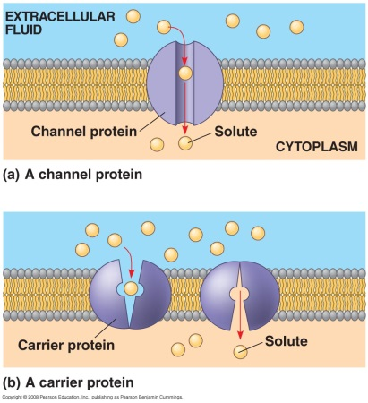Channel proteins provide hydrophilic corridors for the passage of specific molecules or ions.
* For example, water channel proteins, aquaporins, greatly facilitate the diffusion of water.
* Kidney cells have a high number of aquaporins, allowing them to take up water from urine before it is excreted.
* It has been estimated that a person would have to drink 50 gallons of water per day and excrete the same volume if the kidneys did not perform this function.
* Many **ion channels** function as **gated channels**.
* These channels open or close depending on the presence or absence of a chemical or physical stimulus.
* If chemical, the stimulus is a substance other than the one to be transported.
* For example, the stimulation of a receiving neuron by specific neurotransmitters opens gated channels to allow sodium ions into the cell.
* Some transport proteins do not provide channels but appear to actually translocate the solute-binding site and the solute across the membrane as the transport protein changes shape.
* These shape changes may be triggered by the binding and release of the transported molecule.
* In certain inherited diseases, specific transport systems may be defective or absent.
* Cystinuria is a human disease characterized by the absence of a carrier protein that transports cysteine and other amino acids across the membranes of kidney cells.
* An individual with cystinuria develops painful kidney stones as amino acids accumulate and crystallize in the kidneys.

Concept 7.4 Active transport uses energy to move solutes against their gradients.

* Some transport proteins can move solutes across membranes against their concentration gradient, from the side where they are less concentrated to the side where they are more concentrated.
* This **active transport** requires the cell to expend metabolic energy and enables a cell to maintain internal concentrations of small molecules that would otherwise diffuse across the membrane.
* Compared with its surroundings, an animal cell has a much higher concentration of potassium ions and a much lower concentration of sodium ions.
* The plasma membrane helps maintain these steep gradients by pumping sodium out of the cell and potassium into the cell.
* ATP supplies the energy for most active transport by transferring its terminal phosphate group directly to the transport protein.
* This process may induce a conformational change in the transport protein, translocating the bound solute across the membrane.
* The **sodium-potassium pump** works this way in exchanging sodium ions (Na+) for potassium ions (K+) across the plasma membrane of animal cells.

Some ion pumps generate voltage across membranes.

* All cells maintain a voltage across their plasma membranes.
* Voltage is electrical potential energy resulting from the separation of opposite charges.
* The cytoplasm of a cell is negative in charge relative to the extracellular fluid because of an unequal distribution of cations and anions on opposite sides of the membrane.
* The voltage across a membrane is called a **membrane potential** and ranges from −50 to −200 millivolts (mV). The inside of the cell is negative compared to the outside.
* The membrane potential acts like a battery.
* Because the inside of the cell is negative compared with the outside, the membrane potential favors the passive transport of cations into the cell and anions out of the cell.
* *Two* combined forces, collectively called the **electrochemical gradient**, drive the diffusion of ions across a membrane.
* One is a chemical force based on an ion’s concentration gradient.
* The other is an electrical force based on the effect of the membrane potential on the ion’s movement.
* An ion does not simply diffuse down its *concentration* gradient but diffuses down its *electrochemical* gradient.
* For example, there is a higher concentration of Na+ outside a resting nerve cell than inside.
* When the neuron is stimulated, gated channels open and Na+ diffuses into the cell down the electrochemical gradient.
* The diffusion of Na+ is driven by the concentration gradient and by the attraction of cations to the negative side of the membrane.
* Special transport proteins, called **electrogenic pumps**, generate the voltage gradient across a membrane.
* The sodium-potassium pump, the major electrogenic pump in animals, restores the electrochemical gradient not only by the active transport of Na+ and K+, setting up a concentration gradient, but also because it pumps two K+ inside for every three Na+ that it moves out, setting up a voltage across the membrane.
* 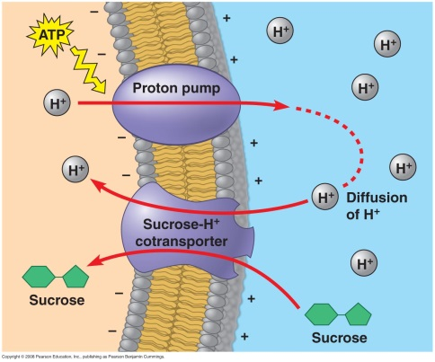In plants, bacteria, and fungi, a **proton pump** is the major electrogenic pump, actively transporting H+ out of the cell and transferring positive charge from the cytoplasm to the extracellular solution.
* By generating voltage across membranes, electrogenic pumps store energy that can be tapped for cellular work.

In cotransport, a membrane protein couples the transport of two solutes.

* A single ATP-powered pump that transports a specific solute can indirectly drive the active transport of several other solutes in a mechanism called **cotransport**.
* As the solute that has been actively transported diffuses back passively through a transport protein, its movement can be coupled with the active transport of another substance against its concentration gradient.
* Plants commonly use the gradient of hydrogen ions generated by proton pumps to drive the active transport of amino acids, sugars, and other nutrients into the cell.
* One specific transport protein couples the diffusion of protons out of the cell and the transport of sucrose into the cell.
* Plants use the mechanism of sucrose-proton cotransport to load sucrose into specialized cells in the veins of leaves for distribution to nonphotosynthetic organs such as roots.
* An understanding of cotransport proteins, osmosis, and water balance in animal cells has helped scientists develop effective treatments for the dehydration that results from diarrhea, a serious problem in developing countries where intestinal parasites are prevalent.
* Patients are given a solution to drink that contains a high concentration of glucose and salt.
* The solutes are taken up by transport proteins on the intestinal cell surface and passed through the cells into the blood.
* The resulting increase in the solute concentration of the blood causes a flow of water from the intestine through the intestinal cells into the blood, rehydrating the patient.
* Because of the specific proteins involved, both glucose and the sodium ion from salt must be present.
* The same principle underlies athletes’ consumption of solute-rich sports drinks after a demanding athletic event.

Concept 7.5 Bulk transport across the plasma membrane occurs by exocytosis and endocytosis.

* 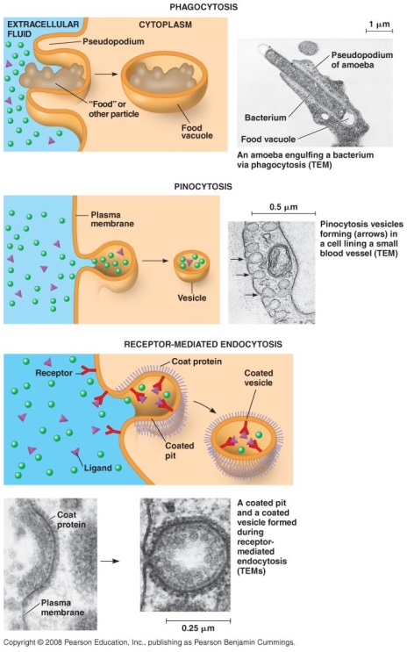Small solutes and water enter or leave the cell through the lipid bilayer or by transport proteins.
* Particles and large molecules, such as polysaccharides and proteins, cross the membrane via packaging in vesicles.
* Like active transport, these processes require energy.
* In **exocytosis**, a transport vesicle budded from the Golgi apparatus is moved by the cytoskeleton to the plasma membrane.
* When the two membranes come in contact, the bilayers fuse and spill the contents to the outside.
* Pancreatic cells secrete insulin into the blood by exocytosis.
* Neurons use exocytosis to release neurotransmitters that signal other neurons or muscle cells.
* When plant cells are making walls, exocytosis delivers proteins and certain carbohydrates from Golgi vesicles to the outside of the cell.
* During **endocytosis**, a cell brings in macromolecules and particulate matter by forming new vesicles from the plasma membrane.
* Endocytosis is a reversal of exocytosis, although different proteins are involved in the two processes.
* In endocytosis, a small area of the plasma membrane sinks inward to form a pocket.
* As the pocket deepens, it pinches in to form a vesicle containing the material that had been outside the cell.
* There are three types of endocytosis: **phagocytosis** (“cellular eating”), **pinocytosis** (“cellular drinking”), and **receptor-mediated** **endocytosis**.
* Receptor-mediated endocytosis enables a cell to acquire bulk quantities of specific materials that may be in low concentrations in the environment.
* Human cells use this process to take in cholesterol for use in the synthesis of membranes and as a precursor for the synthesis of steroids.
* Cholesterol travels in the blood in low-density lipoproteins (LDL), complexes of protein and lipid.
* These lipoproteins act as **ligands** by binding to LDL receptors on membranes and entering the cell by endocytosis.
* In an inherited disease called familial hypercholesterolemia, the LDL receptors are defective, leading to an accumulation of LDL and cholesterol in the blood.
* This condition contributes to early atherosclerosis.
* Vesicles not only transport substances between the cell and its surroundings but also provide a mechanism for rejuvenating or remodeling the plasma membrane.
* Endocytosis and exocytosis occur continually in most eukaryotic cells, yet the amount of plasma membrane in a nongrowing cell remains fairly constant.
* Apparently, the addition of membrane by one process offsets the loss of membrane by the other.