Dear Station 32 Families,

I am so excited to be your child’s third grade teacher! Thank you for helping your child gather the following **supplies for the first day of school, Monday, August 7th** at 7:50 AM. Students should be in line (at the back gate) **before 7:50 AM.**

* Plug-in headphones or ear buds in a bag, clearly marked with their name (nothing wireless please)
* 5 **sharpened** pencils (NOT mechanical)
* 1 big eraser
* 2” ring binder
* 5 dividers/tabs (preferably with pockets)
* Box of crayons (no more than 24)
* Colored pencils
* Highlighters: pink, yellow, and green (1 of each color please)
* Small pencil box or pouch (desk space is limited)
* 2 pens
* 2 single subject, spiral notebooks OR a 3-subject spiral

notebook (wide ruled)

* A pair of small scissors
* 2 EXPO markers (dark colors only)

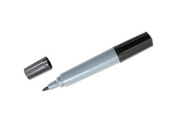The following supply donations would also be appreciated for our **class** and are welcome *any* time of the year:

* 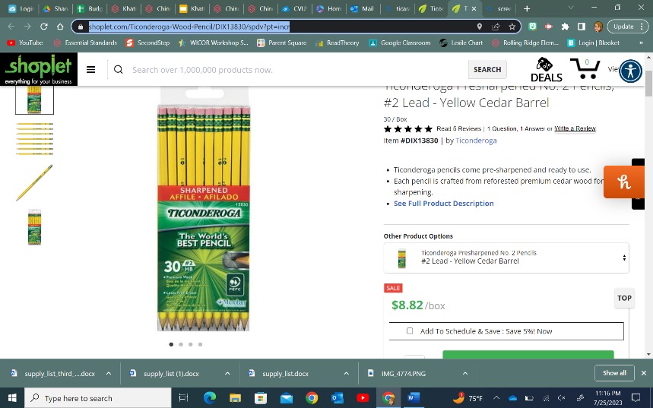Sheet/page protectors
* Colored copy paper
* EXPO (whiteboard) markers
* Ticonderoga #2 pencils (sharpened please)
* Individually wrapped treats for the jar
* Items to sell at the “Khatiblootique”

Thank you in advance for your support! If you have any questions, don’t hesitate to **message me on Parent Square**. I look forward to seeing you at **Back-to-School Night on August 30th**! Here’s to a GREAT year!

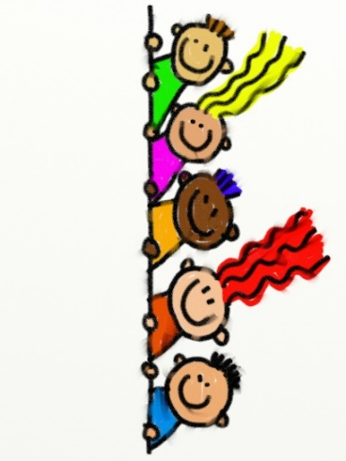

Kindest regards,

*Ms. Khatibloo*