SPORTS PHYSICALS

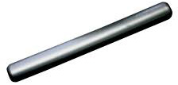Chino High School

Male & Female



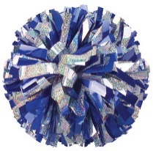**Dates: May 14th & May 21st**

**Times: 8:00am-10:00am**

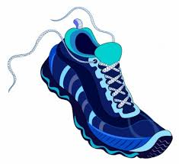**And May 22nd 8:00-9:00am**

**Location:** **Don Lugo High School**

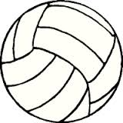**Cost:** $25 Cash Only (100% to trainer supplies)

**What to Wear:** Comfortable Shorts & T-Shirt

**Appointments:** Limited appointment times:

Please email Terrie Briones, Athletics Secretary, to

 receive your appointment time.

 Terrie_Briones@chino.k12.ca.us

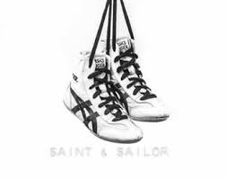**Registration:** ALL Student Athletes **MUST** register online at <https://athleticclearance.com> **prior** to having the physical. All athletes must have a **physical** on file with Kevin Sells, CHS athletic trainer, to participate for the 2022-2023 school year. This includes 2022 summer camps. Physical papers can be printed from <https://athleticclearance.com>. Physicals MUST be done after May 1, 2022, to be good for the 2022-2023 school year.