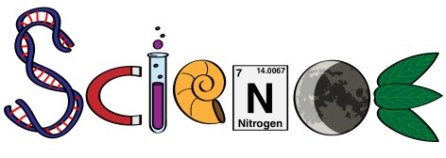**Mrs. Naramore’s Blended Learning Classroom**

**2020-2021**

Dear Students and Parents,

I look forward to working with your child as we dive into the Next Generation Science Standards (NGSS). This year we will pilot Amplify curriculum for our integrated studies in Life Science, Physical Science, and Earth Science This policy is to inform you of the standards and expectations Classroom and how our class will function online.

**Blended Learning Expectations:**

* Students should not share their login information, meeting links, or passwords with others.
* School and classroom rules apply to the virtual instructional environment
* Students who use inappropriate language, share inappropriate images, or behave inappropriately on video conferences will be subject to appropriate discipline.
* Student should have a quiet workplace in order to work, free of distractions

**Google Meet Expectations:**

* Students will be on-time with cameras ON, microphones OFF and your full name typed by the start of class
* Students should dress appropriately for virtual instruction sessions
* Students should not conduct audio or video recordings of sessions or take any pictures unless permission is granted by teacher.
* Once the virtual meeting is finished, students must log off the meeting entirely
* Students will always conduct themselves in a respectful manner to their teacher and fellow peers.

CVUSD Model Distance

These are hours which I will be available,

live, on Google Meet, for questions

regarding assignments, schedules, and

for my Virtual Office hours in our Google Classroom, Classwork page, under the

**ADDING PAGES TO YOUR TEACHER**

**Distance Teaching and Learning**

· Students who use inappropriate language, share inappropriate images, or in any

**Classroom Expectations:**

* Students will check teacher’s website/Google Classroom daily. **Students have already been placed in their Google Classrooms. There is no need for a class code.**
* All students will complete all the assignments and turn them in on time.
* Students will follow the school-wide expectations: responsible, respectful, safe.
* Students will follow academic honesty and not engage in plagiarism or cheating.
* Students should take notes in their notebooks to help them with assignments and assessments.

**Parent/Student/Teacher Communications:**

**Teacher Webpage (on Cal Aero Website)** <https://www.chino.k12.ca.us/Domain/1322>

**Email**: [michele_naramore@chino.k12.ca.us](mailto:michele_naramore@chino.k12.ca.us)

**Remind:** please join the correct Remind classroom so I can send you out important reminders. You can sign up by getting the Remind App or text 81010 with the message saying:

7th grade code: **@naramore7**

8th grade code**: @naramore8**

**Virtual Office Hours (via Google Meet):**

Mondays 8:30-9:15am

Tuesday 2:40-3:25pm

Wednesday 2:40-3:25pm

Friday 8:30-9:15am

If you have any other questions please feel free to email me at any time, and I will respond within 24 hours.

If needed, we can set up a time/date for a Google Meet.

**Classwork Assignments:**

Assignments due dates will be shown on the daily agenda slide and on each google classroom assignment. At this time, all work will be submitted through Google Classroom.

**How to Find and Submit Assignments/Assessments**

We will be using Google Classroom for on-line work and for online assessments. Google Classroom is accessible through ClassLinks. Assessments will be given at the end of each chapter. Parents are encouraged to join Google classroom (as a guardian) and the Remind App.

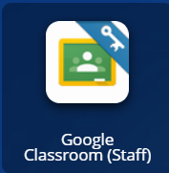

**If you need ANY help at all, please reach out to me!**

**Mrs. Naramore 😊**